Dear Member,

We are excited to announce a new promotion from Callaway!

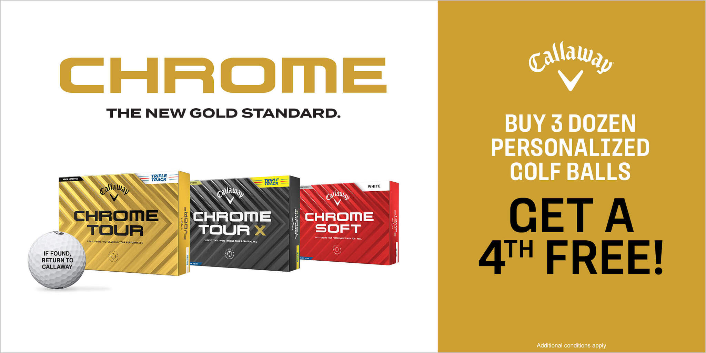

Offer:
- Buy 3 dozen personalized Chrome Soft, Chrome Tour, or Chrome Tour X Golf Balls and receive a fourth personalized dozen FREE! Plus, orders receive free personalization.

- Available Models:

Chrome Tour White | Chrome Tour X White | Chrome Soft White
Chrome Tour White Triple Track | Chrome Tour X White Triple Track | Chrome Soft White Triple Track
Chrome Tour Yellow | Chrome Tour X Yellow
Chrome Tour Yellow Triple Track

Personalization Options:
- Personalization is offered in black, red, blue, green, pink, purple, orange, or brown block letters on a white golf ball. Yellow golf balls only offer black ink. Three lines, 20 character maximum per line (including spaces and punctuation)
- Line Rite (a Callaway Exclusive) is available in two alignment options, target or straight, with up to three initials in black, red, blue, green, pink, purple, orange, or brown block letters on a white golf ball. Yellow golf balls only offer black ink. Line Rite is not available on Triple Track models.
- Not Available on Truvis, with a Higher Player Number, with a Custom Player Number, with a Logo, or for Tournaments

You can build and customize your golf balls and submit the order to the shop.

Please contact the Pro Shop for more information!

