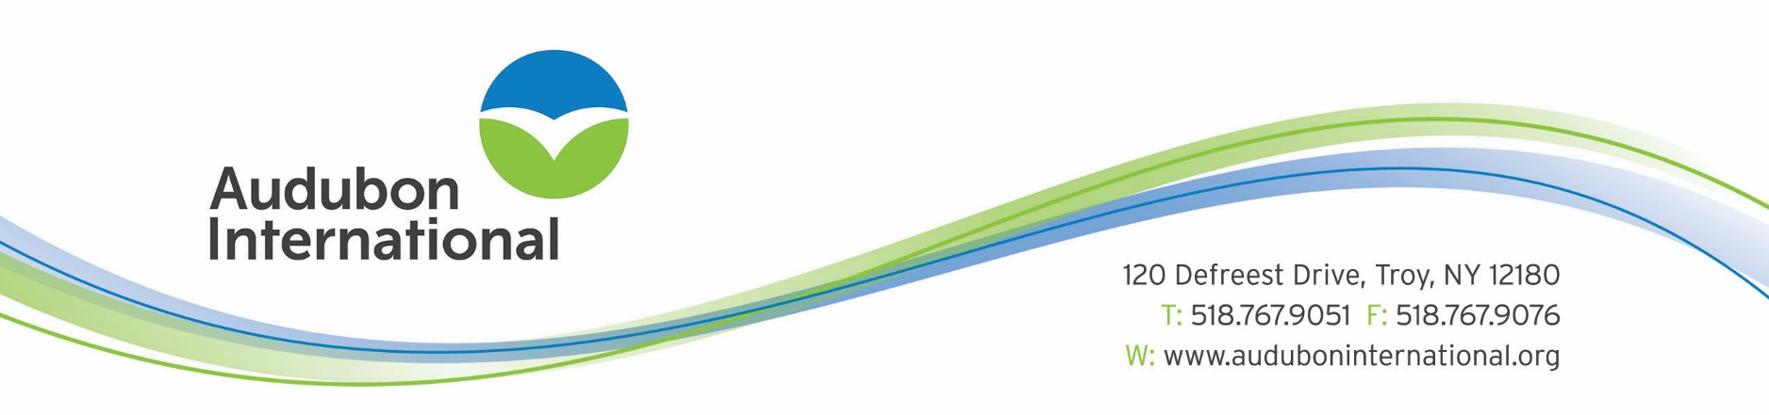

FOR IMMEDIATE RELEASE – December 2023
CONTACT: Frank LaVardera, Director of Environmental Programs for Golf
(518) 767-9051 x 115
frank@auduboninternational.org

Bayville Golf Club Recognized for Environmental Excellence

VIRGINIA BEACH, VIRGINIA – Bayville Golf Club has achieved designation as a "Certified Audubon Cooperative Sanctuary" through the Audubon Cooperative Sanctuary Program for Golf Courses. Scott Mauldin, Director of Golf Course Operations led the effort to obtain sanctuary designation on the property. The course is now one of over 900 courses in the world to hold certification from Audubon International.

"Bayville Golf Club has shown a strong commitment to its environmental program. They are to be commended for their efforts to provide a sanctuary for wildlife on the golf course property," said Christine Kane, CEO at Audubon International.
"To reach certification, a course must demonstrate that they are maintaining a high degree of environmental quality in a number of areas," explained Kane. These categories include: Environmental Planning, Wildlife & Habitat Management, Outreach and Education, Chemical Use Reduction and Safety, Water Conservation, and Water Quality Management. The club’s accomplishments include:
- Expanding Native Vegetation
- Removing Invasive Plant species
- Providing quality wildlife habitat
- Conducting water quality testing
Bayville golf club strives to host sustainable management practice to enhance the land and waterways around the course and the Virginia Beach area.
The Audubon Cooperative Sanctuary Program for Golf Courses, endorsed by the United States Golf Association, provides information and guidance to help golf courses preserve and enhance wildlife habitat and protect natural resources. Golf courses from the United States, Africa, Australia, Canada, Central America, Europe, New Zealand, and Southeast Asia have achieved certification in the program.
Audubon International is a 501(c)(3) nonprofit organization based in Troy, NY. In addition to golf courses, Audubon International also provides programs for businesses, schools, communities, and new developments with the purpose of delivering high-quality environmental education and facilitating the sustainable management of natural resources. For more information, call Audubon International at 1-844-767-9051 or visit www.auduboninternational.org.

