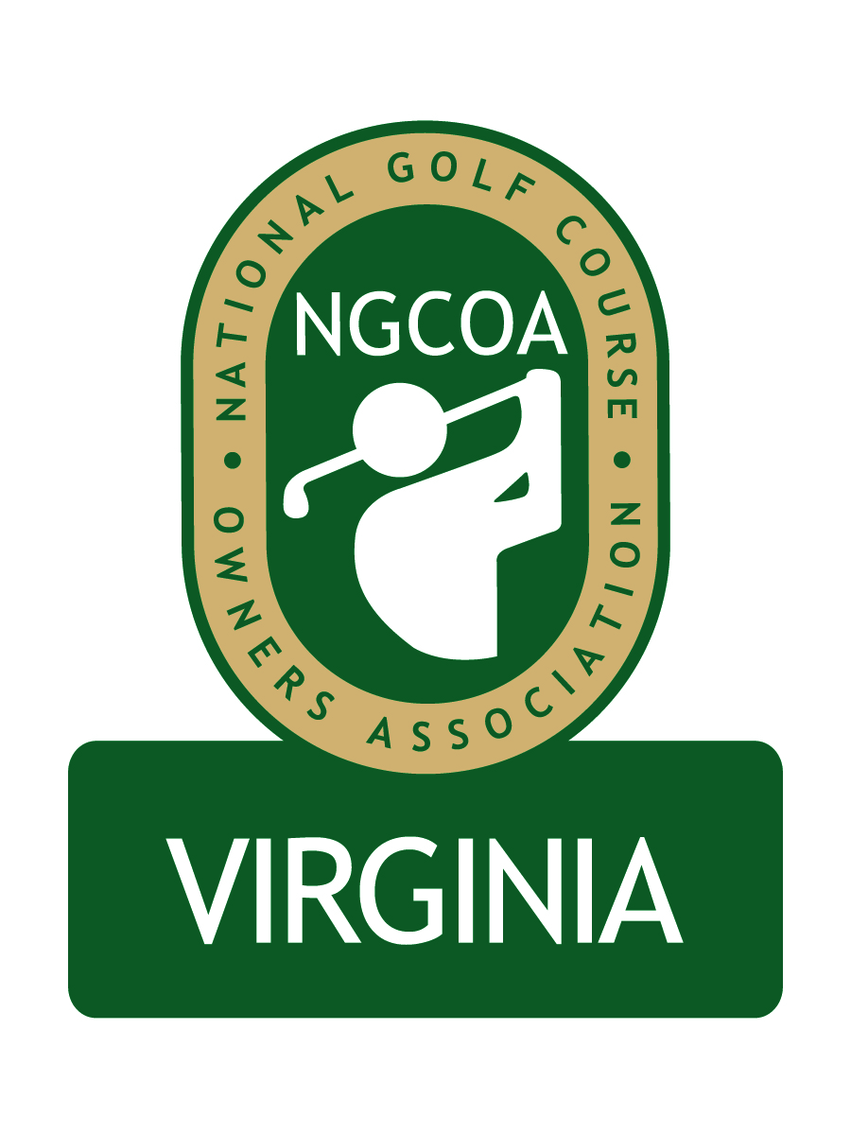

NGCOA Virginia Board Conference Call
January 27, 2014

Minutes

Attendance – David Norman, Bob Swiger, Phil Owenby, Don Ryder Joe Rice

The meeting was called to order at 11:00 a.m.

Discussion of Regional Expansion

This was a special meeting to review the proposed chapter expansion.

Rice reiterated the national office’s support for this initiative. They have pledged their support both financially and operationally, including an offer of personal visits by NGCOA leadership.

Swiger suggested that we move forward with the nominees selected. He cited comments from DeVito in support. Ryder agreed that the new board members are great people from great clubs. Owenby also expressed support. Rice agreed from the standpoint of the national office, citing the careful methodical approach to the expansion. The group formally approved moving forward.

The board decided that the February 13th conference call should be with the new full board, introducing the new board members.

Adjournment

The meeting was adjourned at 11:22 a.m.

