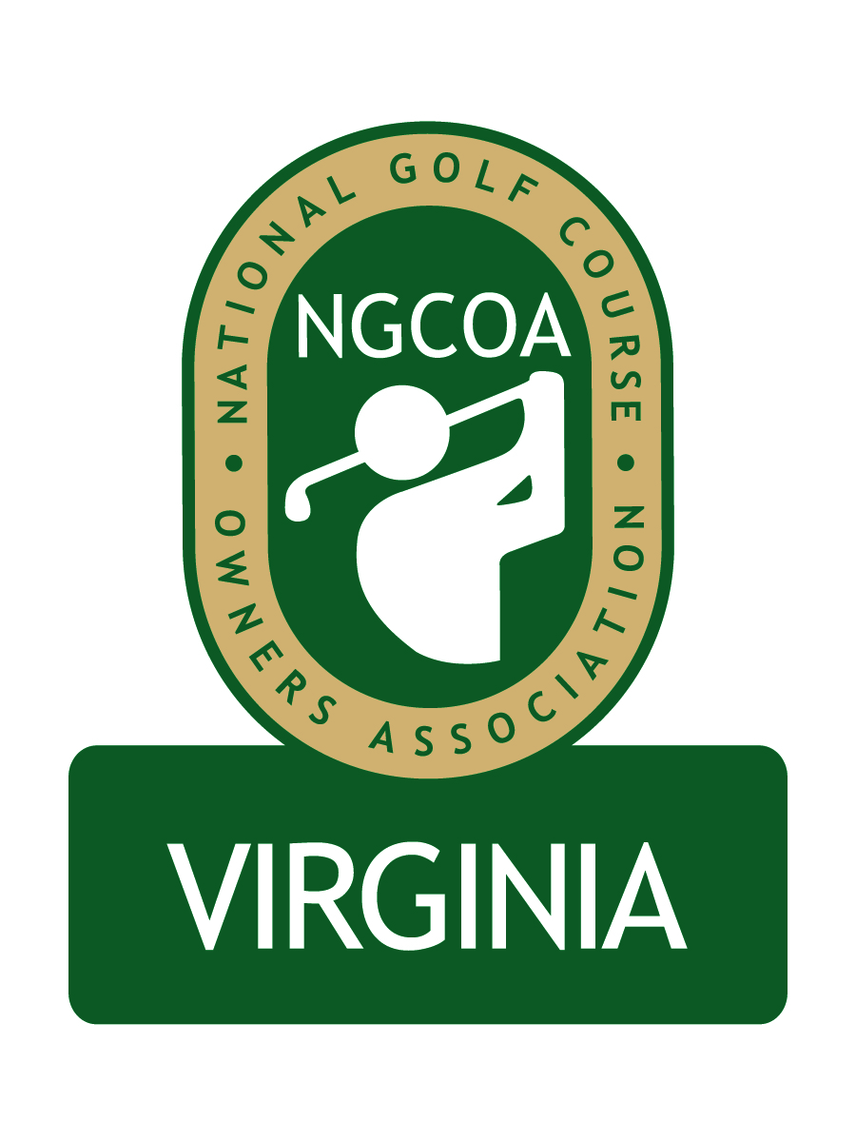

NGCOA Virginia Board Conference Call
January 9, 2014

Minutes

Attendance – David Norman, Mike Bennett, Mike Hatch, Bob Swiger, Phil Owenby, Mike Fentress, Joe Rice

The meeting was called to order at 2:04 pm.

Roll Call of Participants

The meeting began with a roll call of participants. Mike Bennett wished everyone a Happy New Year!

Approval of Minutes

The minutes of the previous meeting were approved.

Treasurer’s Report

Norman gave the Treasurer’s report, which was approved.

Economic Impact Study Update

The Economic Impact Study commissioned by the Virginia Golf Council has been published in Executive Summary format – the Full Report is being finalized. Our share of the cost is approximately $1,700, which is now payable.

Newsletter Update

The Winter Newsletter was published and distributed via email and on the website on December 18 and again on January 2.

Partner Program Update

Billy Casper Golf has committed to be a Gold Partner in 2014. Norman is developing literature for the 2014 program.

Auction Update

The 2013 online auction was the most successful one to date, grossing nearly $8K. All receivables have been collected except one.

Regional Expansion

Bennett cited the desire to grow our chapter and expressed excitement about expanding into Maryland and D.C. He seeks to grow the membership base and the corporate partner program. Additional revenues will allow us to provide better member services. He mentioned the possibility to host the annual meeting in Maryland. Norman brought up the question of size of the new board, and Bennett suggested that it be 13. He noted that two current board members have Maryland courses (DeVito with Musket Ridge and Cutler with Billy Casper Golf). The group discussed how to communicate the news to Maryland clubs, and it was suggested to recruit prominent Maryland board members first. Rice mentioned that the national office could support the initiative with $2,500 from the marketing fund. The board then discussed possible nominees for the board. Course type and geographic location were considered in the discussion. Norman will work with Bennett and Swiger to select the nominees, then Norman will personally visit the prospects to invite them to serve.

Management Agreement

The group acknowledged that the board expansion will bring additional management responsibilities. Bennett will work with Norman on the agreement. Part of the process will be the development of a budget for 2014.

National Conference Preview

Rice reported that conference registration is way up. Jack Nicklaus will be in attendance and will do a Q&A. The project toward a national online tee time distribution platform continues, with input from all industry segments. The work on the Strategic Plan also continues, with a goal to build relevance.

Old Business / New Business

The next board call is set for 2 pm, Thursday, February 13th.

Adjourn

The meeting was adjourned at 2:53 pm.

