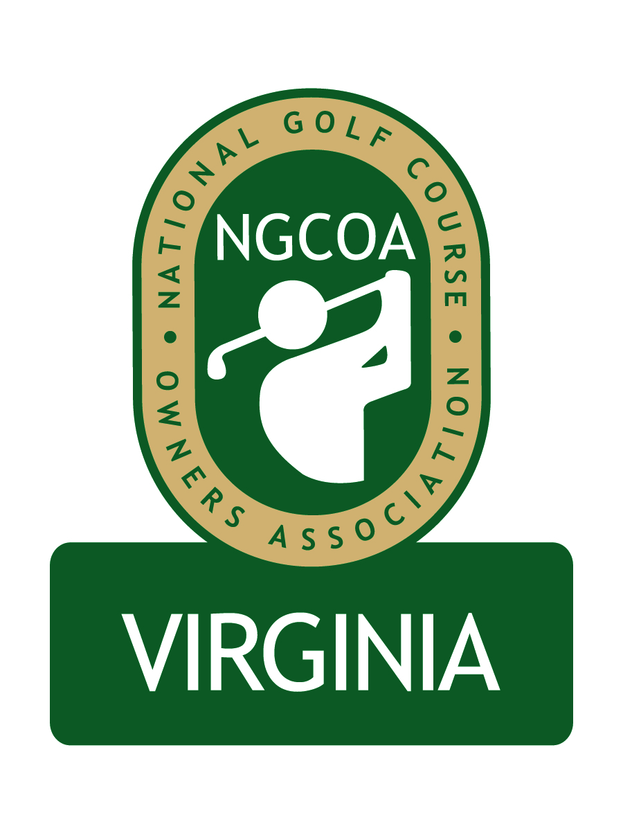

NGCOA Virginia Board Conference Call
October 9, 2013

Minutes

Attendance – David Norman, Mike Bennett, Damon DeVito, Glen Byrnes, Mike Hatch, Phil Owenby, Don Ryder, Bob Swiger, Mike Fentress

The meeting was called to order at 2:04 pm.

Roll Call of Participants

The meeting began with a roll call of participants.

Approval of Minutes

The minutes of the previous meeting were approved.

Treasurer’s Report

Norman gave the Treasurer’s report, which was approved.

Annual Meeting Recap

Bennett reported that the Annual Meeting went well and that keynote speaker Mike Tinkey from NGCOA did a great job. He also cited the panel discussion as engaging – the panel featured Mike Hatch, Glen Byrnes and Damon DeVito. He suggested we might allot more time to the panel next year, possibly making it the first part. There were some new faces this year, including Piankatank River and the Willard Companies from southwest VA. We need to continue to attract new faces, but also keep the ones from the previous year. Fentress agreed with the popularity of the panel discussion and DeVito said he was pleased to be a part of it. Norman gave an overview of the awards portion of the meeting, as well as the golf event. It was noted that not everyone will have time for golf but that it is still an important part of the day. It was suggested that the dinner did not have to be as elaborate. Norman noted that dinner was sponsored by PFG, and it was an opportunity to showcase their offerings.

Chapter Leaders Meeting

Norman recounted the Chapter Leaders Meeting on September 30-October 2 in Charleston, SC. Around 35 leaders attended, including Norman and Bob Swiger representing the Virginia Chapter. One of the key elements was a focus on delivery value to members. In particular, four areas were initially discussed: member savings programs, advocacy, networking & education and player development. Then Mike Hughes led a discussion on tee time systems, with a dialogue on the issue of third party resellers. The event featured excellent networking opportunities, including the overlap with the national board meeting, where Mike Hatch represented NGCOA VA. The event concluded with a networking golf event at Stono Ferry GC, a very nice daily fee course.

Hatch then recounted the National board meeting. Currently the association has around $1 million in reserves. The meeting featured a discussion of Golf Now, which included input from Dana Garmany of Troon Golf and Peter Hill of Billy Casper Golf. Casper is concerned about the impact of Golf Now on price integrity. As a result of the discussion, NGCOA is planning to research a strategic partnership related to tee time systems. They are also planning to do an extensive strategic planning initiative for the association.

Partner Program Update

In the Partner discussion, Norman announced the addition of the Korean Golf Guide publishers as new Diamond partners. Board members reported that they were bombarding everyone with emails seeking course listings. Norman said he would call them to explain protocol and to help them strategize to the best market. Bennett suggested that IBS might be a good prospect. Owenby said he knew their principal Mr. Strange and would contact him on our behalf.

Webinar Education

Norman reported that tomorrow (October 10th), Mike Aldrich would be presenting a webinar, “What Golfers Really Want.”

Regional Expansion

The regional expansion to a Mid-Atlantic Chapter was discussed. There is interest in this, but proposed action was postponed until after the annual meeting. Swiger offered to discuss it with Maryland owners who participate in the Raspberry Golf Trail. Bennett noted the key timing to attract more partners at the first of the year. He suggested a conference call among him, Swiger and Norman to discuss further.

Old Business / New Business

The next board call is set for 2 pm, Tuesday, November 12.

Swiger added some comments on the Chapter Leaders event. He indicated that it was good networking and that the representative from Myrtle Beach Golf Holiday adequately characterized the challenge to develop tee time system software (cost and rapid technology advancement were hurdles). The key is to not let Golf Now dictate market pricing.

Bennett then quickly polled the board on use of Performance Trak – in general, the response was “no.” PGA and NGCOA are hoping more people will participate.

Adjourn

The meeting was adjourned at 2:56 pm.

