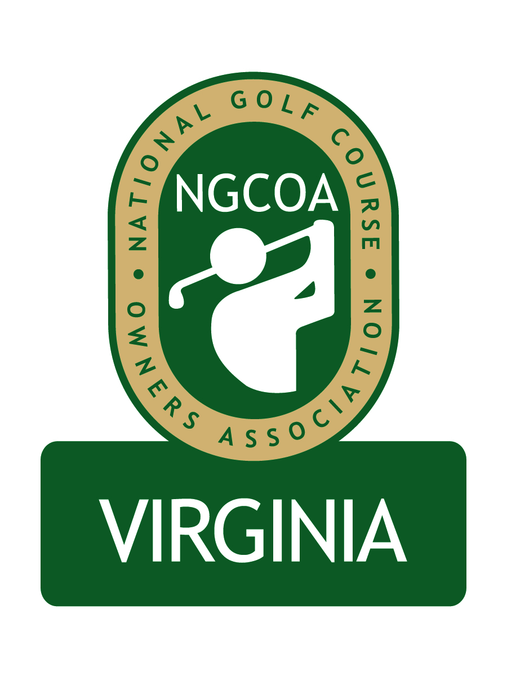

NGCOA Virginia Board Conference Call
February 13, 2014

Minutes

Attendance – David Norman, John Anderes, Bob Swiger, Joel Gohlmann, Glen Byrnes, Mike Hatch, Mike Fentress, Mike Bennett, Joe Rice, Nancy Downie, Rick Rounsaville, Joe Hills, Keith Miller, Damon DeVito, Mike Hughes

The meeting was called to order at 2:02 pm.

Introductions

The meeting began with an introduction of board members, including four new board members from Maryland and another from Virginia. Bennett said that our organization will be stronger and that he was excited for our future.

Minutes

The minutes of two meetings in January were approved.

Treasurer’s Report

Norman presented the Treasurer’s report, pointing out the normal cash flow of the association. The Holiday Auction provides a revenue base to start the year to accommodate negative cash flow in January.

Welcome & Update from National Office

Hughes remarked that our new chapter has full support from the national office. The NGCOA Conference in Orlando had excellent attendance. The board is now going through a strategic planning process led by Harrison Corver. A goal is to make the organization relevant for small operators and local chapters. The plan should be completed sometime this fall.

Another issue is third party tee time resellers, and a task force has been set up with a goal of making the individual operator stronger. Four companies are being interviewed on the possibility of developing an NGCOA platform: IBS/Play 18, Golf Now, Open Tee and EZ Links.

The WE ARE GOLF events in Washington, DC are slated for May 20-21. There is a possibility of having a meeting with NGCOA Mid-Atlantic in tandem with the event.

National Conference Recap

Rice first remarked that he liked the methodical approach used to form the Mid-Atlantic chapter. The “Day at the Golf Facility” program remains very popular. A local hospitality school participated in the event. The Annual Dinner featured Jack Nicklaus in a Q&A, and he was gracious with his time. Attendance at the conference was excellent. Next year’s event is in San Antonio.

Mid-Atlantic Expansion

Norman reviewed the process for updating our Bylaws to accommodate our expansion. He also reviewed the public relations efforts to announce the expansion.

Discussion of Current Issues.

Hills commented on the Golf Now issue, suggesting a strong focus on this issue. The barter model is hurting golf, and he favors a commission model. There is a need for a tee time network but we need to change the current scenario – it should be our #1 focus. Hatch agreed that this is a significant issue, and he pointed out that some good minds are on the NGCOA’s Committee studying this, including Peter Hill, Dana Garmany, Matt Galvin and Brock Lucas. Swiger suggested that this should be a part of the Annual Meeting discussion. Hatch advised against using Golf Now. Rounsaville said that Bulle Rock does not utilize Golf Now, and he suggested a survey of our board on the pros and cons. Rounsaville added that PGA involvement could be good.

Board Representation for Billy Casper Golf

A motion was approved to appoint Joel Gohlmann onto the board, replacing Mike Cutler.

Economic Impact Study

Norman gave an update on the newly published report, “Virginia’s Golf Economy,” which is currently being promoted to the Virginia legislature. He noted that the last Maryland study was done in 2010 and is posted on the World Golf Foundation website (www.wgf.org).

Partner Program Update

Billy Casper Golf committed as a Gold Partner effective January 1. Promotional literature on the program is currently being updated.

Webinar Series

There were 8 webinars in 2013, and the schedule for 2014 is being developed, to commence in March. Rice clarified that the new national webinars are geared toward orientation of new member facilities.

Annual Meeting

Norman queried whether the 2014 Annual Meeting should feature two in events (one in MD, one in VA) or one – the board favored one event. Norman suggested we seek a course in the D.C. area. DeVito offered Musket Ridge in the Frederick, MD area.

Next Meeting
The next board conference call will be at 3 pm on Thursday, March 20, 2014

Adjournment

The meeting was adjourned at 3:05 pm.

