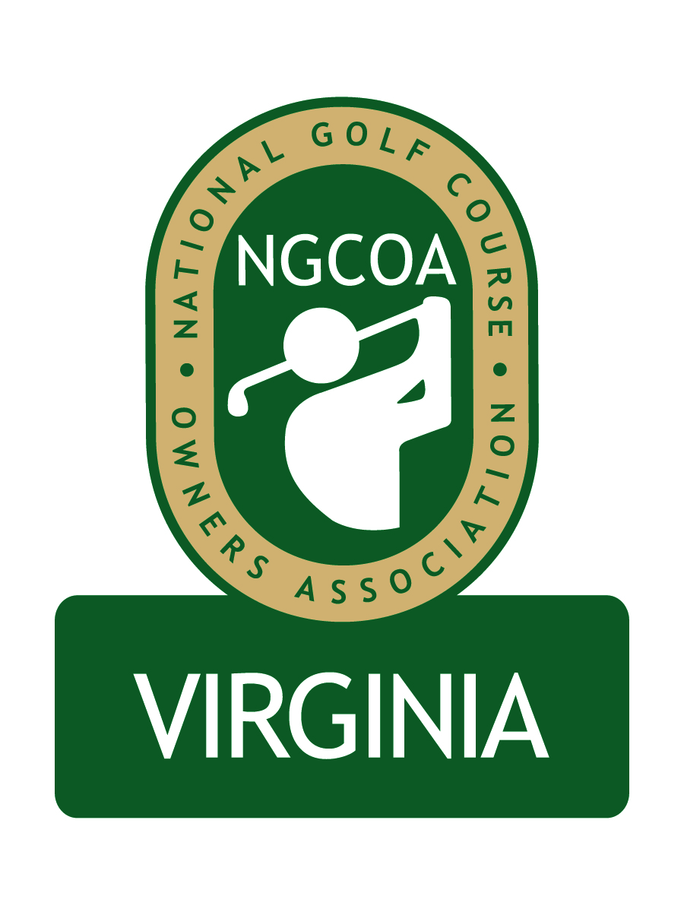

NGCOA Virginia Board Conference Call
Thursday, April 12, 2011

Minutes

Attendance – David Norman, Mike Bennett, Phil Owenby, Mike Hatch, Rob Waldron, Don Ryder, Bob Swiger, Andy Weissinger

The meeting was called to order at 1:33 pm.

Roll Call of Participants

The meeting began with a roll call of participants.

Approval of Minutes

The minutes of the March meeting were approved.

Treasurer’s Report

Norman gave the Treasurer’s report, which was approved.

Management

Bennett reviewed the plan to transition to self-sufficiency, since the current management agreement will expire at the end of this month. The plan to be self-sufficient requires membership growth and sponsorship revenue. Currently 20 sponsors are being solicited. The goal is to establish a base of $20K to cove admin costs. Bennett asked the Board to help identify sponsor leads. He suggested that we will need to seek interim support from national, and that we must show positive effort on our part. Bennett said we might consider regional expansion, such as MD or WV – this could make sponsorships more valuable to vendors. Owenby asked about sponsorships in other chapters – we could get their lists and ask the same companies in Virginia. Norman gave an overview of the terms of the current management agreement. Bennett said we should contact national with a request to extend assistance. Weissinger noted that a regional approach might be good, since many manufacturers’ reps’ territories include MD. Hatch suggested we acquire turf product vendors as sponsors, perhaps giving them a discount if they already support the superintendents’ association. Bennett and Hatch offered to contact the national office. Waldron said if we decide to involve MD, we should contact John Shields (Glenn Dale GC) and Charlie Birney (Atlantic Golf).

Membership & Partner Program

Norman gave an overview of membership recruitment and partner solicitation. Rock Harbor just renewed for three years. We are recruiting new partners – some recent ones are CeSafety, Fore Reservations and Crown Battery. Current prospects include Club Car Visage, Golf Invite, TerraVea and Western Golf Properties.

Electronic Newsletter

Norman reported that we are initiating an electronic newsletter to help recruit new members and provide regular communication to our constituency.

Open Board Slot

The group discussed the open board slot, noting that we are seeking an owner/operator of a public course. Mike Fentress of Virginia Beach Golf Management (Kempsville Greens, Red Wing Lake, Bow Creek) was recommended. Weissinger offered to contact him to determine if he was interested. It was noted that we need to check their membership status.

Event Schedule

Norman noted that the conference call series commences May 12, featuring Mike Tinkey discussing “Tee Time Resellers.” Bennett noted that it is a great topic and asked Board members to help promote the program. Norman also mentioned the upcoming joint meeting with the Club Managers association on June 20 at The Country Club of Virginia.

Old & New Business

Bennett gave an update on the Virginia Golf Trail from a call he received from Gary Schaal. Schaal indicated they now have 24 courses (Highlands and Waynesboro CC are the newest). Their website is up now. Bennett said he was somewhat conciliatory. We will not endorse them as a group. It was noted that one insider had made a negative remark indicating that VGT might be better off without a NGCOA VA endorsement, and a board member who knew the person offered to investigate.

Adjournment

The meeting was adjourned at 2:40 pm.

