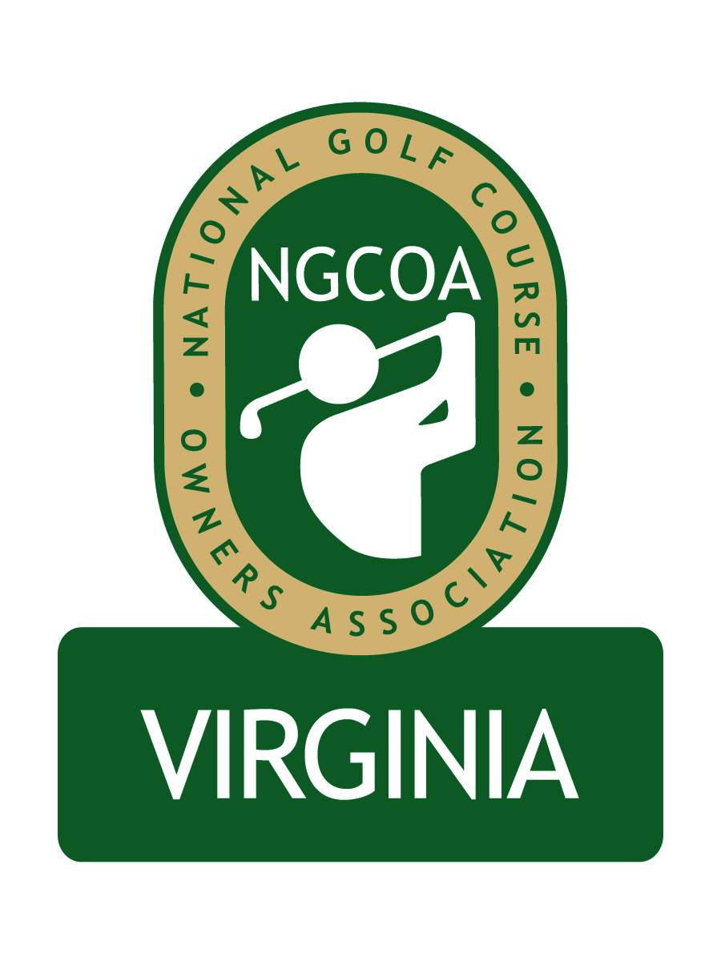
NGCOA Virginia Board Conference Call
Thursday, July 23, 2009

Minutes

Attendance – Glen Byrnes, Richard Cromwell, Dave Donofrio, Bob Swiger, Nancy Downie, David Norman

The meeting was called to order at 1:32 pm.

Roll Call of Participants

The meeting began with a roll call of participants. Norman reported that Paul Mauk has hired Mike Bennett for his company, Traditional Golf Properties. With Bennett already on the Board representing TPG, Mauk has resigned his position on the Board

Approval of Minutes

A motion (Cromwell/Cromwell) to approve the minutes of the June 18, 2009 Board Conference Call passed.

Membership Initiative Update

Downie gave an update of the membership initiative. The national office has had to direct its energy towards fighting a proposed recreation tax in North Carolina, which would significantly affect golf courses at a 7% rate. It appears their opposition campaign will be successful. This is positive news for NGCOA VA members. Downie complimented the responsiveness of North Carolina’s golf industry. The membership initiative phone calls will resume soon.

Annual Event

Cromwell and Norman reported on plans for the NGCOA VA annual meeting at The Country Club of Virginia on Monday, September 28, 2009. We are striving to keep the entry fee in the $50-60 range, which should help attendance. Details of the event are being finalized. Donofrio expressed his approval of the event. Norman indicated that Jeff Fleishman would be invited to speak. Norman suggested that we produce a professionally printed promotional piece on the event, and the Board expressed approval. Byrnes thanked Cromwell for hosting the event.

Industry Partner Update

Norman gave an overview of the Industry Partner concept. Davis-Garvin Agency, in association with the J.S. Fisher Agency, will be “presenters” at the annual meeting.

Bylaws, Articles of Incorporation

Norman reported that he had drafted Bylaws and forwarded them to the Board for review. Officer’s terms will be two consecutive one-year terms. It was suggested to combine the offices of Secretary and Treasurer. Byrnes suggested redrafting Article 10, Section 7 to provide greater detail on the scope of duties of the executive director relative to disbursements.

Administrative Update

Norman plans to set up a bank account and accounting systems once incorporation takes place and a tax I.D. number can be obtained.

Dealing with the Economy

Cromwell noted that at The Country Club of Virginia, rounds are up for members but down for guests. Donofrio indicated that his course is hitting projections, giving some credit to the good weather. He mentioned that seven-day forecasts often hurt the golf industry when potential rain in the forecast (even if it doesn’t rain that day). Swiger said his rounds in May/June were down 6-7% due to bad weather in his area. For Swiger, July has been better – it seems that when there is a good daily forecast, he will get excellent traffic. Swiger is currently using third party discounters on a limited basis, allowing them to sell weekend rounds on Thursday of the current week. Due to the market, the per-person spending has dropped. Cromwell noted that retail sales are down, particularly soft goods. Swiger noted that his golf academy helped sales. Byrnes asked for more detail on the N.C. revenue bill, and Downie said she would send this to him.

Old & New Business

The Board decided that they want the next meeting to remain in conference call format. The date is September 3, 2009 at 1:30 p.m.

Adjournment

The meeting was adjourned at 2:16 p.m.

