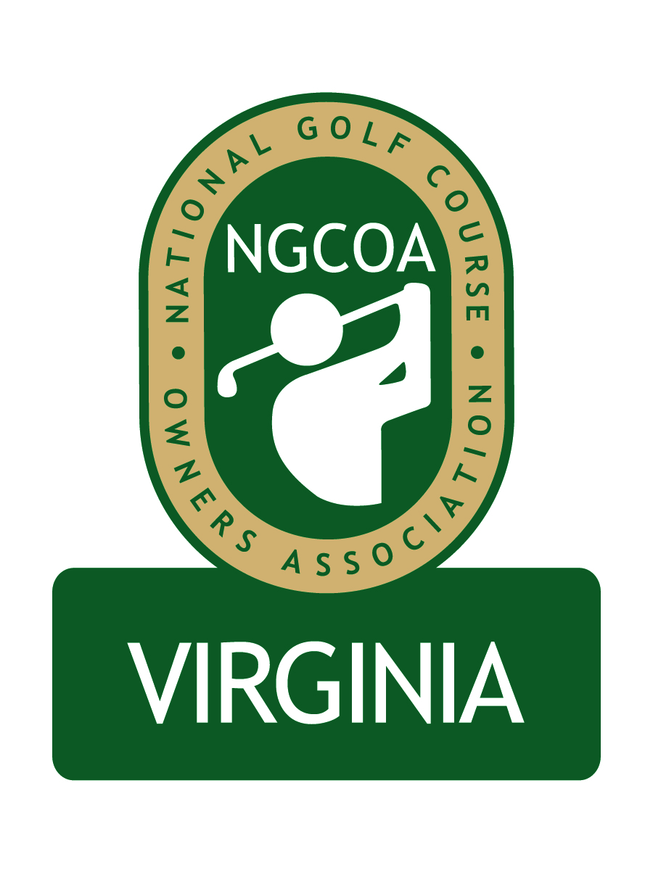

NGCOA Virginia Board Conference Call
July 9, 2013

Minutes

Attendance – David Norman, Mike Bennett, Mike Cutler, Mike Fentress, Damon DeVito, Glen Byrnes, Bob Swiger, Don Ryder

The meeting was called to order at 2:07 pm.

Roll Call of Participants

The meeting began with a roll call of participants.

Approval of Minutes

The minutes of the previous meeting were approved.

Treasurer’s Report

Norman gave the Treasurer’s report, which was approved.

Report from National Office

It was reported that Ryan Johnson, NGCOA Acquisition Manager, has left NGCOA. He has not been replaced.

Partner Program / Newsletter Feedback

Norman reported that 5 Partners had renewed since the last meeting for total revenue of $3,700.

Feedback on the recent newsletter included a suggestion by Cutler to run analytics on the email distribution to determine open rates and clicks. We could target non-members who read the newsletter. Swiger liked the newsletter, and said it was good to track news on a regional basis – he cited the “We Are Golf” initiative on Capitol Hill. The next newsletter is scheduled in the fall, following the Annual Meeting.

2013 Events

The webinar program is going well, and Cutler suggested we post recordings on our website. (We did so for two webinars.) A suggested topic is the Golf Now/Fore Reservations merger, and DeVito offered to speak with Pellucid about making the presentation.

The joint event with CMAA and VGCSA at Princess Anne CC featuring Billy Fuller went well, with over 60 attending.

The NGCOA VA Annual Meeting is set for Wednesday, September 25th at Ford’s Colony CC in Williamsburg, and the group discussed the program. The new awards program will be one segment. One group offered to do a presentation on valuation – one comment was that this had already been done – another was to offer this to Larry Hirsh at Golf Property Analysts if we decided to feature this, since he is a Corporate Partner.

Annual Meeting Award Program

On the awards program, Norman noted that no public announcement had been made on the program. DeVito suggested we identify winners by the end of August, and he offered to help with the process. Two awards will focus on marketing (public and private). Sponsorship is being sought, with top prospects being STI, Club Car, Entegra and Pepsi (i.e., the national partners). It was suggested to keep the time frame flexible for the process. It was suggested to have an Ad Hoc Committee develop a short list of nominees, then let the Board vote on the selection. The criteria will not be specific in the first year. A motion to move forward with the Awards Program passed.

Government Relations Update

Norman reported on the Nutrient Management Plan initiative – all Virginia golf courses will be required to have a NMP by July, 2017. A new grant program is being offered on a 50-50 cost sharing through planners who registered with the Department of Environmental Quality.

Regional Expansion

Norman gave an overview of the concept to expand our chapter regionally to include Maryland and Washington, DC. He noted that there was a Maryland Chapter several years ago, and it ultimately disbanded, and one issue was the preferential position of municipal courses versus daily fee courses. He indicated that the NGCOA national office was supportive of the concept. The Raspberry Golf Trail does give us some infrastructure and relationships with top daily fee courses in Maryland. It was suggested that Board members receive a list of Maryland course owners. Cutler indicated that he has a good relationship with Ocean City representatives. The expansion would be good for our revenue. A motion to pursue regional expansion passed.

Old Business / New Business

The Virginia Golf Council meeting is coming up on July 17th at Independence GC. DeVito contacted Pellucid during the meeting, and reported that they would be happy to do a webinar on the Golf Now/Fore Reservations merger. The next meeting is scheduled for Tuesday, August 20 at 2 pm.

Adjourn

The meeting was adjourned at 3:22 pm.

