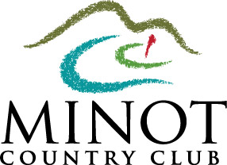

Golf Minot Inc. dba
Minot Country Club

2015 Membership Application
$4,000 Initiation Fee (Option to pay $1,000 now & $1,500 in May 2016 & 2017)
&
$3,250 Membership in 2015 & 2016 & 2017

Last Name: _________________________ First Name: ____________________ MI: _____
Spouse’s Name/Significant other (if applicable): ___________________________________
Address: __________________________________________
City: _____________________ State: ____ Zip: ___________
Home Phone: (_____)_________________ Mobile Phone: (_____)__________________
Date of Birth: ___ /___ /____ Email Address: _______________________________________
Business Name: _________________________ Business Phone: (_____)__________________
Business Email: ________________________________
Children (please note that all children will be able to charge unless otherwise notified)
Child 1: _____________ Birth Date: ____ /____ /____ Child 2: _____________ Birth Date: ____ /____ /____
Child 3: _____________ Birth Date: ____ /____ /____ Child 4: _____________ Birth Date: ____ /____ /____
Payment: Check # ______ Amount: $__________ Make Checks payable to Golf Minot Inc.
VISA / MC / DISC # ______________________________ EXP__________
Mail Application and Payment to: PO BOX 879 / Minot, ND 58702
If accepted as a member of Golf Minot Inc. DBA Minot Country Club, A North Dakota Non-Profit Corporation, I agree to conform to all the rules and regulations and to pay all fees as set by the Board of Directors as per the corporation by-laws. I further agree to pay my membership fee and dues in accordance with the options on this application and to pay all charges made by me or my family promptly when due. If members are not current 60 days from billing date, their charges and play are automatically suspended; 90 days from billing date, their membership is terminated. Any exception must be granted by appeal to the executive board only.
Your Signature: ______________________________ Date: ______________
Thank you for your application. You will receive notification whether your
application is accepted in 10-12 business days.

