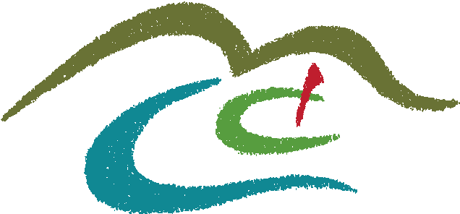
Minot Country Club

Golf Minot Inc. dba
The Minot Country Club
Ph: 701-852-3591/ Email: minotcountryclub@gmail.com

2015 Corporate Sponsorship Application

Last Name: _________________________ First Name: ____________________ MI: _____
Spouse’s Name/Significant other (if applicable): ___________________________________
Address: __________________________________________
City: _____________________ State: ____ Zip: ___________
Home Phone: (_____)_________________ Mobile Phone: (_____)__________________
Date of Birth: ____ /____ /____ Email Address: _____________________________________
Business Name: _______________________________
Business Phone: (_____)____________ Business Email: ________________________________
Please Choose One:
_____Corporate Legacy Sponsorship Level #1 (please fill out another sheet for 2nd Member)
_____Corporate Legacy Sponsorship Level #2
_____Social Legacy Corporate Sponsorship
Payment: Check # ______ Amount: $________ Make checks payable to Golf Minot Inc.
VISA / MC / DISC # ______________________________ EXP__________
Mail Application and Payment to: PO BOX 879 / Minot, ND 58702
If accepted as a member of Golf Minot Inc. DBA Minot Country Club, A North Dakota Non-Profit Corporation, I agree to conform to all the rules and regulations and to pay all fees as set by the Board of Directors as per the corporation by-laws. I further agree to pay my membership fee and dues in accordance with the options on this application and to pay all charges made by me or my family promptly when due. If members are not current 60 days from billing date, their charges and play are automatically suspended; 90 days from billing date, their membership is terminated. Any exception must be granted by appeal to the executive board only.

Your Signature: ______________________________ Date: ______________
Thank you for your application. You will receive notification whether your
application is accepted in 10-12 business days.

