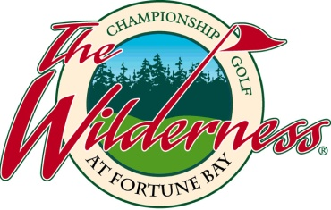

FOR IMMEDIATE RELEASE
The Wilderness at Fortune Bay Raises over $34,000 during 11th Annual Indian Summer Classic
The Wilderness hosted a fundraising tournament for educational scholarships.
TOWER—The Wilderness at Fortune Bay Resort Casino raised $34,829 during the 11th Annual Indian Summer Classic.
The proceeds from the tournament go toward the Bois Forte Scholarship Fund, which provides students with financial assistance while attending college or vocational training.
The event was held on Thursday, August 20th with a morning and afternoon tournament that set an attendance record with over 175 total players for the day.
“This year’s number was achieved due to the generosity and support of many local and national businesses that sponsored the tournament,” said Tom Beaudry, who is the General Manager for The Wilderness at Fortune Bay. “We would like to extend a special thank you to Fortune Bay Resort Casino, Konami Gaming, Aristocrat Technologies, Northern State Bank of Aurora, and Key Bank as Title Sponsors of this year’s event.”
Other major sponsors included: Ainsworth Game Technologies, National Indian Gaming Association, McGladery, Delta Dental, KemperSports, Red Circle, Jacobsen Law Group, Spectrum Healthcare, Bally Gaming, TPI, CCStpa, Twin Metals MN, American Bank, Pepsi Co. and the Minnesota Indian Gaming Association.
If you would like more information regarding the 2015 Indian Summer Classic, please visit www.golfthewilderness.com or call 1-800-992-4680.
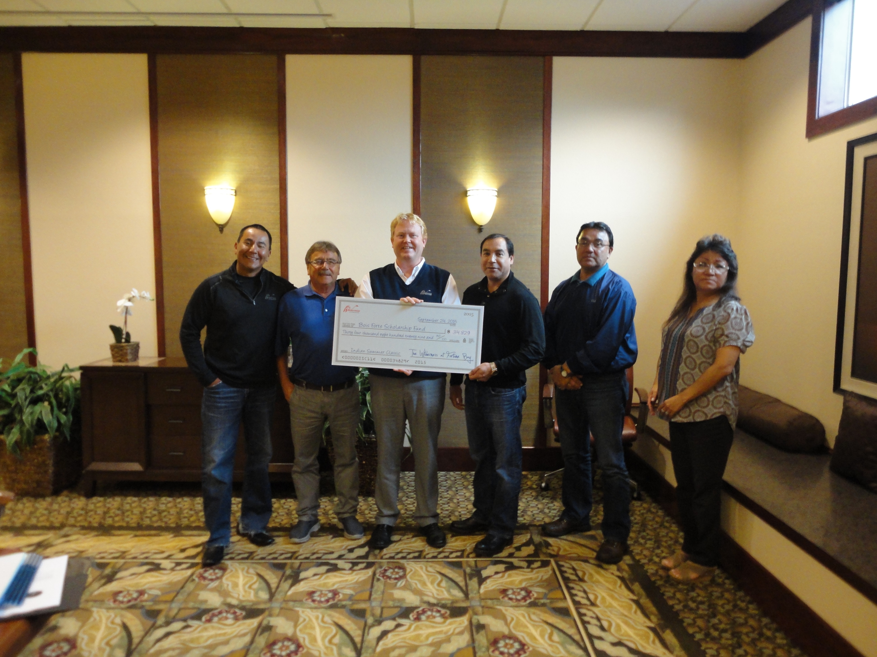
END
###
About the Wilderness at Fortune Bay
Owned by the Bois Forte Band of Chippewa and operated by KemperSports Management, this highly acclaimed Northwoods golf getaway is renowned for its wild beauty and exceptional amenities, making it a shining star and solidifying its ranking as #1 in Minnesota. The Wilderness is part of Minnesota’s premier resort destination Fortune Bay Resort Casino.
About KemperSports
Northbrook, Ill.-based KemperSports operates golf facilities as well as athletic clubs, lodging venues and major sporting events, including nationally ranked courses and tournament venues such as Bandon Dunes Golf Resort, Dorado Beach Resort & Club, The Glen Club, Harding Park, Desert Willow Golf Resort and Chambers Bay, host of the 2010 U.S. Amateur and the 2015 U.S. Open. Affiliate KemperSports Marketing & Communications, a sports marketing, events and public relations agency, has produced and managed major national and international events, including the EA SPORTS Maui Invitational college basketball tournament. For more information, visit www.kempersports.com.

###
Media Contact:
Ryan Garry
The Wilderness at Fortune Bay - KemperSports
p: (800) 992-4680
rgarry@kempersports.com

