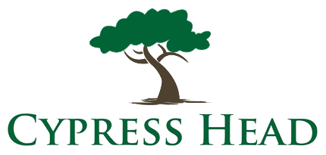

PLAYER DEVELOPMENT CLINICS
January 2023 Schedule__

Date | Time | Clinic Topic
Saturday Jan 7 | 11:00 am | Drive like a Beast
Saturday Jan 14 | 11:00 am | Pitch Perfect
Saturday Jan 21 | 11:00 am | Solid Hybrid Play
Saturday Jan 28 | 11:00 am | Better Bunker Play
Come join our weekly Saturday Player Development Clinics!
Free to all Cypress Head Golf Club Pass Holders.
Non-Pass Holders may join for $15.
Taught by PGA Golf Professionals with years of experience!

For more information about golf instruction at Cypress Head Golf Club contact us at 386-756-5449 or e-mail Jeff Dayton, PGA at jdayton@kempersports.com or Dylan Quintrell at dquintrell@kempersports.com.

