APPROVED

The Place at Corkscrew, The Place HOA Master Association, Inc.
BUDGET MEETING
Board of Director’s meeting
When: 11/1/2022 7:00PM
Where: Barefoot Bar & Grill, 19921 Beechcrest Place, Estero, Florida 33928

Board of Directors
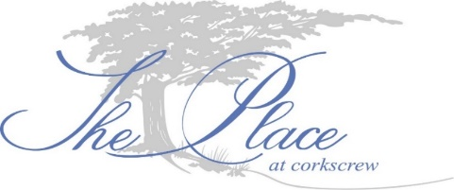
Eileen Barrett (P) Term expires 2024 – In person
Tom Butler (VP) Term expires 2024 – In person
Ed Casey (T) Term expires 2024 – In person
Nick Correll (S) Term expires 2023 – In person
Gary Helwig (D) Term expires 2023 – On phone

- Call to order. The meeting was called to order at 7:00PM.
- Establish a quorum. All directors are present either in person or via phone.
- Proof of notice. Notice was posted in accordance with F.S. 720.
- New Business.
Treasurer, Ed Casey motioned to accept the DRAFT 2023 budget as proposed. Quarterly assessment for 2023 will be: 52’ Lot = $1,134.16 quarterly assessment, 62’ Lot = $1,149.91 quarterly assessment, & 75’ Lot = $1,180.12 quarterly assessment. Vice President, Tom Butler seconded the motion. All in favor. The motion passes without objection.

- Next BoD Meeting. Currently scheduled for December 12, 2022 at TBD PM.
- Owner Comments. Owners commented and asked questions after the 2023 DRAFT budget was presented.
- Adjournment. The meeting was adjourned at 8:41PM.

Respectfully submitted,
Ron Czarnik, LCAM
For the Board of Directors

