APPROVED

The Place at Corkscrew, The Place HOA Master Association, Inc.
Organizational Board of Directors Meeting Minutes
When: 07/08/2022 4:00PM
Where: Barefoot Bar & Grill, 19921 Beechcrest Place, Estero, Florida 33928

Board of Directors
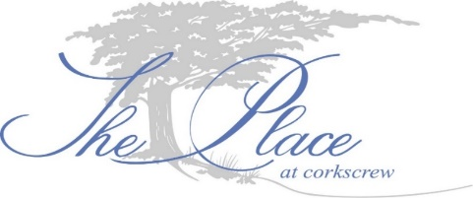
Eileen Barrett (P) Term expires 2024 – In person
Tom Butler (VP) Term expires 2024 – In person
Ed Casey (T) Term expires 2024 – via phone
Nick Correll (S) Term expires 2023 – In person
Gary Helwig (D) Term expires 2023 – In person

- Call to order. The meeting was called to order at 4:00PM.
- Proof of Notice. Notice was posted in accordance with F.S. 720.
- Election of Officers.
MOTION: Tom Butler motioned to appoint Nick Correll as Secretary. Motion seconded by Eileen Barrett. All in favor. Motion passes without objection.

MOTION: Tom Butler motioned to appoint Ed Casey as Treasurer. Motion seconded by Eileen Barrett. All in favor. Motion passes without objection.

MOTION: Tom Butler motioned to appoint Eileen Barrett as President. Motion seconded by Ed Casey. All in favor. Motion passes with one objection.
MOTION: Eileen Barrett motioned to appoint Tom Butler as Vice-President. Motion seconded by Nick Correll. All in favor. Motion passes without objection.

- Approval of Bank Signers.
MOTION: Eileen Barrett motioned to appoint Eileen Barrett, Tom Butler, Ed Casey and Nick Correll, as bank account signers for the Association’s Busey Bank. Motion seconded by Ed Casey. All in favor. Motion passes without objection.

- Discussion and appointment of committees. The Board of Directors discussed the formation of committees. ARC committee will be handled by Directors of the Board until the ARC is formed. Manger is to blast out to the community the request for volunteers.

- Discussion: Subcommittee recommendations. This matter is tabled. Reports will be provided once collected. The manger will forward reports to the Board of Directors.

- Discussion: Bar License/Signature Cards/ Board Certification Forms. No action currently.

- Membership communication. The Board of Directors discussed how the Board may communicate better with the membership. No action currently.

- Discussion: define our principles of governance. The Board of Directors discussed the way to govern. No action currently.

- Discussion: meeting with Pulte, Sunnygrove and Allied Security. The Board of Directors discussed the suggestion to ask the vendors to meet informally with Board. No action currently.

- HOA website. This matter is tabled.

- Next BoD meeting. Next scheduled meeting is July 26, 2022 4PM at the Barefoot Bar and Grill.

- Adjournment.
MOTION: Tom Butler motioned to adjourn the Organization Meeting. Motion seconded by Eileen Barrett. All in favor. Motion passes without objection. Meeting adjourned at 6:01 PM.

Respectfully submitted,
Ron Czarnik, LCAM
For the Board of Directors

