Men’s League Rules and Information
Fees:
- The sponsor fee will be $200.00 per team. This must be paid before the first night of the league.
- Each Player must have a yearly pass or a punch card.
- Each player must have a MSGA (GHIN) handicap -- $40.00.
- The nightly fee will be $5 covering the weekly game and the nightly drink.
- Each player must check in and pay fees at the pro shop before play begins.
- Introducing a Deuce pot for the 2024 Season: Optional fee of $2 nightly paying out anyone who scores a Deuce on any whole. Must be paid in cash.
Teams:
- All teams from last year will have their spot held until April 30th and their full roster and sponsor fee is submitted.
  - New teams will be accepted on a first come first serve basis starting on the 1st of May.
- A team may list up to 6 players but only 4 will play each night.
- If a player on your team is 60 or older, they must note this on the team entry form.
  - Players choosing to play from the white/blue tees will not be allowed to change.
  - “Rule of 85”

Scoring Format
- Each Match will be worth 10 points. 1 point a hole and 1 point for the match.
- No Show: We will be using a ghost system for this year’s league for the team who is missing a player(s). **(picture below)**
  - 1 player missing: Teammate with closest handicap’s score will be doubled to play against opposing team.
  - 2 players missing: 1 teammate will play in each group depending on handicaps doubling each score.
  - 3 players missing: 2 closest handicaps will play in a group. The other two will automatically receive 7 points (14total) and an additional 2 points for a sub-par round.
  - Whole team missing: Opposing team automatically receives 28 points and an additional 2 points for any sub-par rounds.

    - “Ghost” players can only score a maximum of 4 points. Ghosts are not guaranteed 4 points.
    - Golfers playing a “ghost” only receive points they earn. You are not guaranteed the remaining 6 points.
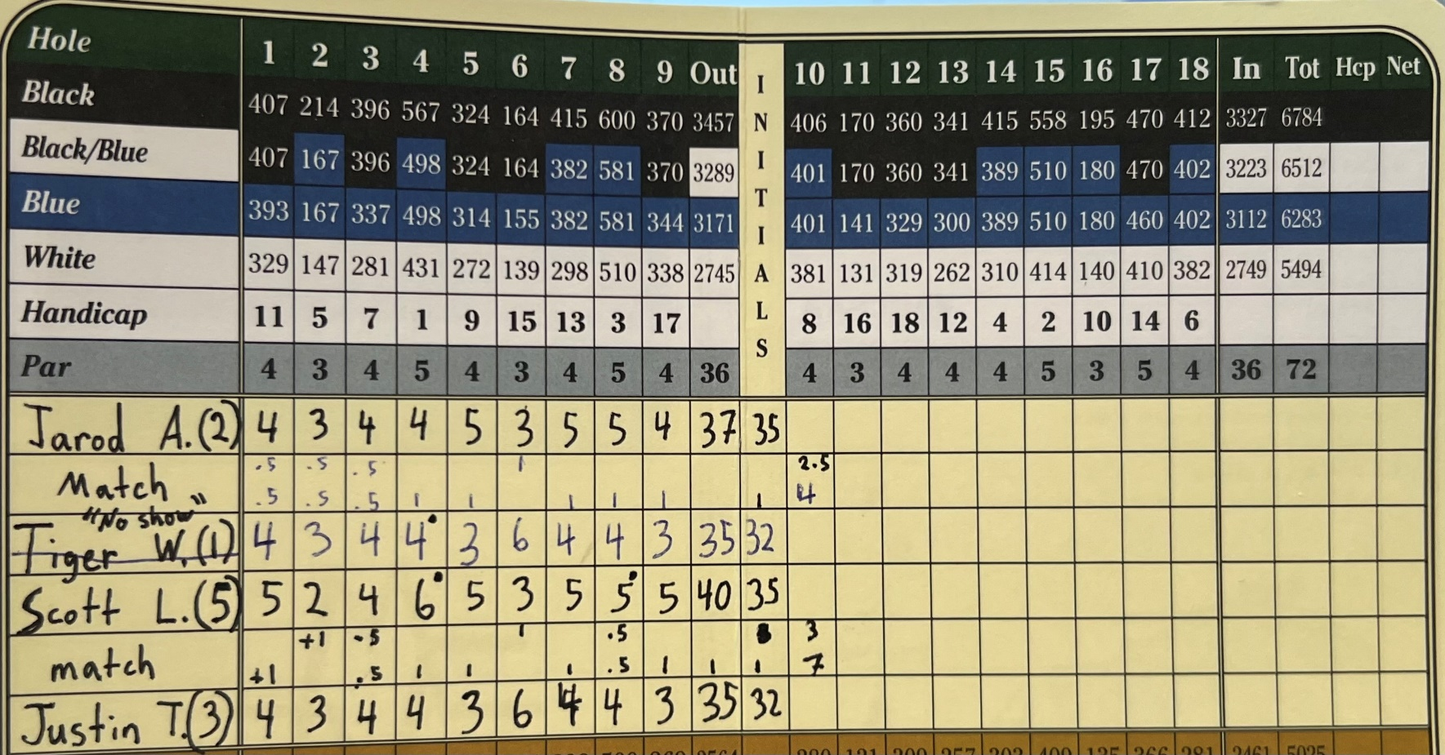
Substitutes
- All subs must check in at the pro shop and pay nightly fee prior to starting play.
- The Pro shop will have a sub list available for teams looking for subs.
Cancellation:
- Golf Course staff will decide on the cancellation due to weather or course conditions. The decision will be made at 5p.m. on the night of the league. If conditions are bad early, the league will be cancelled before that time and KSEN will be notified. All cancellations will be posted on Facebook & Instagram.
- If a lightning storm hits the players will be pulled off the course. This will be identified by one long blast of the horn.
- We will have one safety week scheduled for any canceled night. First cancellation takes place if needed. If no cancellations occur the league will proceed with the start of playoffs.
- If league is cancelled due to weather after play begins the prize money will carry over to the next week and prizes will be doubled.
General Rules of League
- All USGA rules apply.
- Teams must be called into the Pro Shop by 3p.m. every Monday so staff can print scorecards and have the proper pairing finished.
  - You can call at any time starting Tuesday.
- Late to Match
  - If a player is late to a match (All other players have teed off) the late player cannot play that hole. They will have to join on the next hole.
  - The Late golfer will not be eligible for low gross or net score.
  - The points for the absent holes will be used by doubling the present player’s score. (“Ghost”)
- League will begin on May 6th and run for 16 weeks (No League on May 13, May 27.) Playoffs will follow in the next three weeks. Unless there is a cancellation and needs to be made-up.
- All league Players will play from the Blue Tees except if your age and handicap add up to 85 (Rule of 85). This cannot be changed and must be decided before the league starts on week 1.
- All Matches must be played on Monday night during the given time unless prior approval is given from Jarod. No prize money will be awarded unless played during the scheduled night and time.

Playoffs
- The top eight teams will qualify for the main playoffs to determine the Champions.
- The remaining teams will play in a weekly fall game for weekly pay outs.
- The Season will be split into two halves. Points will be awarded to the top 10 teams in each half. The points will be awarded as such.
1st -- 11 Points 2nd--- 9 Points
3rd -- 8 Points 4th -- 7 Points
5th -- 6 Points 6th -- 5 Points
7th – 4 Points 8th -- 3 Points
9th – 2 Points 10th – 1 Point

- If there is a tie in the playoffs there will be a standing playoff. The total of the last week of each half will break ties.
- Playoffs are single elimination.
- A maximum of two subs will be allowed for playoffs and subs must have an established MSGA handicap.
Pace of Play
We should be able to play in 2 hours if we do the following.
- Be ready to hit when it’s your turn.
- Watch each ball in the group.
- Keep pace with the group in front of you.
- Mark your scores at the tee box, not the green.
- Be at the golf course 15 minutes before your tee time.
- Be ready to tee off once the horn goes off.
- Out of Position –
  - A group will be considered out of position if it reaches the tee of a par-3 hole and the preceding group has cleared the next tee, reaches the tee of a par-4 hole and the putting green is clear, or reaches the tee of a par-5 hole when the preceding group is on the putting green.

Schedule
May  6  20  June  3  10  17  24  July  1  8  15  22  29  August  5  12  19  26  September  2  9  9  16  23 |  | Scramble  Scramble  Makeup/First week of Playoffs  Championship  Championship if Makeup required

