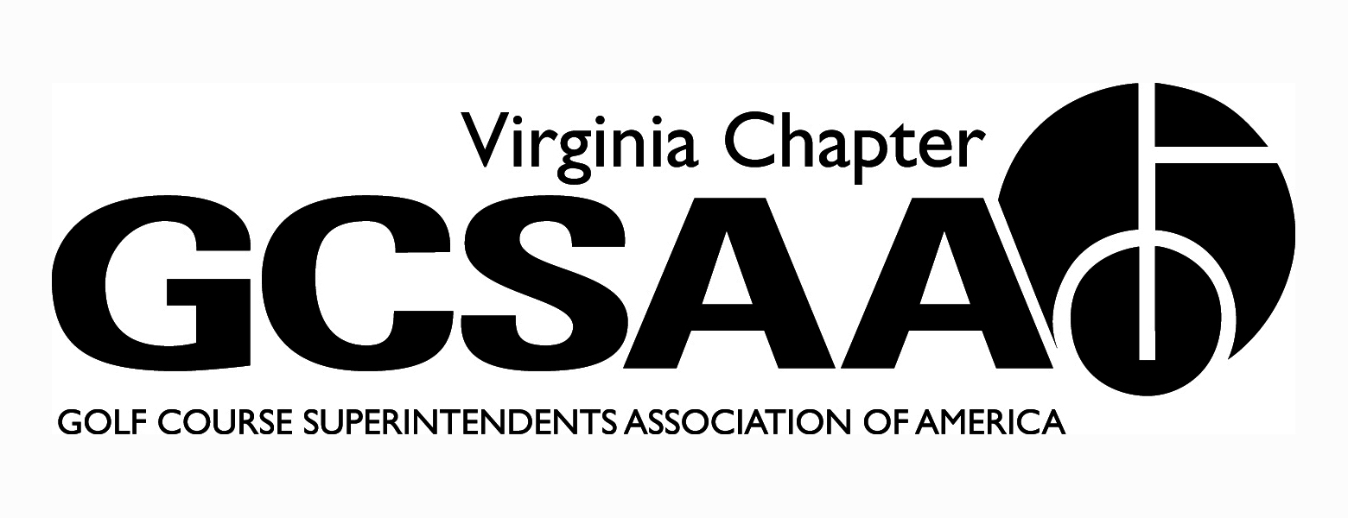

VGCSA Board Meeting
Hermitage Country Club, Manakin-Sabot, VA
Thursday, January 25, 2018
10:00 a.m.

Agenda

Call to Order (10:01 A.M.) - Mark Cote

- Introduction of New Board Members - Director Stephens stated that he would be resigning. He introduced his replacement Mr. James Mazowieski, Golf Course Superintendent at Kingsmill Resort in Williamsburg, Va.

- Approval of Minutes - Motion to Approve Baskette, 2nd Stephens. Minutes approved.

- Treasurer’s Report – Jeff Whitmire

- Dues revenue is up compared to 2017
- Invoices for dues and partner program are out - we will have more information at next meeting
- Motion to approve - Baskette, 2nd Wells. Approved.

- External VP Reports

- GWGCSA (Wells) - expect low turnout for MATE due to conflict with GIS. Pesticide certification is coming up. Working on schedule.

- SVTA (Eagle) - 4 meetings scheduled this year. Same BOD, people have been moved around in different positions.

- ODGCSA (Mauldin) - BOD meeting today. Meetings so far - 2/21 - Bayer seminar; 3/15 - March Madness in Richmond, Williamsburg, Charlottesville; 4/23 - Scholarship Tournament @ Magnolia Green. Other meetings are in planning.

- VTA (Baskette) - plan to meet next week. Similar schedule as last year planned.

TTA (Stephens) - Meetings - 2/23 Top Golf; 4/3 joint with ODGCSA @ Kingsmill; 4/30 Field Day @ Riverfront GC ; 5/21 - Dick Cake @ James River CC; Sept. meeting being planned; 11/12 - Annual Meeting (location unknown).

- Recap of Recent Events – VAC Banquet (Cote) - had good representation at VAC Banquet. Best thing is getting to know legislators.

- Annual Conference

- Mark Cote said he received positive feedback. Darden would like to have us back next year. .
- Survey indicated mostly positive reviews about speakers and topics, although some thought speakers needed more time.
- Discussion about how to improve attendance and topics and speakers for next year.

- SB520 - bill introduced by Sen. Monty Mason to provide more regulations on drilling of deep wells in Eastern Virginia.

- Mark Cote, David Norman, Jeff Holliday, Scott Mauldin, Jay Wade, Peter McDonough, Jeff Whitmire, and Skeeter Heath met with members of the Senate Agriculture Committee on Jan. 22 to discuss concerns with SB520.
- Brent Graham and Rob Wilmans agreed to speak in front of Senate Agriculture committee today to express our position.
- More meetings with members of the legislature will be required if the bill passes the Senate.

- Government Relations

- Mark Cote believes more work is needed on the Government Relations...SB520 was a wakeup call.
- Mark Cote encouraged all members to visit legislature on Feb 15.
- Discussions about continued use of the VAC or hiring another lobbyist.
- Need to invite legislators to our events.
- Committee needs more involvement from the general membership. Cote will step up recruiting efforts.
- Many legislators are already members at our clubs - we need to take advantage of this.
- Mark Cote encouraged members to get involved with National Golf Day
- We need to fill all of our GCSAA Ambassador positions in the state.

- 2018 VGCSA Member Survey (Baskette)

- Working on survey...thanked board for suggestions.
- Want to send out on Feb. 10.

- Rounds4Research

- Only raised $2500 last year. VTA was responsible for 50% of that total.
- Mark Cote said this needs to be improved
- Discussion on strategies to improve participation.

- Va Tech Research Classic and Field Day (Keene & Norman)

- Event will be held at Independence on May 21.
- Only 18 holes vs. 36 last year so revenue potential not as great.
- Need to get legislators at this event
- Silent Auction was not very successful last year…discussion on ways to improve

- Mid-Atlantic Regional Golf Conference (Holliday)

- 48 signed up so far
- VGM is key sponsor
- Project 200 will sign up

- GCSAA Social Event (Norman)

- To be held at "Howl at the Moon" piano bar
- Attendance looks good in San Antonio for GIS so should have good attendance at event.

- GCSAA Chapter Leaders - Aaron Wells to attend Chapter Leaders Conference

- Match Play (Whitmire) - Details are being worked out. Hope to have everything finalized soon and have brackets set by April 1. Kinloch to host final match. Goal is to encourage ALL superintendents to play golf.

- VGCSA Championship, Joe Saylor (Whitmire) - Venues are being finalized.

- VGCSA-CMAA-NGCOA Joint Meeting (Norman) - No dates or topics yet. Working on details

- Virlina Cup (Holliday) - Princess Anne to host this year in October. Still working on final dates.

- Assistants Forum (Fowler) - Working on details. May want to host with MAAGCS again to encourage participation and continue Ryder Cup format started last year.

- Strategic Planning (Cote) - Want to hold before or after Annual Meeting. Get GCSAA help with this.

- 2018 Committee Assignments (Cote)

- Assistant Superintendent - Garrison Fowler
- Awards - Aaron Wells
- Best Management Practices - Sean Baskette
- Bylaws - Bill Keene
- Certification - Scott Mauldin
- Communications - Bill Keene
- Community Service - Jeff Holliday
- Conference - Mark Cote, Ian Grove
- GCSAA - Mark Cote
- Golf - Jeff Whitmire
- Government Relations - Mark Cote, Jeff Holliday, Jeff Whitmire, Cutler Robinson
- Long Range Planning - Mark Cote, Jeff Holliday, David Norman
- Membership - Jeff Holliday, All External Vice-Presidents
- Mid-Atlantic Golf Council - Mark Cote, Jeff Holliday
- Nominating - James Mazowieski
- Partner Program - Ian Grove
- Survey - Sean Baskette

- Old Business - discussion concerning Dr. Ervin's replacement at Virginia Tech. Mark Cote will set up meeting with Dean to get more information.

- New Business – board meeting dates (April 19, August 9, November 15)

- Executive Session - Not Needed

- Adjourn at 1:20 P.M.

