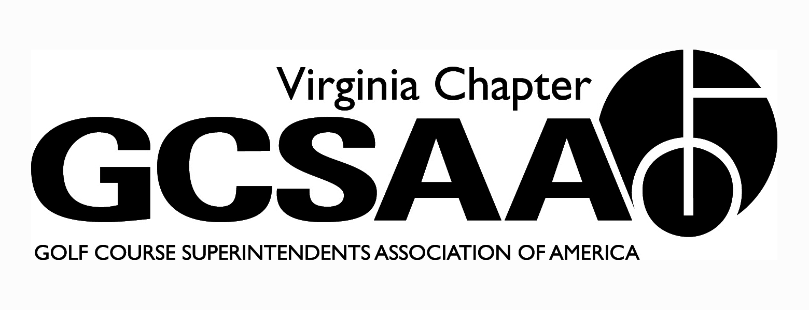
VGCSA board meeting: February 16, 2012 at 10 AM
Location: VGCSA office, Glen Allen, VA
Attendance: Matt Boyce, Jeff Holliday CGCS, Chris Petrelli, Jeff Van Fleet, Mark Cote, Dan Taylor CGCS, Dave Lewallen, Rob Wilmans, Patrick Connelly, Matt Sobotka, Jeff Berg, David Norman.
- Call to order at 10:00 AM (Boyce)
- Introductions of board members
- Boyce’s President message; excited about new board, setting goals for committee chairs.
- Approval of previous meeting minutes:
- Motion: Wilmans, second: Taylor.
- Treasurer Report(Petrelli)
- Annual meeting is break- even event; dues are up due to early billing.
- Motion: Van Fleet, second: Cote
- John Robertson from Buy Sod
- Distribution of company information and discussion of Scholarship program.
- Existing customers would be included in program
- Extensive board conversation on concerns with favoritism toward Buy Sod, parameters of program, marketing etc.
- Board decides that Buy Sod funds scholarship, VGCSA select winner, no exclusivity, VGCSA advertises, minimum of $500 to winner
- Motion: Cote, second: Taylor.
- Gov’t Relations/BMP Update:
- BMP is distributed to external VP’s and to legislature, thumb drives not ready yet, will be sent to highest turf official at each facility in VA.
- Norman, Berg and McDonough will all speak at GCSAA conference
- Highlights of manual in next Virginia Golfer Magazine(March/April)
- GCSAA Chapter Outreach program is highlighted, cost around $1750 with 50% from GCSAA, no final decision made.
- External VP’s Reports:
- GWGCSA(Van Fleet): handout for upcoming schedule
- April 24th is Pro/Super with Mid Atlantic
- BMP tourney at Creighton Farms is May 21st
- ODGCSA(Taylor): handout for upcoming schedule
- 1st event is March Madness on March 15th
- Joint meeting with TTA is March 29th at Kingsmill.
- TTA(Wilmans)
- 45 attended Norfolk Admirals game
- April 26th event at Broad Bay, topic is conversion of greens to ultra-dwarf.
- May 24th event is at Bay Creek and at Hampton Roads AREC
- VTA(Cote)
- April 10th meeting with DEQ Reporting Tammy Stephenson
- June 11th at Homestead, overnight rate is available
- SVTA(Lewallen)
- March 29th at Winchester, April 26th at Spotswood CC
- 30th anniversary possible dinner in Harrisonburg
- June fundraiser moved from July to June.
- Recap of Recent events
- Virginia Golf Council: BMP discussed and council is supportive
- Annual Meeting: Overall big success, extensive conversation on improvements including; shorter event, better trolley service, cocktail area small, late registration, etc.
- Next year’s event; Boyce proposes taking over ODGCSA education on Monday, annual meeting at night, and Superintendent’s roundtable on Tuesday morning. Extensive discussion about plan, agree that the 5 Locals need to gauge interest before proceeding, VTC needs to be notified ASAP, vendors will support both VGCSA and VTC. No vote taken.
- Partner Program Update (Norman)
- 60% through the process
- Consensus from partners is slightly higher
- Rounds for Research
- We will continue with our partnership with Carolina’s and looking to expand nationally.
- Trying to address issues with bidding process in VA
- Committee Reports and Assignments: looking for goals and expectations from each assignment
- Assistant’s (Sobotka): looking at superintendents recently hired that have experience with process for Roundtable discussion, possibly Willow Oaks on November 5th.
- Education(Petrelli): 28 from VA for last seminar in December
- GCSAA/Voting Delegate (Berg): Barajas and Maynard will be our votes.
- Golf(Boyce): Tollie Quinn May 8th, Virlina Cup October 14-16 in D.C area, Berg will captain
- Research(Cote): Idea to merge BMP and Research committee’s
- Survey(Van Fleet): Survey is to start soon, strictly electronic, same as last time
- Old Business: None
- New Business: Discussion on interest for non-traditional categories
- Next meeting: April 19th
- Meeting adjourned at 1:51, motion: Van Fleet, second: Boyce.
Respectfully Submitted,
Chris Petrelli
Secretary/Treasurer

