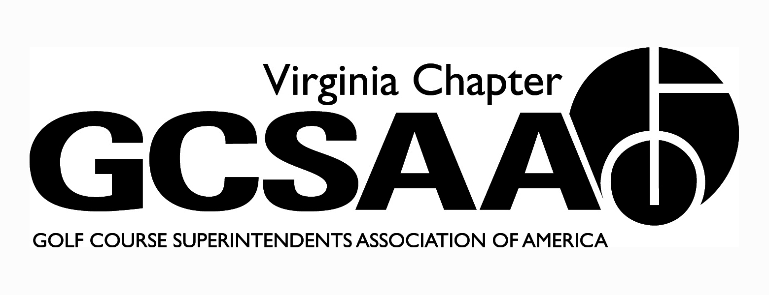
VGCSA Board Meeting
Farmington Country Club, Charlottesville, VA
August 10, 2017
9:00 Am Start
Minutes
Tyler Eastham, David Norman, Steven Ball, Bill Keene, Sean Baskette, Mark Cote, Eric Spurlock
Pete Stephens, Aaron Wells, Jeff Whitmire, Jeff Holliday, Scott Mauldin, Ed Eagle

- Call to Order – 9:05
- Approval of Minutes – Need to post current bylaws to website. Motion: Sean Baskette, 2nd: Bill Keene
- Treasurer’s Report – Jeff Whitmire
  - Investment accounts are doing well
  - Dues are down from last year a little bit as cash basis – invoices usually deleted in September for those not paid
  - David Norman notes – Two locals are above budget, Two locals below, One flat
  - Motion: Sean Baskette, 2nd: Scott Mauldin
- External VP Reports
  - Pete Stephens – TTA
    - Fall schedule – still working on locations for September
    - Joe Saylor – JRCC
    - Annual meeting – late October or early November
  - Scott Mauldin - ODGCSA
    - 3x $1,000 scholarship applications
    - TE will add to weekly email, send stand-alones
    - Tim Hiers for fall Conference – ODGCSA portion
  - Sean Baskette - VTA
    - Fundraiser in May, successful
    - Salem RedSox – Aug 26th, usually well attended 20-30 people
    - EOY meeting – potentially Ballyhack – no date yet
  - Aaron Wells - GWGCSA
    - Maintenance Open well attended in July
    - Next week, social event in Gainesville
    - Sept. 26 – Par-three challenge, two man teams – pending location
    - October 23, Super/Asst. Challenge, Springfield CC
    - October 30, Assistants Forum at Belmont
  - Ed Eagle – SVTA
    - Meeting in June at Blue Ridge – 15 people – good conversation
    - October 20, fundraiser at Caverns CC
- Event Review – David Norman
  - VGCSA Championship
    - Great Event, exciting, playoff between Whitmire and Yancey – Whitmire 8-time winner, Garrison Fowler won assistant’s division, Jim Wilson won vendor division and Bobby Friend won senior division
  - National Golf Day
    - April 26th, MAAGCS did community service project on National Mall, GCSAA officers working as volunteers, impressive team work
    - Visited legislators, Dave Brat, Mark Warner
    - Most people attended from around the nation ever
  - Virginia Tech Turfgrass Research Classic
    - Bill Keene – record breaking amount of funds raised, very well attended, filled up 2 golf courses at CCV, sponsorship committee was very successful getting support, exceeded expectations of what it would be in the first year, pressure to be as successful next year
    - Next year is planned for Independence
    - Current plan for next year is 8:00 shotgun and 1:00 shotgun
      - Mark Cote suggests Championship course shotgun and short course shotgun at the same time – one serious tournament and one fun tournament, or combination of short course 9 and long course 9
    - Salisbury could be an option for a second golf course
    - Silent Auction was not successful – we need to ramp it up next year
    - Mark Cote mentioned that Jack Higgins of Earthworks is on the committee for Rutgers tournament, may be a good resource for planning next year
      - Auction next year should focus less on product and more on neat items – sporting event tickets, dinners, signed memorabilia, fishing trips, hunting trips, resort stays, golf
      - Steven Ball mentions making a reach out “Hackin Hokies” association for VA golf nuts, as a possible place to get silent auction donations and tournament support
  - Joint Meeting at Two Rivers – Mark Cote
    - Joint with CMAA
    - Topic was H2B – very good meeting, Keith Fabian was the expert speaker
    - TE & DN can post H2B info on website and newsletter
  - Joint Meeting at Willow Oaks
    - Craft Beer meeting – good networking
- Partner Update – David Norman
  - Right around Budget
  - DN following up on collections
- GCSAA Update
  - Rounds4Research - $2,551 raised for VA – around 20 courses donated, very few high profile courses donated – GCSAA had the best year ever as a national fundraiser
    - DN suggests we make R4R inclusive to our VT Research tournament – give 20% of golf auction proceeds to GCSAA – If done, VGCSA would need a percentage of funds raised for the R4R portion so supplement the Gov’t relations fund since that is where R4R dollars were going in the past
  - Chapter Delegates Meeting
    - Very good meeting, leadership talk by guy from Navy Seals
    - National GCSAA staff addressed everyone with updates

  - Chapter Delegates Meeting - Mark Cote going this year - November 7 - 8.

  - 2018 GCSAA Social Event (San Antonio)
    - Prices are higher than last time in SA
    - Social event will be good, may need to adjust the menu to keep the costs down
    - DN will work on getting a $199 or lower hotel and negotiate with them on the social event for a break
    - Suggested by board to get rid of liquor drinks
  - Chapter Assessment Report
    - Jeff Holliday mentions meeting attendance is a struggle– everything else we are doing pretty well
    - Mark wants to renew the strategic plan and budget for it.
- Annual Conference Education
  - Separate worksheet lists schedule and speakers
  - Location phenomenal, speakers are very good, pub for the social event, hotel rooms $99 each
  - USGA doing a colorant workshop the day before our conference for free if anyone wants to attend
  - Cale Bigelow – Choose 2 of 5 topics
    - Student pipeline – Tuesday
    - Fairway grass selection
    - Water use
    - Bentgrass putting greens
    - Organic nutrition programs – Mark Cote, Jeff Holiday, Sean Baskette (Monday)
  - Tim Hiers – Challenges and Opportunities (Tuesday)
  - Bob Helland – Gov’t Update (Tuesday)
  - USGA – still looking for representor – may get Elliott or Addison – don’t need year end in review – VGCSA board can come up with specific points when the date gets closer
  - Energy Management – Everette Fortner
- Scholarships
  - Buy Sod Program – 1% of all VA sales to go to scholarship tournament
  - LSI fall promotion – Mark Cote spoke with Kevin Connelly about a scholarship for children of superintendents to be funded in a different way – during early order, buyer asks LSI to donate a % of the rebate given by LSI to go to the scholarship fund - look into doing this in 2018 – Each super has option to allocate this rebate money to the scholarship fund
  - Board is good with trying this new scholarship program
- Committee Reports
  - Assistants (Forum) – Steven Ball
    - October 30, Belmont Country Club in Ashburn
    - Match VGCSA vs MAAGCS
    - Topic – Etiquette: playing with members, in dining facility, committee meetings, etc. – keeping relations between Superintendents, Pros, Members
    - Trying to get a formal commitment from Bobby Wadkins to do a clinic / talk – potential to get Vinny Giles as well
    - Would like superintendents and a golf pro on a panel for discussion of etiquette
      - Possible Kevin Haney from Spring Creek as the golf pro
      - Brian Vincel from Spring Creek is a suggested Super for the panel
  - Awards – Aaron Wells
    - Awards for annual meeting and Scholarships
    - Buy Sod Scholarship
    - Aaron will communicate with Erik Ervin for nominations – David will need to know nominations and voted on by November meeting
    - Sean Baskette suggests each local nominate someone for Distinguished Service and Environmental Award – External VPs then vote on the winner
  - Communications – in good shape
  - Golf - Whitmire
    - Committee – Jeff Yarborough, Brent Graham, Dick Fisher
      - Would like to do a match play event – net – USGA handicap, put in newsletter that everyone that wants to participate must have a handicap. Will iron out details
    - Saylor
      - David Norman working with Jeff Whitmire on BEO
    - Virlina Cup – October 1-3 – The Highlands, NC
      - Team has been completed
        - Cameron Yancey is out
        - Jeff Whitmire will be the playing captain
        - Need shirt sizes
          - Jeff Whitmire
          - Garrison Fowler
          - Jeff Yarborough
          - Chip Bass
          - Matt Zarnstorff
          - Brent Graham
          - Scott Cornwell
          - Trevor Hedgepeth
          - Captain - Jeff Holliday
  - Government Relations (Voluntary Pollinator Protection) – Pete Stephens
    - VDAC – they have BMP pollinators – possibly put on our website as general information
    - Ed Eagle mentioned Dr. Wang is a good speaker on pollinators if you have any questions
  - Membership – BOD to look through delinquent dues and let David Norman know of anyone gone, moved, etc…
  - Nominating - No Report
  - Research - No Report
  - Survey
    - Some confusion about the budget questions and when the survey will close – DN will ask Gil Grattan to clarify
  - Mid-Atlantic Golf Council (2018 Regional Conference) – March 5-6
    - Jeff Holliday and committee working on the event
    - Looking for one big sponsor – possibly VGM as the key sponsor 5K? to offset individual costs
    - Chris Harriman (MAAGCS) and Jamie Conkling doing F&B
    - VIP event, night before
  - Website - No Report
- Old Business / New Business
  - Green Industry Survey – Gil Grattan’s survey – need to get superintendents to participate – will continue to promote – maybe a stand-alone email
  - NMP status – 39 clubs have not begun the NMP
  - Adopt a Highway Program
    - Mark Cote did the program and the Homestead and Aaron Wells does it at Belmont CC.
    - If a club is on a VDOT road they should be participating.
    - We will promote the program in the weekly eLetter
  - 2018 Video – promo video about what we do as an industry and in superintendent profession. We could show to legislators. Seek GCSAA grant for 2018
  - Jack Hall is retiring from VTF – VGCSA should nominate someone to fill his place
- Executive Session - Not Needed
- Adjourn – 11:23 am

