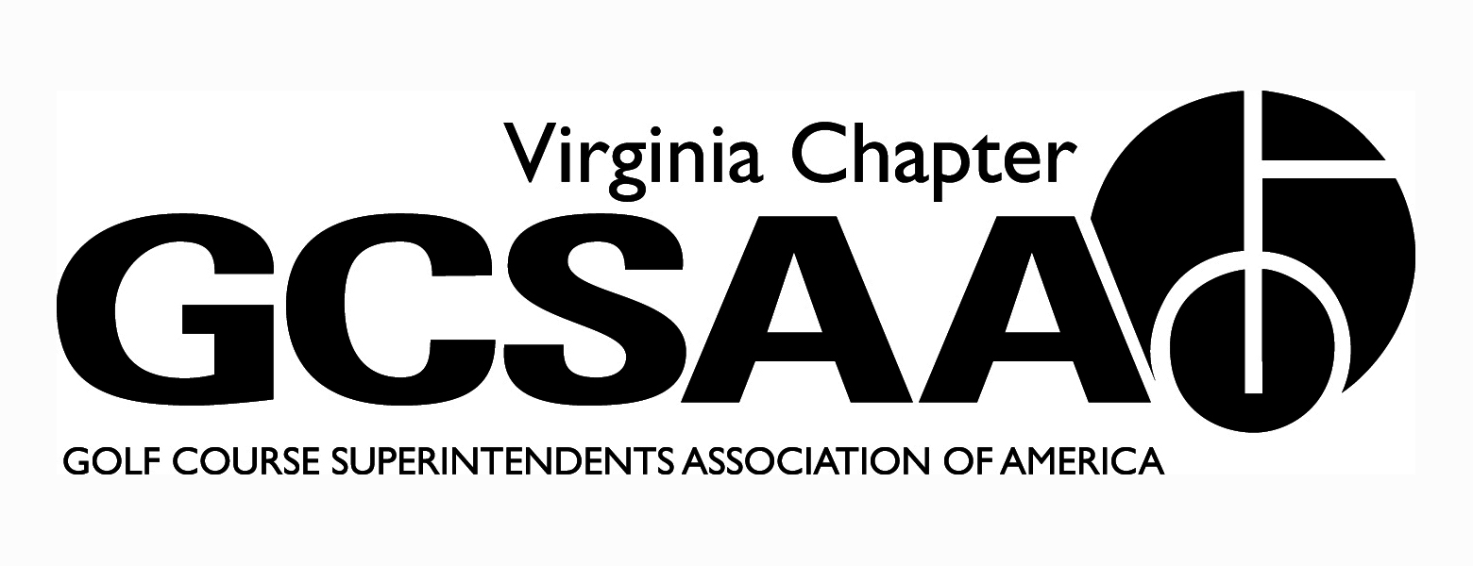

VGCSA Board Meeting
Hermitage Country Club, Manakin-Sabot, VA
August 7, 2014
10:00 Am Start

Attendance : David Norman, Jeff Holliday, Mark Cote, Larry Adcock, Chad Karr, Rob Wilmans, Brent Graham, Bill Keene, Shawn Gill, Scott Cornwell

Call to Order 10:00am

- Approval of Minutes

Motion: Cornwell, Second: Keene

- Treasurer’s Report
Discussion of transfer of funds from VTF to an account under VGCSA control
Motion: Keene, Second: Gill

- Recap of Recent Events – Joint Meeting; BMP Tournament; Other
Joint Meeting Norman
Cavalier Golf and yacht club, Darin Brevard spoke, 50 attended

BMP Tourney Norman
Sold out, savings on rates, expenses were down

- External VP Reports
VTA Keene
Successful meetings, Derek Cataldi spoke, Fundraiser raised 2,000 for scholarships, Jeff Snyder qualified for Virlina Cup

SVTA Cornwell
Fund raiser August 19th, Virlina Cup qualifier Ed Eagle, no major updates.

Greater Washington Gill
Virlina Cup Qualifier Scott Cornwell, May meeting at Montclair, June meeting at Twin Lakes, July is the Maintenance open.

Old Dominion Graham
Member survey done, Different ideas on increasing participation at events.

TTA Wilmans
Virlina cup qualifier Matt Boyce, Issues with fewer superintendents showing up at meetings.

- Fall Conference Discussion – registration policy, CGCSA conference
Discussion regarding registration form for fall conference and any priority given to superintendent registration.

- Government Relations - Nutrient Mgt. Planning Grants
Nutrient Management Planning grants extended, 2015 funds for rest of state. 48 courses plans approved anticipate 80 by the end of the year. $100,000 available in funding next year.

- Partner Program Update- Norman
$4500 over last year at this time –a 4.5% increase

- GCSAA Update - Rounds4Research, Chapter Outreach Grant, BMP Grants
R4R- Gill numbers not up, we are second in country, will probably down from last year.

Chapter Outreach Grant –Holliday - administrative error by GCSAA so we were left out this year, have been guaranteed a full grant next year.

BMP discussion on ad in VA Golfer Motion to have 1 add: Wilmans, Second : Cote
Use BMP money

- Buy Sod Scholarship – winners, “endowment” fund
Discussion on revamping application process and views expressed to limit to one larger scholarship versus multiple smaller ones.

- Event Previews - Virlina Cup, Assistants Forum, 2015 GCSAA Social Event
Virlina Cup Cornwell
Oct. 5-7 at Primland, Practice round at Spring Creek Monday.
Assistants Forum—Karr
Location will be Spring Creek, Topic to be Technology issues with the speaker Bill Brown of The Turf Republic Website.

GCSAA Social Event—Norman
With MAGCS at San Antonio River Walk,

- Miscellaneous Committee Reports
Bill Keene --Research
Discussion regarding concerns of Va Tech and VTF and future funding.

- Old Business / New Business – website update
Norman upgrade to website—low cost

- Executive Session

- Adjourn

Meeting Adjourned at 1:10 pm

