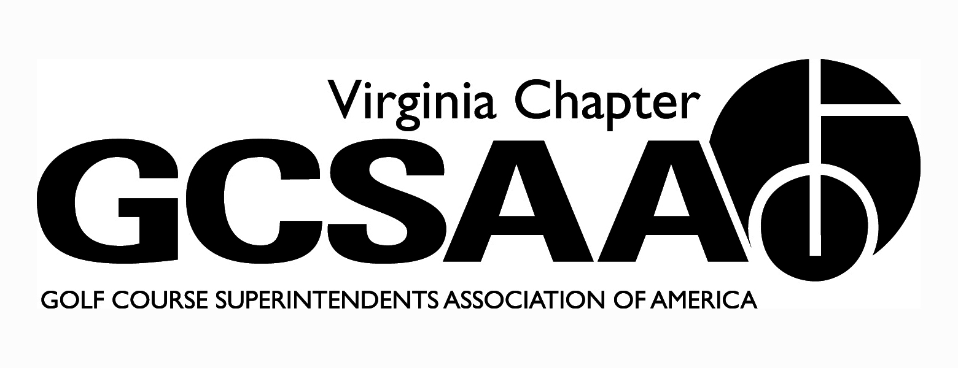

VGCSA Board Meeting
Hermitage Country Club, Manakin-Sabot, VA
Thursday, April 19, 2018
10:00 a.m.

Mark Cote, Bill Keene, Garrison Fowler, James Mazowieski, Scott Mauldin, Jeff Holliday, Ed Eagle, Aaron Wells, Ian Grove, Jeff Whitmire, Tyler Eastham, David Norman

Minutes

- Call to Order – 10:02
- Approval of Minutes – motion Scott Mauldin, 2nd Aaron Wells

- Treasurer’s Report – Jeff Whitmire

  - Income up
  - Dues are up for every local except TTA who grew last year.

- Motions to approve, Ed Eagle, 2nd Bill Keene

- External VP Reports

  - VTA – Westlake, H.T. Page will speak
    - June – Chatmoss in Danville, Bermuda Grass
    - August Family night Salem red sox
    - Annual Meeting at Blacksburg CC
    - Working on a fishing trip

  - TTA – Feb Topgolf was a good meeting
    - Joint event with ODGCSA was great at Kingsmill
    - Senate Bill 520 big win
    - April 30 meeting at Riverfront
    - May 24 – Dick Cake, Virlina Cup Qualifier at JRCC
    - Sept 20th – Kilmarlic in Outer Banks
    - Kingsmill Champ – May 14th at River Course – TTA will sponsor a lunch that week

  - ODGCSA March Madness in RVA and Williamsburg
    - Scholarship Tournament at Magnolia Green on Monday 23rd April
    - Baseball game in late June/early July
    - September event maybe joint with SVTA
    - Reaching out to tech center – professional type oriented classes for high school students to learn about a trade. There is a landscaping class, maybe Supers can join with the tech center school and possibly get a class going
  - SVTA
    - March meeting cancelled
    - May at Brice
    - July at Ed’s Place
    - October - Caverns CC

  - GWGCSA
    - March Madness Social Event well attended
    - May 8th Virlina Cup Qualifier at Piedmont GC
    - Dates for other events set, locations pending

- Recap of Recent Events

  - GCSAA Conference & GIS Social
    - Great event, Social had record attendance. Good to be out of a hotel and in the public
    - Good to keep in walking distance from hotels
    - Goal is to keep it thriving, young
    - Everyone can’t be happy but the majority had a great time
  - Mid-Atlantic Regional Conference
    - 5 speakers, one each from NGCOA, PGA, GCSAA, WGF, USGA
    - Great networking for everyone from each of the associations plus CMAA members
    - Looking at doing the event every year and switch between Charlottesville/RVA & NOVA
    - Pete Bevacqua committed for 2019, talking to Steve Mona and Mike Davis, hopefully Rhett Evans and Jay Karen can commit
    - Possibly push a team concept for attendees, recruit clubs to bring multiple employees
  - GCSAA Chapter Leaders Symposium
    - Aaron Wells attended
    - Great day and a half, Rhett talked to the group and does a great job
    - New programs for assistants and equipment operators are growing
    - FFA career day with high schools is a new program and geared toward students that have choses an agriculture career path but have not decided on their concentration
  - ODGCSA/TTA Joint Meeting
    - Successful event with turnout around 50, heavier from ODGCSA side. TTA looking for ways to increase attendance. It was spring break week so that affected attendance
    - Jeff Whitmire mentions the municipality members have trouble getting off of work and getting meeting costs reimbursed

- Annual Conference

  - site secured – Darden School of Business at UVA
  - speaker update
    - Frank Wong
    - Mark Kuhns
    - Looking to get Cal Ripken, Jr but he is booked. Possibly we can recruit him for 2019
    - Jeff Holliday suggests Bill Keene ask Frank Beamer for a future conference
    - A request for John McGuire – legislature from Henrico County. First time legislature, former Navy Seal, also does motivation speaking – 2 birds with one stone – legislative angle and motivational speaker information
    - Pat Gross from USGA, in California will speak about water and conservation, etc.
  - On Sunday evening Steve Randall from GCSAA and the BOD will do a strategic planning session.
  - Colorant Workshop the morning before with USGA like last year

- Government Relations

  - Senate Bill 520 – bill was squashed, VGCSA testified and presented a case
  - Legislature Visit
    - Successful visit and spoke to various legislatures and senators
    - We are recognized in the capitol now as an organization that helps with getting our points across to these legislatures
  - National Golf Day – April 24-25
    - Jeff Holliday is on GCSAA Gov’t affairs committee
    - Monday is meeting day
    - Tuesday 24th is community service project, VGCSA is representing well with volunteers – Aaron Wells and Jeff Holliday will be there
    - Wednesday 25th - NGD
  - VAC staffing update
    - Katie Frazier took another job and her assistant Johnathan Harding also took another job
  - Lobbyist Discussion
    - David Norman, Mark Cote and Jeff Holliday met with a lobbyist Trip Perrin to see if we may be able to have him aligned with VGCSA and the golf business
    - Benefit are that Tripp would be our golf lobbyist with a more direct approach
    - He would be a hands on ally. He is a golfer and we are looking to share the cost with the golf council - $25K per year to monitor and keep us involved and knowledgeable of what is going on. There may be more cost if he must step up and push an issue. We currently pay $1,200 to VAC and would retain that membership
    - We currently get updates from Tripp, DN will put government relations committee members on that email list
    - David and Mark will schedule a meeting with Jamie Conkling and present the idea of joining in on lobbyist fees

- 2018 VGCSA Member Survey Results

  - 88 respondents - 15-20% of membership
  - Seems to be the same people that take the survey every year

- Rounds4Research

  - Last year we got $2,500
  - This year the goal is to get more participation
    - Aaron wells will get Belmont CC to donate
    - Garrison will ask Brent Graham to donate for Two Rivers
    - We need to push members and others to bid

- Virginia Tech Turfgrass Research Classic & Field Day

  - Eric Snelsire of Bayer is managing silent auction and soliciting donations
    - Ed Eagle donated a Driver or the Silent Auction from Massanutten
    - Working on golf items, package items, etc.
    - Mark Cote has LSI willing to donate VT football tickets
  - Down to approx. 6 teams available
  - Pledges of 55K through today
  - Dr. Erik Ervin is planning to attend

- Other Events

  - Match Play (New)
    - Lots of excitement and will be great
  - VGCSA Championship
    - Keswick on May 16th
      - Net, Gross and Vendor Division
  - VGCSA-CMAA-NGCOA Joint Meeting
  - Virlina Cup
  - Joe Saylor
    - Williamsburg Golf Club September 24th
  - Assistants Forum
    - Stonehenge – October 29th – Garrison working on topic and speakers
  - Strategic Planning
    - Steve Randall from GCSAA coming the Sunday before the Annual Meeting to meet with the board

- Other Committee Reports
  - Communications
    - Newsletter content is coming in timely
  - Membership
    - Need to collect outstanding dues
    - Remove those that are out of the business or moved out of state
  - Partner Program
    - Two years ago pricing was changed for first time in 10 year, grandfathered renewals for two years. This is the first year the new pricing was enforced across the board
    - We lost 7 partners – 1 diamond
    - We have 3 new partners
    - Bayer picked up Saylor tournament from Pro Golf Arborists
    - We will be right around budget
  - Turfgrass
    - Peter McDonough approached Mark Cote about a case study the USGA did and suggested we contact USGA to get a case study done on BMPs, NMPs, Water Quality Study, etc.
      - The study will quantify and put all of the data together and include VGCSA and USGA logos
      - Price for the study is approximately $1,800.
      - We could use this document at the capitol for our legislative visit
    - Motion by Aaron Wells to allocate $1,800 for case study – 2nd James Mazowieski.

- Old Business / New Business
  - Make calls for R4R donations

- Executive Session - No

- Adjourn – 12:30 pm

