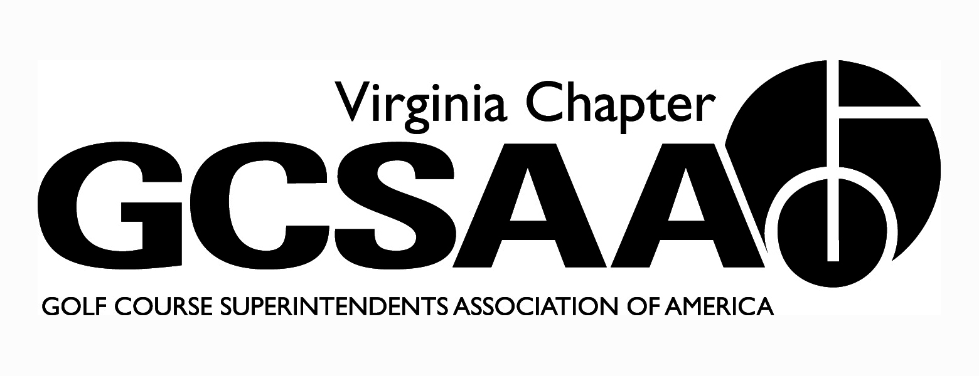

VGCSA Board Meeting Minutes
Hermitage Country Club, Manakin-Sabot, VA
November 17th, 2016

In attendance: D. Norman, T. Eastham, J. Holliday, M. Cote, S. Baskette, B. McCurry, S. Mauldin, P. Stephens, D. McCall, M. Boyce, W. Day

Call to Order - 10:06 - Discussion of attaining new GWGCSA external VP

- Investment Report (Day) - Started in low risk with 80% investment in bond market. We want to make money yet manage risk, longer term investment mitigates some risk. We could consider additional investment in February.

- Approval of Minutes – Motion Baskette, Second McCurry– minutes approved

- Treasurer’s Report – Motion Baskette, Second Mauldin - report approved

- Executive Director Report - (Norman) – Update on plans for conference and recent events

- Budget Review - Keep partner program the same pricing structure. Noted vendors were shouldering enough cost. The budget includes a $5 dues increase for 2017 for just superintendents and vendors (not assistants). Cote wants to increase the budget for the annual conference to ensure the best speakers and book them in advance. We are looking to boost attendance by adding Yeti cooler and Redskins tickets as door prizes.

- Chapter Delegate report - (Holliday) Attended with Jay Wade of ODGCSA. It was a two day event at GCSAA headquarters in Kansas. $5 dues increase was proposed. A bylaws change was enacted, changing SM to B, adding equipment managers and international members. New membership director wants to increase membership to 20K by 2020. A new political action committee formed to support government relations. Rounds4Research showcased Carolinas prowess and highlighted our weakness. New board members were named.

- Committee Reports
- Assistants (McCurry) - Assistants Forum held at Independence GC. 46 attended to hear Kelli Thompson, HR Director at CCV, speak. Talked about hiring and firing. Panel of Holliday, Fisher, Whitmire, and Rogan. Assistants’ video was given to McCall’s wife, a high school counselor and she shared with golf coach and AD. Adults liked it, students found it boring. Must be approved to disseminate in schools. Video also needs to be linked to website.
- Awards - Buy Sod Committee funded two $750 scholarships (even though only $650 was donated this year). Environmental Stewardship award was given to Mike King for work at Mt. Vernon CC for reconstruction. Fred Biggers of Wintergreen was the Distinguished Service award winner and Steve Snare was the recipient of the President’s Award.
- BMP - Template will be released at GIS. Environmental Cup (EC) needs to engage vendors better. Could combine VTC and EC, afraid we lose government relations funding. DM took idea to VTC and wanted to keep EC goals. Lots in play right now with VT moving field days. Vendors want to write on check to VT.

- Communications - (Cote) - Suggestion to hold newsletter until after conference. Bo Jumbercotta will write the GWGCSA article this quarter.
- Government Relations – December 1 is the deadline for the new minimum salary overtime rule. We need to keep recruiting courses who have not submitted their nutrient management plan.
- MAGC – Considering spring meeting similar to USGA regional conference in 2018. Get all involved with golf at your facility to attend. Could become an annual event, we want to gather information.
- EIFG (McCall) - Proposal submitted, should know in December. Field Day at CCV in spring. Could also partner with Independence for research on par-3 course. Independence could be a regular location for field day in the future.
- Rounds for Research - Better this year than in the past. Timing of auction in the spring was good
- Website - We need to update email addresses. Several email are being returned.

- External VP reports
- VTA - Held annual meeting in October. No scholarship was awarded this year because no one applied. All in all, a good year despite an awful summer.
- ODGCSA - Monday of Fall conference will be rapid fire questions on a range of topics. Meeting on 9/26 at Magnolia Green had 25 and 10/25 at Kanawha had 20 players. Need to call more to encourage participation. Chad Karr was named new board member and others moving up
- TTA- 10/19 at Indian Creek was well attended. Annual meeting at James River CC, Rob Wilmans was named president. New board wants to start a social media promos. All events will be free. TTA wants a standalone email list. Also want name taken off list once they have RSVP’d.
- No reports from SVTA or GWGCSA

- Executive Session – discussed board nominations

- Adjournment – meeting adjourned

