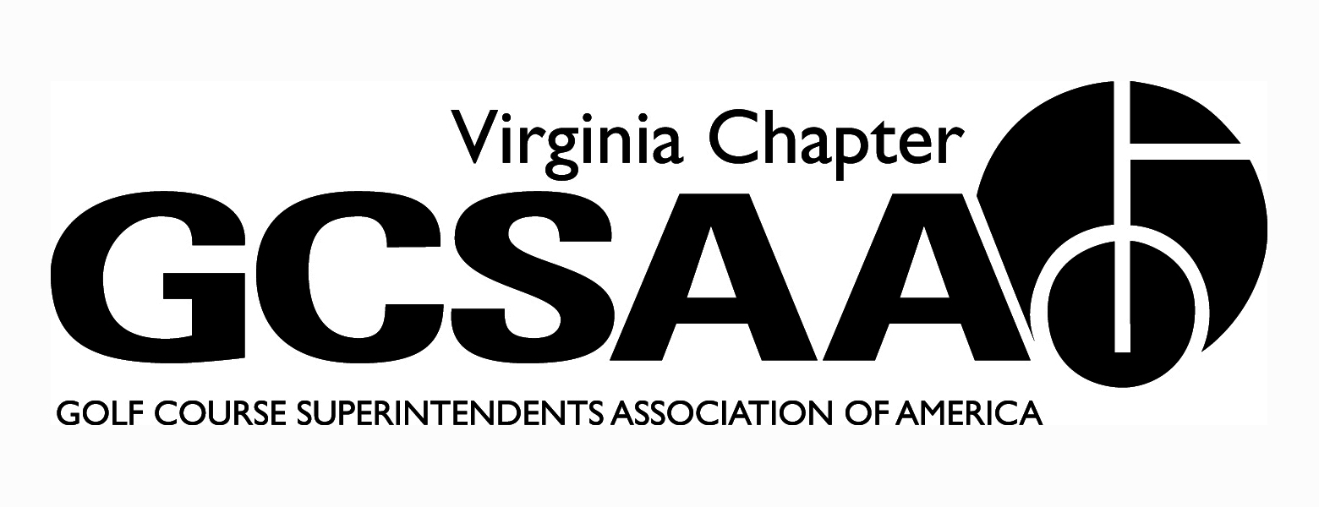
VGCSA board meeting: April 19, 2012 at 10 AM
Location: VGCSA office, Glen Allen, VA
Attendance: Matt Boyce, Jeff Holliday CGCS, Chris Petrelli, Jeff Van Fleet, Mark Cote, Dan Taylor CGCS, Dave Lewallen, Rob Wilmans, Patrick Connelly, Matt Sobotka, Jeff Berg, David Norman, Steve Randall GCSAA.
- Call to order at 10:10 AM (Boyce)
- Introduction of Steve Randall GCSAA Senior Manager
- Boyce’s President message: Avoid a dialogue with VTC, let them speak on the issue
- Approval of previous meeting minutes:
- Motion: Van Fleet, second: Holliday.
- Treasurer Report(Petrelli)
- Income is up due to earlier dues payments, expenses also slightly higher.
- Motion: Holliday, second: Van Fleet
- Partner Program update: (Norman and Connelly)
- Looking for 5 to 10 additional partners, feel that it is very attainable (Connelly).
- BMP money needs to keep coming in to fund water monitoring and Nutrient Management Program (Berg). Money from state is still not set yet.
- Looking for $25,000 from BMP tourney (Connelly)
- Partner Program has some new partners, some upgraded, lost only 3 so far (Norman).
- Recap of Recent events:
- GCSAA conference and joint social event were excellent (Boyce).
- Around 300 attendees for social event.
- GCSAA annual meeting went well, Rafael and Maynard won elections.
- Berg, McDonough and Norman all spoke at GCSAA conference
- Government Relations and BMP Update: (Wilmans)
- Need to get more volunteers for water monitoring sites (Wilmans).
- Water monitoring will cost around $10,000 a year for next couple of years (Wilmans).
- McDonough is trying to get cost sharing from state (Wilmans).
- Kevin Fortune is helping with Water monitoring program (Wilmans).
- Nitrogen, Phosphorus and sediment are the most important things to be concerned with (Berg).
- Phase 2 of Chesapeake Bay Cleanup Plan is now getting public comments, Norman will send out email for input. (Boyce).
- BMP tourney: Precision and BASF are in for $1500, biggest thing now is getting more teams (Connelly).
- External VP’s Reports:
- GWGCSA: (Van Fleet):
- Pro Super is coming up on April 24th, 70 players registered.
- North-South in June
- TTA: (Wilmans):
- 1st meeting with ODGCSA at Kingsmill with Treadway had around 70 people
- April meeting at Broad Bay and speaker about ultra-dwarf bermuda.
- May meeting at Virginia Tech extension and golf at Bay Creek.
- ODGCSA: (Taylor)
- Wee One Committee formed, event will stay at Cypress Creek this year but may go to central location in future.
- VTA (Cote)
- April 10th meeting with DEQ Reporting Tammy Stephenson had 3 excellent presenters. Must report pulling of water and best to establish records for tracking history. If you had a history of reporting before 1989, you are grandfathered into getting a permit.
- June 11th at Homestead, with Treadway
- SVTA (Lewallen)
- March 29th at Winchester first meeting went well
- April 26 meeting at Spotswood CC has Dr. Askew speaking on new poa product.
- Committee Reports
- Assistants: (Boyce): Looking at superintendent from Augusta National or Valhalla for assistants outing on November 5th at Willow Oaks
- Community Service: (Holliday): Looking for more participation from ODGCSA for First Tee event in May
- Golf: (Boyce): Gave overview of upcoming events, Joe Saylor is October 29th at Princess Anne CC. Need another Club for hosting Virlina Cup.
- Membership: (Van Fleet): Numbers are up, still trying to get more assistants to sign up.
- Survey: (Van Fleet): Had 96 completed last year, only at 62 so far. Need to get more emails out and maybe extend the deadline.
- Education: Holliday will come up with a list of topics for VTC meeting and Norman and Holliday will attend the meeting.

- Rounds for Research: (Norman)
- Date has moved to August, working with a new platform.

- GCSAA Update: Steve Randall Senior Manager for Chapter Outreach
- The EIFG will be relaunched with the goal of 51 percent of members donate something
- More field staff, approved for Mid-Atlantic and Southeast regions, goal for field staff is to enhance chapter’s ability to provide services.

- VTC Presentation:
- The VGCSA heard presentations from representatives of VTC about the 2013 VTC Conference and Show. The emphasis was on preserving the partnership with VGCSA on this event.
- The VGCSA expressed its concerned to ensure appealing education content for its members. The VTC representatives acknowledged that they were amenable to this.

- Next meeting: August 2nd, 2012
- Meeting adjourned at 2:39 PM, motion: Van Fleet, second: Berg.
Respectfully Submitted,

Chris Petrelli
Secretary/Treasurer

