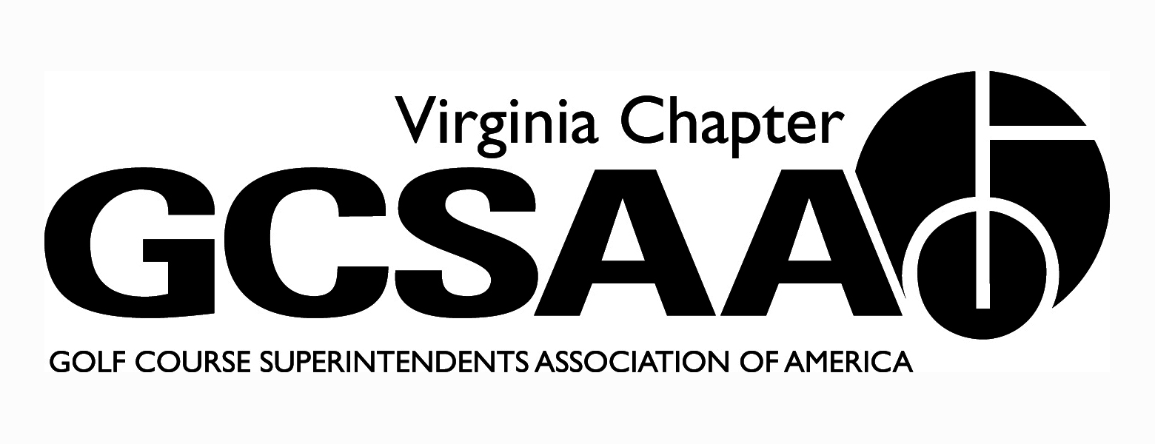
VGCSA Board Meeting
Hermitage Country Club, Manakin-Sabot, VA
Thursday, April 20, 2017
10:00 a.m.

Sean Baskette, Scott Mauldin, Mark Cote, Aaron Wells, Steven Ball, Eric Spurlock, Jeff Whitmire, Erik Ervin, Ed Eagle, David Norman

Minutes

- Call to Order – 10:01 am

- Introduction of Board Members (Jeff Holliday, Bill Keene, & Pete Stephens Absent - Erik Ervin was present in place of David McCall)

  - Aaron Wells – GWGCSA External VP – Belmont Country Club, Ashburn VA
  - Steven Ball – Asst. Rep – Kinloch Golf Club
  - Eric Spurlock – Vendor Rep - Landscape Supply
  - Jeff Whitmire – Secretary/Treasurer – Williamsburg Golf Club
  - Ed Eagle – SVTA External VP – Ingleside Resort
  - Sean Baskette – VTA External VP – Hidden Valley CC
  - Scott Mauldin – External VP ODGCSA – The Foundry GC
  - David Norman – Executive Director – Hermitage CC
  - Mark Cote – President – Pete Dye River Course
  - Erik Ervin - Virginia Tech

- Approval of Minutes
  - General comments that minutes were too detailed.
  - Motion to Approve - Sean Baskette, 2nd Eric Spurlock. Motion passed unanimously.

- Treasurer’s Report – Whitmire
  - All dues revenue is up versus 2016. This is mostly due to $5 increase in Superintendent dues this year. Membership is steady.
  - All associations were reimbursed on March 14.
  - Investment Account is up $2,058 for the quarter.
  - Finances appear to be in order.
  - Motion to approve – Sean Baskette, 2nd Eric Spurlock. Motion passed unanimously.

- External VP Reports
  - SVTA (Eagle) - meeting today @ Spotswood. Next Meeting June 15. Venue will be determined.
  - VTA (Baskette)
- 1st meeting at Cinebowl next week
- May Meeting @ London Downs
- (Ervin) 10 students in 4 year program @ VT, 5 are interested in golf. 20-25 in 2-year program. Students will attend fundraiser at London Downs.
  - ODGCSA (Mauldin)
- Held joint with TTA @ Two Rivers Country Club was successful event
- Scholarship tournament at Richmond Country Club was well received by those who attended. Turnout was lower than expected. Two $1000 scholarships will be awarded from this event. .
  - GWGCSA (Wells)
- Held Virlina Cup Qualifier at Creighton Farms - Matt Zarnstorff was the winner.
- Next meeting is joint with Mid-Atlantic on May 23.
- GWGCSA reached out to courses on NMP list in their region. Approximately 65% of courses responded and said they were working on their plan.
  - TTA – (Whitmire for Stephens)
- next meeting is at Virginia Beach National on April 26
- Dick Cake will be back at Elizabeth Manor on May 24
- TTA Board would like to have individual meeting notices sent out in addition to the mention in the Friday newsletter. David Norman said he would make that happen.

- Nutrient Management Plan
  - Board was presented with a list of courses who have not completed plan as of March 14.
  - All local associations reported that they have contacted or attempted to contact everyone on the list in their regions who do not have a plan.
  - Cote stated that realistic goal would be to have 65-70% compliance by deadline.

- Chapter Leaders Meeting - Pete Stephens and Bill Keene attended. No report as they were absent.

- Golf 2.0 (Norman & Cote)
- Norman & Cote represented VGCSA at last meeting
- Norman presented board with summary of the meeting
- Approximately 40 people in attendance representing all factions of the industry
- Next meeting will focus on making golf affordable

- Event Schedule
- National Golf Day (Norman)
- David Norman is going
- Should be largest one yet
- Mid-Atlantic will be doing a community service project on the mall
- VGCSA Championship (Whitmire)
- David Norman organizing the event
- 3 divisions - Superintendent, Assistant, Vendor
- Considering Match Play Championship for 2018 (in addition to, not to replace, stroke play event) - Golf Committee is working on details
- VA Tech Turfgrass Field Day & Golf Classic (Norman)
- Had some early surprise pledges. $34,000 pledged to date.
- Have 72 spots committed as of today
- Want to make it a memorable event, lots of excitement
- Will have a great lunch, craft beers on the course, beer stein as tee gift, dinner reception
- 4 man scramble, gross & net
- Looking at holding auction at event (not golf rounds)
- Marc Petrus and Fred Biggers have been very helpful in organizing the event
- Mark Cote mentioned that this will be the primary funding mechanism for research projects going forward. Discussion followed on VT Research funding mechanisms.
- VGCSA-CMAA-NGCOA Joint Event (Norman)
- June 12 at Two Rivers Country Club.
- Topic will be staffing with H2B Visa workers
- Joe Saylor Memorial (Whitmire, Norman)
- Will be held October 9 at James River Country Club
- Pro-Arbor has signed on as sponsor

- Virlina Cup (Whitmire)
This year will be at Highlands Country Club in Cashiers, NC in early October

- Assistants Forum (Ball)
October 30 at Belmont Country Club. Will be joint with Mid-Atlantic GCSA

- 2018 MAGC Conference (Norman)
- Jeff Holliday has put a lot of effort into this
- Conference will be for all managers (golf professionals, superintendents, managers, Presidents, etc.)
- Tentative date is March 6, 2018 at Belle Haven
- Preliminary speakers include Steve Mona, Rhett Evans, PGA CEO, etc.

- Annual Conference (Cote & Norman)
- Conference will be held in Charlottesville at UVA Darden School of Business
- December 4 & 5
- Cale Bigelow, Tim Hiers, & Darrin Davis are preliminary speakers. Discussion on other possible speakers

- Partner Update (Norman) - all top vendors chose to renew except Quali-Pro (ownership transition)

- Committee Reports

  - Communications (Norman) - collecting ads now for newsletter
  - BMP Template (Cote) - working on getting our BMP plan on to the GCSAA template
  - McCall Project (Ervin) - project has started at Tuckahoe Creek
  - Rounds 4 Research (Norman) - 22 courses donated. EIFG gets 20%, VGCSA 80% of proceeds
  - Turfgrass Survey (Norman) - 41 superintendents have completed, need to encourage participation
  - VGCSA Survey (Cote) - will go out in 2018. Sean Baskette will be in charge of this task
  - Website (Ball)
- Website needs updating
- Trying to link Facebook and Twitter to website

- Old Business / New Business - Visit with Legislature
  - Cote would like more participation at the legislature visit
  - Board was presented with Georgia GCSA video - would like something similar for VGCSA to give to legislature
  - Erik Ervin encouraged everyone to mention NMP, BMP, and Economic Impact when discussing our industry with politicians

- Executive Session
- Funding for David McCall Project - Motion was made to withdraw $10,000 from Environmental Research Fund for David McCall Drone Study. Motion passed.

- The board discussed a Bylaws change to eliminate the Turf Educator position as a member of the VGCSA Board. A motion was made by Baskette and seconded by Mauldin to eliminate the following clause from the Bylaws:

Section 11. Turf Educator Member

A. The Turf Educator Board Member shall be an educator of turf science at a regional university.

B. The Turf Educator Board Member shall have committee responsibilities reporting to the President.

C. The Turf Educator Board Member does not have voting rights on the Board of Directors.

The motion passed. A copy of the revised Bylaws is attached.

- Adjourn – 1:47 pm

