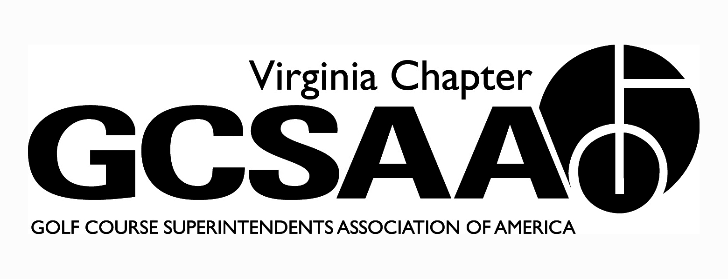

VGCSA Board Meeting Minutes
Hermitage Country Club, Manakin-Sabot, VA
August 4, 2016

In attendance: D. Norman, T. Eastham, J. Holliday, M. Cote, B. Keene, S. Cornwell, S. Baskette, B. McCurry, S. Mauldin, M. Rodriguez, P. Stephens, D. McCall

Call to Order- 9:56

- Approval of Minutes – Motion Baskette, Second McCurry– minutes approved

- Treasurer’s Report (Keene) – Report showed a loss in membership dues in 3 of the 5 associations with the other 2 being unchanged. Environmental Cup revenue was down $8200. Baskette Motion, Cornwell Second – report approved

- Bylaws Resolution from National: GCSAA required a vote to change SM class to class B. By vote, all approved change.

- External VP report-
- SVTA- Board is not active and unorganized. The fundraiser for this year will be on October 27th
- VTA- Fundraiser netted $2000. June meeting attendance was low due to poor timing with other events. Baseball game was well attended, lots of kids. Remaining meetings are 8/16 at Primland and 10/18 at Roanoke CC
- ODGCSA- Monday of annual conference will be rapid-fire questions on a range of topics. Meeting on 9/26 at Magnolia Green and 10/25 at Kanawha will be free. Looking for scholarship applicants, not just turf students, deadline is 9/30
- TTA- Things have been quiet. Last meeting was May. 10/19 at Indian Creek, annual meeting is 11/3 at James River CC

- Event Review-
- Old Dominion Scholarship Tourney- Turnout was great. Event was held at Spring Creek. STI and Toro was the main sponsor.
- JD Dickinson Memorial will be held on 9/25
- VGCSA Championship was held at Boonsboro in Lynchburg. Roughly 40 participated.
- National Golf Day- D. Norman and P. McDonough meet with staff from Sen. Kaine and Warner. They were interested in the economic impact study.
- Environmental Cup- Bev cart service was bad, food was average. Event needs to be memorable for the right reasons. Venue and prizes were great. Funds raised was less than budgeted.
- Virginia Tech Research Fundraiser- McCall likes the idea to merge the VTC and VGCSA events. Vendors like idea of writing one check. To be successful like Rutgers, etc. need all groups involved. Even with all groups involved, 90% of research is golf related. Mauldin stated a good cause is a good selling point. Holliday asked if all money goes to VTF. McCall points out less state funding for VT as whole, not just turf program. Cornwell points out one less event on busy calendar should be a good thing. McCall - VGCSA needs say in set up, wonders if this is something VTC wants long term. Moving locations would be good to get other parts of the state involved. The event needs to be first class. Keene states some of the perceived issues are a lack of transparency with funds. People want to know exactly where the money is going. Norman not sure it will increase money raised, giving same support to one event instead of fully funding two events. Norman also points out GCSAA could help with funding from EIFG for research projects.

- Partner Program- The amount of money we received from the partner program is the same as last year. We would like to see growth in this each year. The fact the money is the same is not bad considering we lost partners from last year.

- GCSAA update
- Rounds for Research were up from last year. A change in the timing and increased participation helped.
- Chapter outreach video was shot in an effort to drum up interest in the turf program and field. Six assistants were used to showcase the industry.
- 2017 GCSAA social event will be at the DoubleTree Seaworld. Hotel is on the bus line and the rate is reasonable. The event can be outside, weather permitting. We will be soliciting sponsors again. This will be a joint event with the MAGCSA.

- Annual Conference Education - The ODGCSA will be handling the Monday afternoon portion of the event. This is when they will be conducting the rapid-fire Q&A. VGCSA is responsible for Tuesday. Options are for the USGA to present. Bill Maynard from the GCSAA is an option. We are in need of a keynote speaker.

- Scholarships- This year we have $650 from Buy Sod versus $3000. Lack of winterkill meant less sod was purchased this past year. VGCSA will give an additional $350 to make $1000.

- Committee Reports-
- Assistants (McCurry) - The forum will be on 11/8 at Independence GC. Speaker is still TBD. A focus on management and leadership is the desired direction.
- Community Service (Holliday)- The First Tee of RVA and VCU is a service opportunity
- Golf (Holliday) - The Joe Saylor is coming up at Fawn Lake on 10/20. The Virlina Cup is on 10/23-10/25 at Belle Haven in D.C.
- Gov Relations (Holliday) - The number of courses with their NMP in place has increased by about 100. Contacting those who have not yet filed their plan may be needed to help get them in compliance.
- Membership (Stephens) - We are looking into a company to drive membership and streamline services. This will allow individual member access to their account. This is all cloud based and will also give local chapters access to contact their members.
- Research (McCall) – Water monitoring funded and submitted to the EIFG by 10/1. Currently have 8 grad students, 5 of which are solely golf. There is lots of disease research on going. They have Indemnify trials out. Drone work to identify water stress and other stressors. $40k is the max funding from the EIFG for 2 years. Field day is in decline. 80 total attendees, 2 superintendents.

- Old Business- VGCSA has been approached for $5000 to help fund the economic impact survey for the Green Industry. Baskette motion, McCurry seconds. All members approve.

- Adjourn 1:12 pm

