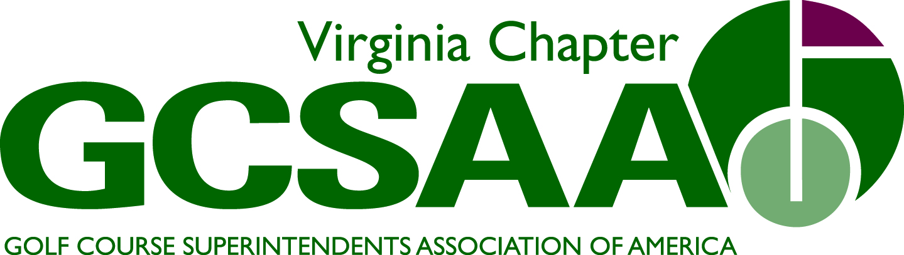

Subject: VGCSA Board of Directors Meeting
Date, Time, Place:
August 4, 2011
10:00 a.m.
VGCSA Office, Glen Allen, Va.

Attendance: Jeff Berg, David Norman, Matt Boyce, Jeff Holliday, CGCS, Mark Cote, Jeff Van Fleet, Dan Taylor, CGCS, Charlie Fultz, Scott Mauldin, CGCS, Bo Jumbercotta, Peter McDonough (phone)

- Call to order at 10:06 A.M. (Berg)
- Approval of previous April 28th BOD Meeting minutes
  - Motion Spurlock, 2nd Petrelli
- Treasures Report (Holliday)
  - Discussed BMP funds
  - Set up NW Mutual account
  - Harmon Turf (Diamond Partner) not paid
  - Reimbursement checks for local Associations going out
  - Motion to approve report Holliday, 2nd Van Fleet
- BMP Update and Nutrient Management Plan (McDonough)
  - Final reading a Hermitage CC July 25th
  - Group discussed content of material
  - Discussed promotion of the Nutrient management Plan, DCR’s help
  - Looking for bullet points on what Superintendents would like to see with Nutrient Management Plan
  - Nutrient Credit Exchange Program for Chesapeake Bay, BMP will have a template on credit values
  - Time line a little behind goal is to finish by late fall
  - How to promote the BMP, not about Superintendents rather it’s the Clubs
- Bill Signing, HB 31 Ceremonial Bill signing
  - August 11 at 2 P.M., Brookmeade Sod Farm
  - Encourage attendance, try to get allied associations to attend
  - Check on attire for bill signing
- 2012 Annual Meeting (Cote)
  - Discussed Vendor sponsorship
  - Timing and location discussed
  - Discussed Fredericksburg CC
  - Discussed transportation from hotels to FCC
  - Discussed cost, $70 pp
  - Motion to approve FCC as sight Spurlock, 2nd Boyce
  - Motion to approve Tuesday night Boyce, 2nd Taylor
- External VP Reports
  - GWGCSA (Van Fleet)
- North/South, ODGCSA won this year, 9 hole event
- Discussed combining tournament, N/S & Tollie Quinn
- Goose Creek BMP, good attendance
- July Maintenance Open, Mt. Vernon CC won
- August 23rd social at Wings Factory
- Sept. 20th Joint meeting with MAGCSA
  - TTA (Petrelli)
- May 31, Dr. Goatley spoke
- June, Dick Cake 30 people in attendance
- July Tides night 15 people in attendance
- July 18th, Wee One, low attendance
- September meeting will be in Nags Head
- No more 9 hole socials
  - VTA (Cote)
- June 14th Blue Hills, McDonough speaker, free lunch
- July meeting was at Primland, great turnout
- September meeting will about the BMP, joint with SVTA
  - ODGCSA (Taylor)
- Tollie Quinn winner was Jeff Whitmire
- Sponsored a team in the Ag. Business Tournament
- Sponsored a team in the Chesterfield First tee event
- Annual Meeting will be held at Independence, par 3 contest
  - SVTA (Distefano)
- Working on 2012 meeting schedule, will theme them
- Loudoun GCC fundraiser was excellent
  - Vendor ( Fultz)
- Absent, no info
- Committee Reports (Berg)
  - Assistants Forum
- Roundtable discussion, Vaughn, Nasser, Cote and Happ
- Rhett Evans keynote speaker
- Dominion Valley CC
- Open to MAGCSA
  - Education (Petrelli)
- Need to check on golf track panel discussion
- Good participation in webinar
- Looking at two webinars for next year
  - First Tee
- ODGCSA sponsored a team in fundraiser
- Discussed equipment contributions
- Boyce reported PACC hold a fundraiser for First Tee
  - GCSAA (Spurlock)
- 2012 conference update
- Spurlock on Nominating Committee
- Looking for field staff representative for north
  - Golf Committee
- Virlina Cup participants, where to host in 2012
- Wee One, discuss helping out Phil Bailey
- Tollie Quinn
- CMAA event at Hermitage CC, VGCSA team won
- Joe Saylor at Creighton Farms
  - Nominating (Petrelli)
- Will nominate new Secretary/Treasure
- Others move up
- Discuss at November meeting, need Vendor and Assistant as well
  - Publications (Holliday)
- Announce Annual Meeting in next newsletter
  - Survey (Van Fleet)
- Due this year, hope to get it out earlier
  - Voting Delegate (Berg)
- Berg designated to represent State at Chapter Delegates meeting
- Present BMP
  - Web Site (Berg)
- Facebook, Berg to manage
- Need to terminate Brent Compton’s site
12:45- Boyce took over meeting in Bergs absence
- Partner Program Update-Status (Norman)
  - Barely making budget
  - Looked at list
  - Harmon Turf
  - Discussed sponsor level (changing $)
  - Economy
- Rounds4Research (Norman)
  - Up this year
  - Continue in 2012
  - Berg commented on announcement in newsletter
- Local Association Discussion
  - Van Fleet, GCSAA needs to work harder on dual affiliation
  - Discussed Wee One ideas
  - Cote discussed pre-payment for association meetings (Pay Pal)
  - Promote more joint events, larger attendance
- Old Business
- New Business
- Next meeting Nov. 10, 2011
- Meeting adjourned at 1:39, Motion by Boyce, 2nd Spurlock

Respectfully submitted,

Jeff Holliday, CGCS
Sect./Treasurer

