SEQUOIA WOODS COUNTRY CLUB MEN’S & WOMEN’S GOLF CLUBS
2019 Rullhausen Charity Classic Golf Tournament

This Year Supporting:

Calaveras Search and Rescue. (http://calaverassar.org/)

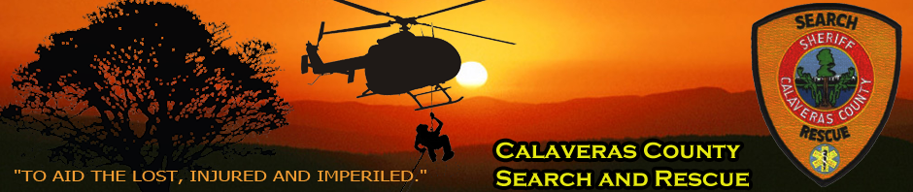

A volunteer organization based in Arnold
________________________________________________________________________________
Sunday, August 18th, 2019 - 1:00 PM Shotgun Start
(12 noon check-in)
Sign up by: August 3rd
________________________________________________________________________________

- Mixed Scramble Event: 2 Men/2 Women per Team
(Sign up as a team, a couple, or individually.)

- SWCC Members: $70 Non-Members: $100 Additional dinners: $28
- (No tickets sold at door)
- Tee Sign Sponsor: $100 (Personal tee sign & certificate for 2 rounds of golf.
Also a great way to advertise your business.)

1st thru 4th Place Winner Closest to the Hole #17 (Men & Women)
Buy Your Drive #6 Shag Bag Drawing, Raffle, Mulligans
Silent Auction Raffle Prizes

- Cocktails on the deck with no-host bar, followed by dinner with complimentary wine on the tables.

- Entry forms and tee sign sponsor forms available at Sequoia Woods Country Club Golf Shop.

COME AND PLAY TO SUPPORT OUR LOCAL COMMUNITY

