Sequoia Woods Country Club
Men’s and Women’s Golf Clubs
Rullhausen Charity Classic
Golf Tournament
This Year Supporting
Calaveras County Search and Rescue
A volunteer organization based in Arnold
http://calaverassar.org
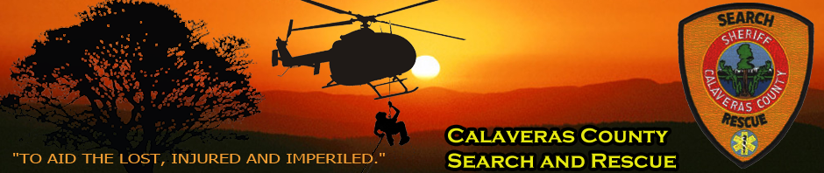
_______________________________________
Sunday August 18th, 2019
(Sign ups required by August 3rd)
_______________________________________

Please help us in this very important fundraising effort
Support Our Local Community By Donating $100.00
For Your Individual Tee Sponsor Sign
Your Check made out to: SWCC Men’s Club PO Box 574 Arnold, CA 95223 would be greatly appreciated

