

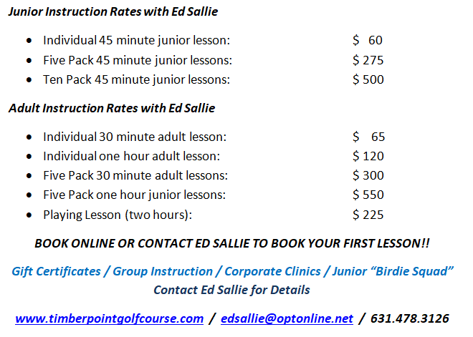

[**CLICK HERE TO BOOK A LESSON**](https://clients.uschedule.com/timberpointgolfcourse/booking)