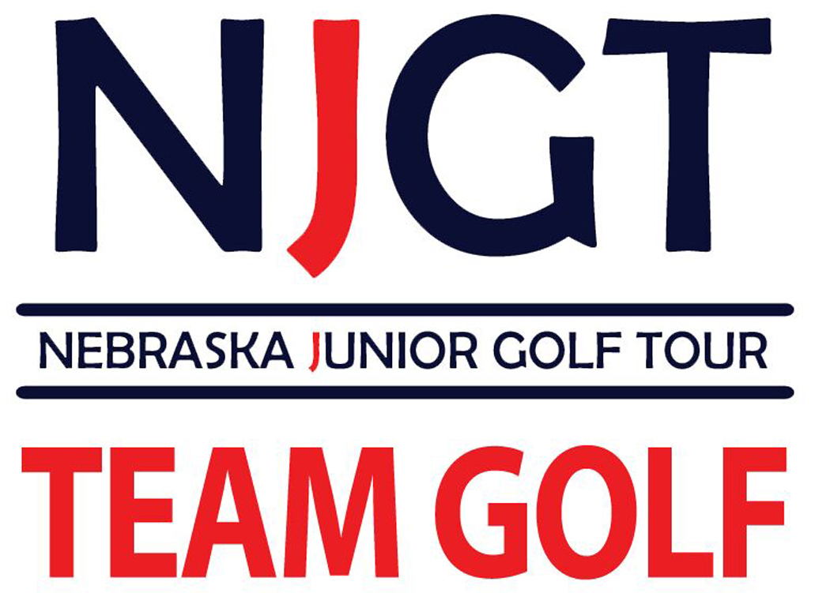  Register today by contacting your Professional Staff and TEAM GOLF coach:  Jason Shock, PGA  (402) 592-7788 work  (402) 880-2881 cell  Jason.Shock@pga.com   |  |  | 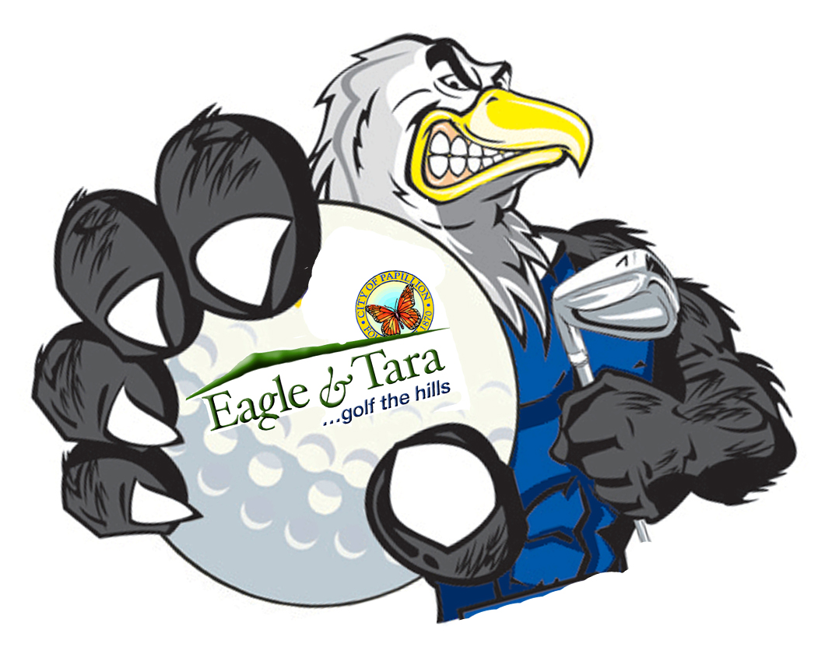  “Jason was terrific with my son. I would highly suggest Mr. Shock to anyone around the metro looking for lessons.” –Jackie A-  “It doesn’t matter what age group or skill level, Jason is the best in town!” -Brian G- |  | 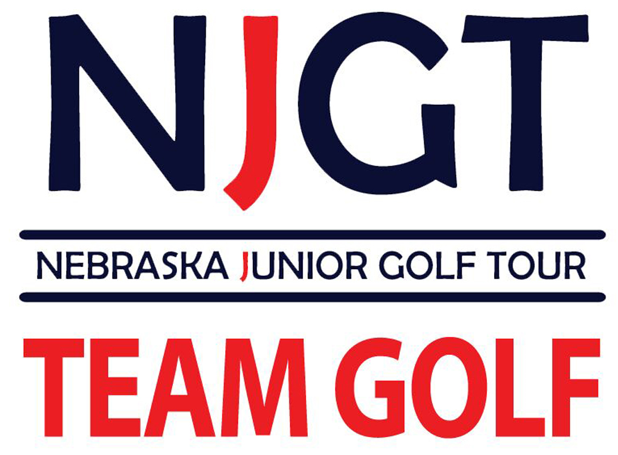  TEAM GOLF offers a fun and social introduction to competitive golf. It’s for the Junior golfer age 7-13 with any level of experience! Juniors compete on teams for their host facility with PGA Professionals serving as head coaches and mentors. All tournaments will be a 9-hole competition. TEAM GOLF will serve as a fun, social and less stressful approach to tournament golf utilizing modified rules, point scoring and a scramble format.

NJGT TEAM GOLF  Junior golfers compete on the  Eagle Hills Eagles with your PGA professionals. Take advantage of a  full schedule of practices,  tournaments and play days. Team  up with your friends to play in a  scramble format against other  teams and facilities across Nebraska,  Western Iowa and parts of South  Dakota. For more information on TEAM GOLF visit your golf professional staff or NJGT.org  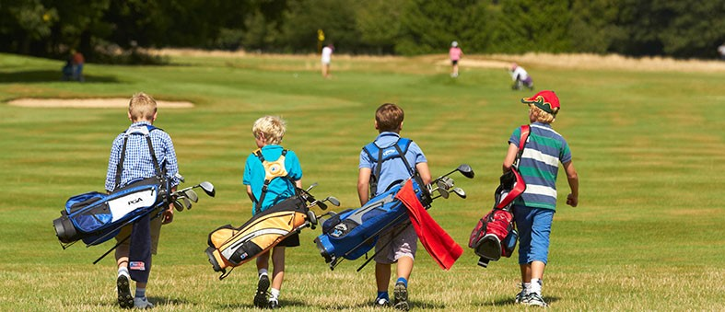 | Benefits  The cost is only $260 per junior and it includes:  - Expert coaching from PGA professionals  - NJGT Registration fees  - Video Lessons  - Opportunity to compete weekly  - Custom Team Jersey & Hat  - USGA Handicap  - 7 Team Practices  - Golf Rules Book  - $10 Golf Play Card  - Bag Tag and much more!!!!   |  | Eagle Hills  Eagle Hills Golf Course has partnered with the Nebraska Junior Golf Tour to deliver this fun and new program to you right here!! By registering at Eagle Hills you will receive expert instruction from our professional team and compete with your friends against other facilities.  The program is being offered for only $260.00  