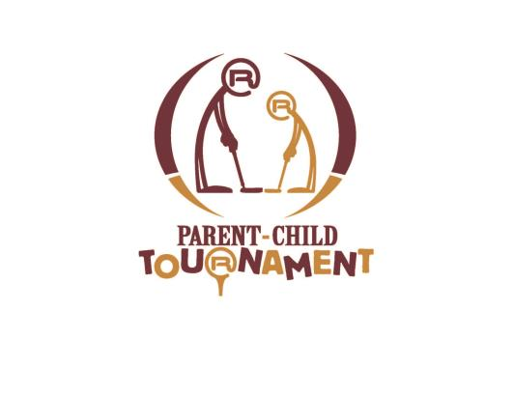

PARENT / CHILD GOLF TOURNAMENT
JULY 7-8, 2018
7:30 / 1:30 SHOTGUN START BOTH DAYS
COST: $130.00 PER TEAM
For entry, complete the form below

Player 1: _________________________ Age: ____ Phone Number: _______________

Address: _________________________ City: _____________ Zip: ____________

E-Mail: ____________________________________

Player 2: _________________________ Age: ____ Phone Number: _______________

Address: _________________________ City: _____________ Zip: ____________

E-Mail: ____________________________________

- Deadline to enter is July 3, 2018 & Payments are non-refundable after July 3, 2018
- Entries without full payment will not be entered into the tournament
- Tournament will be Flighted after the 1st round, your 2nd round tee time will be determined by what flight you are in for day 2.
- For more information go to www.ratliffranchgolfodessa.com or call 432.550.8181

Signature: _____________________________ Date: ______________

Office Use Only:
Payment Type:
Check _____
Cash ______
Credit Card #: ______________________________
Exp. Date: _________ Security Code: ________
PLEASE CIRCLE THE TIME YOU WOULD LIKE TO PLAY
ON SATURDAY:

7:30 AM

1:30 PM

NOTE: SUNDAY’S TEE TIME WILL BE DETERMINED
BY FLIGHT NOT ON WHAT TIME YOU TEE’D OFF
ON SATURDAY

