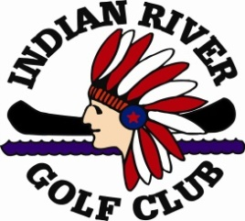 Indian River Golf Club

Give the “Gift of Golf”

The IRGC Board asks all current members to offer this invitation to any friend, neighbor or acquaintance who might be interested in joining “The Friendliest Club in the North.”

The potential member will receive a fantastic first year incentive to try IRGC and the sponsor will also receive a bonus for introducing a potential member to the club. The details are below.

Gift of Golf
1st Year Dues $745 Spouse $355
1st Year Minimum $125 Spouse $125

For the following four years, the Gift of Golf member will pay regular dues and minimums. After 5 years of uninterrupted membership they will receive an Equity Certificate at no cost.

The sponsoring member will receive a $100 account credit for each of the 4 years the invitee remains a member in good standing following the first year.

This is an outstanding opportunity to introduce to potential members all the IRGC has to offer – great golf, great camaraderie and great times.

Please call Corey (231-238-7011) if you have any questions or see the Gift of Golf FAQ in your e-mailed membership packet.

JOIN “THE FRIENDLIEST CLUB IN THE NORTH” TODAY!

