A Novel Method to Facilitate Biodethatching Using Fungal Laccases
Research Progress Report
October 28, 2009
Qingguo “Jack” Huang, the University of Georgia, Griffin Campus

Introduction
The proposed research was designed to explore the feasibility of utilizing extracellular laccases produced by white rot fungi to enhance the biodegradability of thatch. Through the study, we intend to develop the enzymatic pretreatment method that will significantly enhance the effectiveness of biodethatching processes.
Thatch is a layer of organic matter consisting of tightly intermingled dead and living leaves, stems and roots that develop between the soil surface and the green vegetation. Thatch layer intermixed with sand or soil is known as mat layer (Beard 1973). High organic matter accumulation in the form of thatch or mat causes depletion of oxygen, decrease in hydraulic conductivity, and increase in water content (Hartwiger 2004). This further leads to problems like welt wilt, soft surface, black layer, limited rooting etc. (Carrow 2004; O’Brien and Hartwiger 2003).
Lignin, a 3- dimensional amorphous polymer consisting of methoxylated phenyl propane structure, is often regarded as the limiting factor that slows down the degradation of organic matter (Beard 1973). It resists most microbial degradation mechanisms and serves as a barrier in the cell walls to limit the accessibility to the more biodegradable plant materials, such as cellulose and hemicelluloses, by microbial degraders. Oxidative enzymes such as laccases, lignin peroxidases and manganese peroxidases produced by white rot fungi attack the aromatic components of lignin and leads to its effective degradation.
White rot fungi are recognized as the most active lignin degrading microorganisms among few in the nature (Boyle, et al 1992; Gold and Alic 1993). Oxidative enzymes produced by fungi are able to attack the aromatic contents in lignin and produce free radicals, leading to effective degradation of lignin (Nakayamaa and Kamachi 1999). We hypothesize that thatch that has been directly treated with lignin-degrading enzymes will be more amenable for microbial degradation because the lignin barrier that restricts the microbial accessibility has been effectively removed.
Laccases, lignin peroxidases, and manganese peroxidases are enzymes that have been known to be involved in lignin degradation (Nakayamaa and Kamachi 1999). They have been widely studied and used in pulp and paper industry to remove lignin, which serves as strong basis supporting the hypothesis mentioned above. Laccases, the multi copper oxidases are known to act on a wide variety of aromatic compounds by reducing oxygen to water (Baldrian 2006). The capability of degrading lignin utilizing oxygen as well as their strong extracellular activity makes laccases potentially suitable material for bio dethatching.
The proposed research is aimed at verifying the following hypothesis: 1) degradation of organic matter can be enhanced by applying laccase to the thatch layer; and 2) laccase has no appreciable adverse effects on turf quality.
Objectives
To test the hypothesis listed above represents the overarching goal of this study, and this was designed to be achieved in a three phase studies. Phase 1 was a laboratory study aimed to verify the ability of laccase to facilitate the degradation of the organic matter in thatch layer; Phase 2 is a green house study with bentgrass pots to determine the effects of laccase application on thatch layer and on turf quality; Phase 3 will be a field study to evaluate the overall dethatching effect under field conditions.
Progress
Phase 1 study has been completed and reported in our earlier report. Phase 2 study is in progress, and the results that we have collected with this experiment are reported here.
Phase 2 was a greenhouse study started in October 2008. Bentgrass together with 20 cm depth under layer was sampled from a turf field with significant thatch/mat accumulation and divided and placed in 6 inch pots to grow in a green house (25± 2 / 18 ±2 ºC, day/night) at UGA Griffin campus. All the pots were irrigated with 40 ml water every day and fertilized monthly. Laccase is sprayed every two weeks through irrigation water at activity 0, 0.04, 0.4 and 4 units /ml, respectively. The pots irrigated with distilled water containing 0 units/ ml served as controls. The pots receiving 0.04, 0.4 and 4 units/ml were further divided into two groups, one which receives guaiacol along with laccase. Guaiacol is mediator of laccase which is believed to enhance enzyme performance. For all the treatments, twelve replicates were prepared, five of which were sampled during December 2008, about two months of treatment. For the treatment 4 units /ml the samples were only taken during December 2008. The second sampling was made in September 2009.
Physiological performance of each treatment was routinely analyzed by rating turf quality and canopy reflectance. The turf quality was rated on the basis of color, shoots density and uniformity of stand and is given a numerical score, where 1 equals no live turf and 9 equals ideal dark green, uniform grass. Grass index was measured using TCM 500 turf color meter (Spectrum Technologies Inc.). Grass index is based on the color and density of the grass. Canopy reflectance was collected between 400 and 1100 nm wavelengths at 3 nm intervals with a Unispec Spectral Analysis System (PP system , Haverhil, MA). Normalized difference vegetation index (NDVI) is calculated by using canopy reflectance formula (R750-R705) / (R750+R705); with higher value indicating a better green cover.
Thatch layer thickness, organic matter content, lignin content and saturated hydraulic conductivity were measured once during December 2008 for five replications and were measured at the completion of treatments during September 2009 for the remaining replications. Saturated hydraulic conductivity (K_{sat}) of prepared root zone mixes was measured by a constant head using a Marriott tube. Four replications of the root zone mixes were hand packed into the plastic tube of diameter 4.6 cm and sealed with a plastic cap with a liquid electrical tape. The outer reservoir of the Marriott tube was filled with demonized water and the top of the tube was left open to allow the prepared soil columns to saturate. Once, the soil columns were saturated the outer reservoir of the Marriott Tube was caped to maintain a constant head between the outer tube and inner Marriott Tube. Water for the first ten minutes was discarded. Water was allowed to flow for twelve minutes with sub sampling time of three minutes. Two sod plugs, 2.0 cm in diameter, was randomly taken from each pot from five replications, using a golf course cup cutter, to be used in the determination of organic matter. The thatch portion was oven dried at 105 ºC for 48 hours, weighed and then ashed at 600 ºC for 24 hours. Percent organic matter is determined as difference between dry weight and ash weight. Acid soluble and acid insoluble lignin content was determined in the same way mentioned in the previous report for phase 1 study. Organic layer thickness was measured from the edges of the pot with seven replications per pot and then averaging it.
Results
The results for the data analyzed during the initial lab study conducted in summer 2008 and the data analyzed for the greenhouse experiment during December 2008 has been submitted during the earlier reports. The following is the data for the data analyzed at the end of the greenhouse experiment during September 2009.

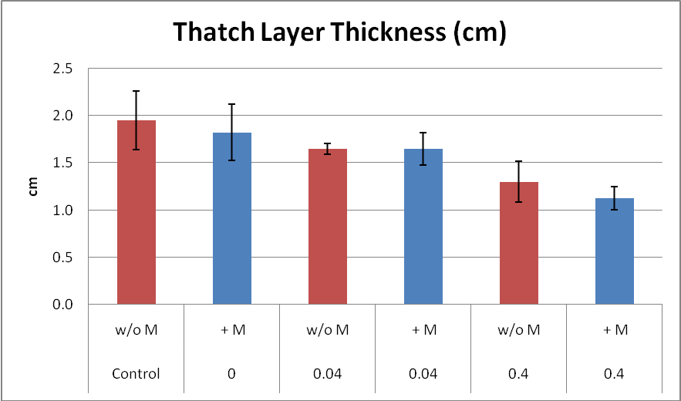
Figure 1. Thickness of thatch layer in pots reciving different tretaments
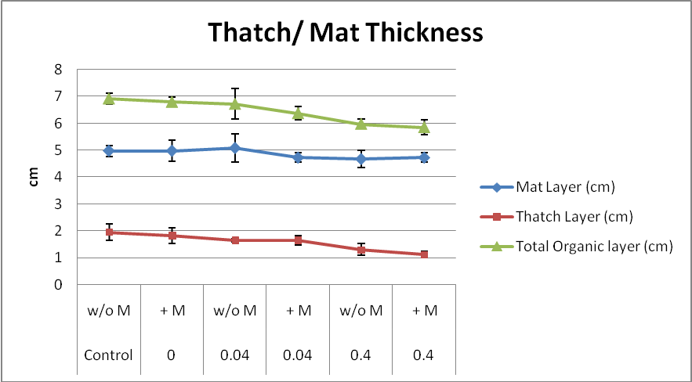
Figure 2. Thicknesses of mat layer, thatch layer and total organic layer in pots receiving different treatments

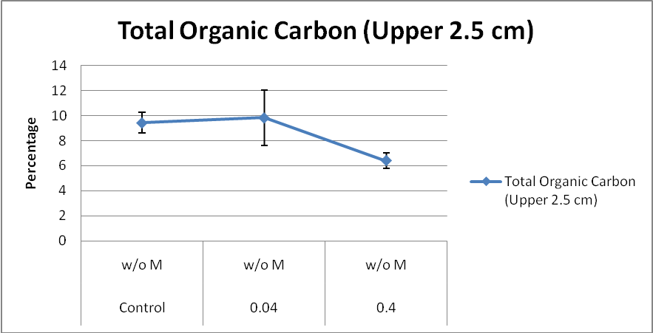
Figure 3. Total organic carbon in pots receiving different treatment without mediator

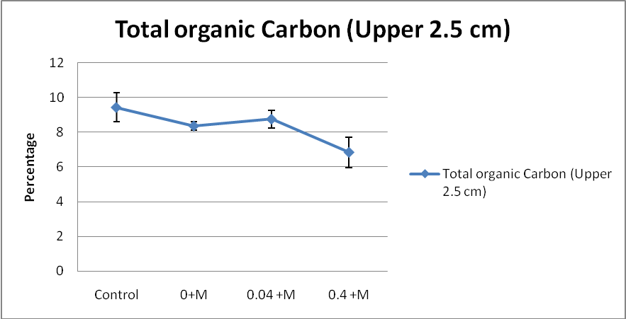
Figure 4. Total organic carbon in pots receiving different treatment with mediator

All four figures displayed above are indicative of the positive effect of laccase in limiting thatch layer build-up. The thatch layer thickness decreases as the dosage of laccase increases (Figure 1), so do the thicknesses of the mat layer and organic layer (Figure 2). The amount of total organic carbon also shows a decreasing trend with increasing laccase dosage, regardless of the use of mediator (guaiacol) or not (Figures 3 &4).
We conducted statistical analysis using SAS. The treatment level 0.04 units/ ml enzyme activity with or without mediator is not significantly different from the control for thatch layer, mat layer, total organic layer thicknesses and total organic carbon amount. The treatments with 0.4 unit/ml enzyme activity (with or without mediator) however show significant differences at 1% level of significance as compared to control and 0.04 units/ml enzyme activity for all major indicators (thatch layer, total organic layer thickness and total organic carbon). The total organic carbon decreased 32.1 % in comparison to the control, and thatch layer thickness decreased 45 % as compared to control. We are still in the process of measuring saturated hydraulic conductivity and lignin content, and the data will be reported in future report. Nonetheless, our results strongly suggest that the use of laccase effectively reduces the buildup of thatch layer, which has a great potential for golf course application.
Reference
Beard, J.B. 1973. Turfgrass: Science and culture. Prentice Hall Inc. Englewood Cliffs, NJ.
Hartwiger, C. 2004. The importance of organic matter dynamics: How research uncovered the primary cause of secondary problems. USGA Green Section Record 42(3): 9-11.
Carrow, R.N. 2004. Surface organic matter in bentgrass greens. Golf Course Mgt. 72(5): 96-101.
O’Brien, P., and C. Hartwiger. 2003. Aeration and topdressing for the 21st centuary: Two old concepts are linked together to offer up-to-date recommendations. USGA Green Section Record 41(2): 1-7.
Boyle, C. D, B. R. Kropp and I. D. Reid. 1992. Solubilization and mineralization of lignin by white rot fungi. Applied and Environmental Microbiology 58 (3): 3217-3224.
Gold, M. H. and M. Alic. 1993. Molecular biology of lignin-degrading basidiomycete phanerochaete chryosporium. Microbiology and Molecular biology reviews. 57(3): 605-622.
Nakayama T. and T. Amachi. 1999. Fungal peroxidases: its structure, function and application. Journal of Molecular catalysisB: Enzymatic. 6(3): 185-198.
Baldrian, P. 2006. Fungal Laccases- occurance and properties. FEMS Microbiol. Rev. 30: 215 -242.

