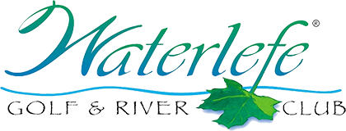

Current 2020 Reciprocal List

7 Days Charlotte Harbor National Before 8:30 -$30/After 9:00 - $37
7 Days Esplanade G & CC Reciprocal - $35
5 Days Feather Sound Reciprocal - $45
7 Days Heritage Harbor GC Reciprocal - $25
3 Days Heritage Oaks G & CC Reciprocal - $35
4 Days IMG Golf Club Reciprocal - $30
7 Days Jacaranda West CC Reciprocal - $25
7 Days Lakewood National Reciprocal - $39
1 Day Laurel Oak CC Reciprocal - $50
7 Days Legacy Golf Club Reciprocal - $32
3 Days Longboat Key Club Reciprocal - $46
7 Days Misty Creek GC Reciprocal - $28
4 Days Pelican Point G&CC Reciprocal - $29
4 Days Peridia G & CC Reciprocal - $24
3 Days River Strand G & CC Reciprocal - $34
7 Days Rosedale G & CC Reciprocal - $25
1 Day Sara Bay CC Reciprocal - $47
7 Days Serenoa Golf Club Reciprocal - $26
2 Days Tara G & CC Reciprocal - $37.50
3 Days University Park CC Reciprocal - $32
7 Days Venetian G & RC Reciprocal - $39

*Please Call Waterlefe Golf Shop To Make Starting Times*

