NGCOA Mid-Atlantic Announces 2022 Award Winners
Hodson, Hermitage, Williamsburg National, Magnolia Green Honored

For Release Wednesday, November 2nd, 12 Noon

Mid-Atlantic Golf Leader Award – Peter Hodson, PGA

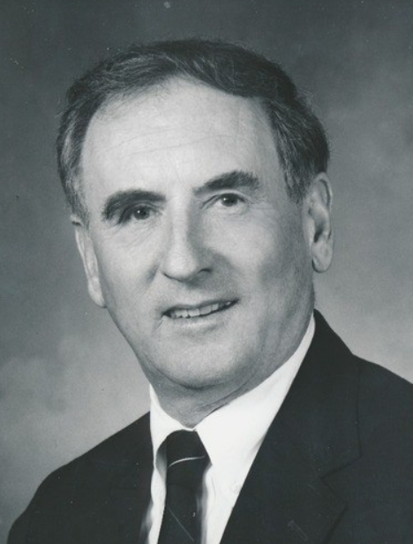
Peter Hodson, PGA (1937-2022)

In recognition of leadership and long-term service to golf in the region, Peter Hodson has been named the 2022 Mid-Atlantic Golf Leader by NGCOA Mid-Atlantic. Hodson was a decorated PGA Professional passionately serving his clientele for many years at Mid-Atlantic clubs. He passed away in 2022.

Born in England, Peter was a member of both the PGA of America and the British PGA. Peter’s expertise in teaching and more accurately determining the benefits and weaknesses of an individual’s swing/club profile was infallible. Apart from being a Professional Golfer for over 65 years, Peter played at most of the top courses around the world and was a member of the Dewar’s Hall of Fame, and past president of the Middle Atlantic Section of the PGA. Peter has received numerous awards and honors including the 1994 PGA Presidents award, 2-time recipient of The Bill Strausbaugh Club Relations Award, and the 1984 Professional of the year award. Peter dedicated his life to his family and the grand old game of golf. He was a coach, teacher, and in retirement volunteered a large portion of his time with the “Links to Freedom” Foundation's Rehabilitation Golf Program at Fort Belvoir.

Peter came to the US from England in 1961 with his wife, Georgena. He worked as the Golf Professional at the Williamsburg Country Club until 1964, then he and his family moved to Richmond when he took the position of Assistant Golf Professional to Jack Isaacs at Willow Oaks Country Club. In 1971, Peter assumed the role of Head Golf Professional, which he proudly served in until 1989. His chosen path from that day forward was golf course construction, re-construction and management, with numerous accomplishments along the way. Peter's philosophy on life could be best summed up as follows: "Life should not be a journey to the grave with the intention of arriving safely in a pretty and well-preserved body, but rather to skid in broadside in a cloud of smoke, thoroughly used up, totally worn out, and loudly proclaiming Wow! What a Ride!"– Hunter S. Thompson.

Peter was in the Royal Air Force and came over to the US on the Queen Elizabeth II. Peter had ties to Willow Oaks, Rivers Bend, Birkdale among others and was a consultant with Acumen Golf. He was at Lemon Bay Club in Florida when he officially retired. Peter was an amazingly kind and generous person.

Private Golf Leader Award – Hermitage Country Club
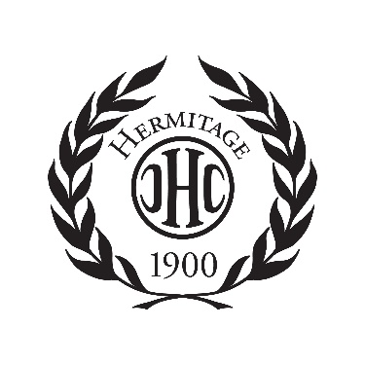
Hermitage Country Club of Manakin Sabot, VA has won the NGCOA Mid-Atlantic’s 2022 Private Golf Leader Award, recognizing a private club for outstanding business success and the promotion of golf in the Mid-Atlantic (VA, MD, DC).

Home to two 36-hole championship courses, the Hermitage membership has reached capacity and there is a waiting list. The recent Manakin Course renovation continues to get rave reviews and now the club is continuing their improvements with a renovation of the Sabot Course this fall, replacing irrigation and installing new Pure Eclipse greens. Another key element in their business operation was the retention of employees during COVID. The club is now expanding outdoor dining facilities with enhanced water views of the Sabot Course. Hermitage is also an Audubon Cooperative Sanctuary Course, boasting tons of wildlife while implementing sustainable practices.

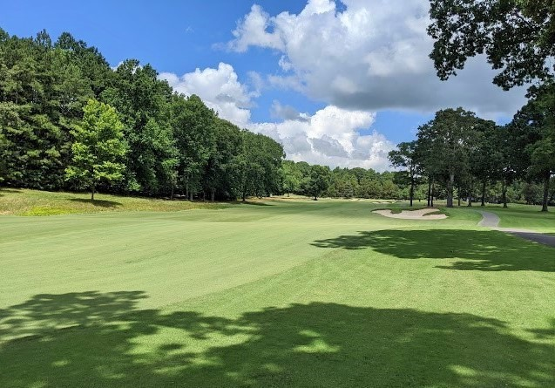
Hermitage’s Manakin Course featuring Latitude 36 fairways

Historically, the club was formed in 1900 and was a founding member of the Virginia State Golf Association. Hermitage members were instrumental in the founding of the Country Club of Virginia in 1906, as well as The Foundry GC in 1991 and Kinloch GC in 2000. It is the only club in Virginia to have hosted a major championship, the PGA in 1949, won by Virginia native Sam Snead. It is also home to Arnold Palmer’s last victory, The Crestar Classic in 1987. Hermitage has hosted a top invitational since 1934, The Valentine.

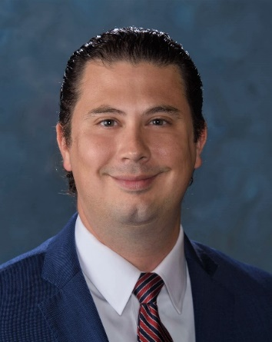
Stephen Burkhart, Hermitage CC GM

Public Golf Leader Award – Williamsburg National Golf Course
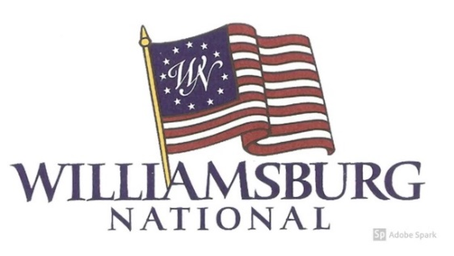
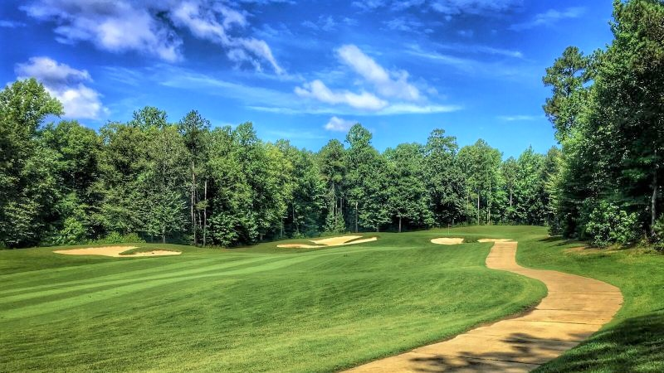
3rd Hole, Yorktown Course, Williamsburg National Golf Course

When the original developers of Williamsburg National were facing bankruptcy, the private noteholders took back the club from the previous owner/operator. They retained PGA Professional Chris Hartig with Carlton Hospitality to manage the facility. The club was unkept and not been properly maintained in several years.

In general, every area of the property needed to be upgraded or renovated. Improvements made included:

o The Jamestown course greens were re-surfaced with Champion Bermuda.
o The Yorktown course’s A1/A4 bent grass greens were nursed back to life.
o A new pumpstation and irrigation control system were installed.
o Bunkers were refurbished along with deferred tree work.
o The clubhouse was renovated from the restaurant to the golf shop, including new bathrooms.
o These initiatives have grown golf rounds from 19,000 to 41,000 annually and the Golf Club revenues have grown from approximately 1 million dollars to 3 million dollars annually.

The club had only 54 memberships when Chris and his team took over. They immediately sought feedback from the current members and put in place a completely revamped membership program. Today Williamsburg National has 280 memberships with over 350 members and is still growing at a steady pace. This is due in large part to the welcoming spirit of the club from staff and club membership. The revamped members event schedule also proved very successful as over 25% of their membership participate in the Club Championship, over 200 members participate in their annual “Revolution matches “and a member’s “Winter Tour,” launched in 2020 with over 100 members participating in the winter.

Hartig and the WNGC team completely reimagined the Food and Beverage experience. First, the restaurant was rebranded as the “1607 Grill”. named for the historic year the first permanent English settlement in America at Jamestown. Second, due to the club’s close proximity to many residential housing developments, plans were put in place to grow the F&B business for golfers and non-golfers alike. Serving breakfast, lunch and dinner, the 1607 Grill has also become a dining hub for the Williamsburg community. This year Food and Beverage revenues will come in close to $900,000 and is a profitable component of the club.

The club is embedded in the middle of several communities with hundreds of kids. Williamsburg National saw this as an opportunity to provide an affordable junior membership to kids interested in golf, giving their families an affordable opportunity to for their kids to learn the game. Cost is just $365 a year, which includes range and walking privileges. Also, in addition to a robust schedule of charity events, WN now hosts many prominent VSGA tournaments and hosted several public and private high school state championships.

All of these initiatives, along with a constant focus on service, have enabled Hartig, General Manager JR Powell, Golf course Superintendent Jay Long, Claudia Ferrini PGA/LPGA Head Golf Professional and Grant Smith with Operations, and the WN team to restore Williamsburg National’s reputation as an excellent golf and dining experience for members and guests in the Williamsburg destination.

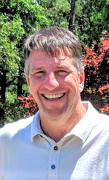
Chris Hartig, Williamsburg National

Sustainability Leader – Magnolia Green Golf Club

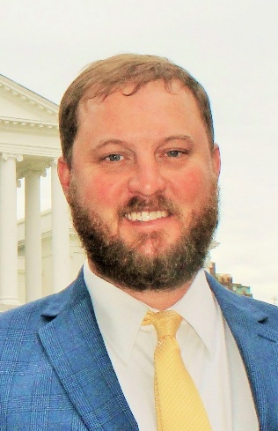
Jay Wade

The NGCOA Mid-Atlantic’s newest award is the Sustainability Award, recognizing the ability to incorporate sustainability and environmental stewardship into operating practices. Magnolia Green GC is the 2022 honoree, in recognition of their focus on environmental stewardship. Jay Wade, Superintendent at Magnolia Green, accepted the award.

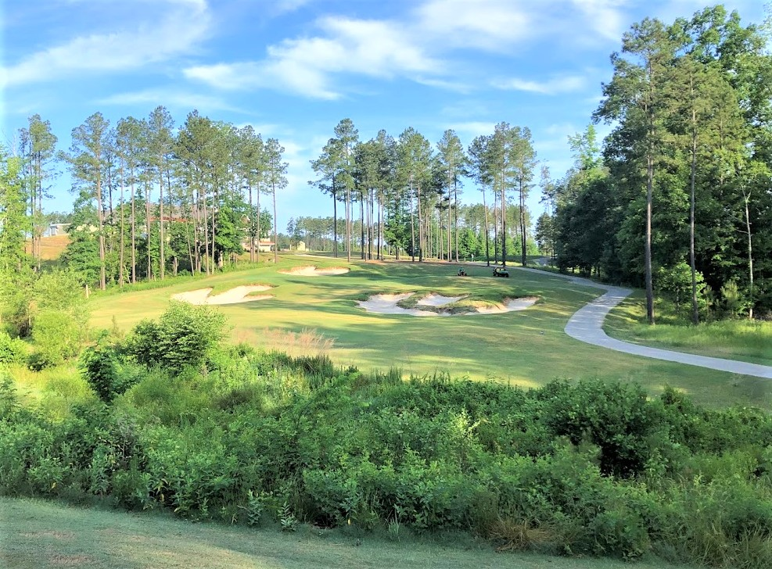
Vegetative Buffers on Hole 18

In 2012 Magnolia Green became a certified Audubon Cooperative Sanctuary. As part of the process, superintendent Jay Wade developed a written environmental plan, protecting native wildlife areas, shoring up creek banks, and regularly testing water. He promoted the certification to inspire others. He established water source filters, limited fertilizer and pesticide use and sought to protect pollinators.

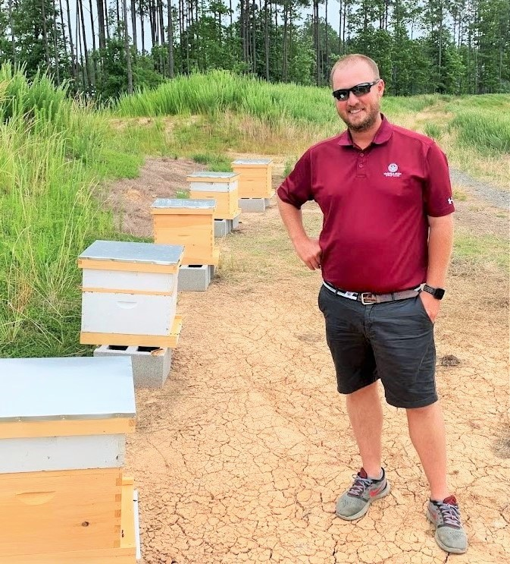
Jay Wade shows off the club’s beehives.

In 2019 Jay embarked in a beehive project and has begun harvesting honey. In addition to the hives, he supports pollinators with new plantings of wildflowers and milkweed. He also adopted a “firm and fast” philosophy for play, which saved water. There are tons of wildlife on his course, including all types of birds, deer, turkey, bald eagles, Bufflehead ducks, black bear, coyote, and fox. The bird list also includes bluebirds, purple martins, ospreys, herons, loons, egrets, Red Tail hawks, hummingbirds, mallards, jays, robins and sparrows.

