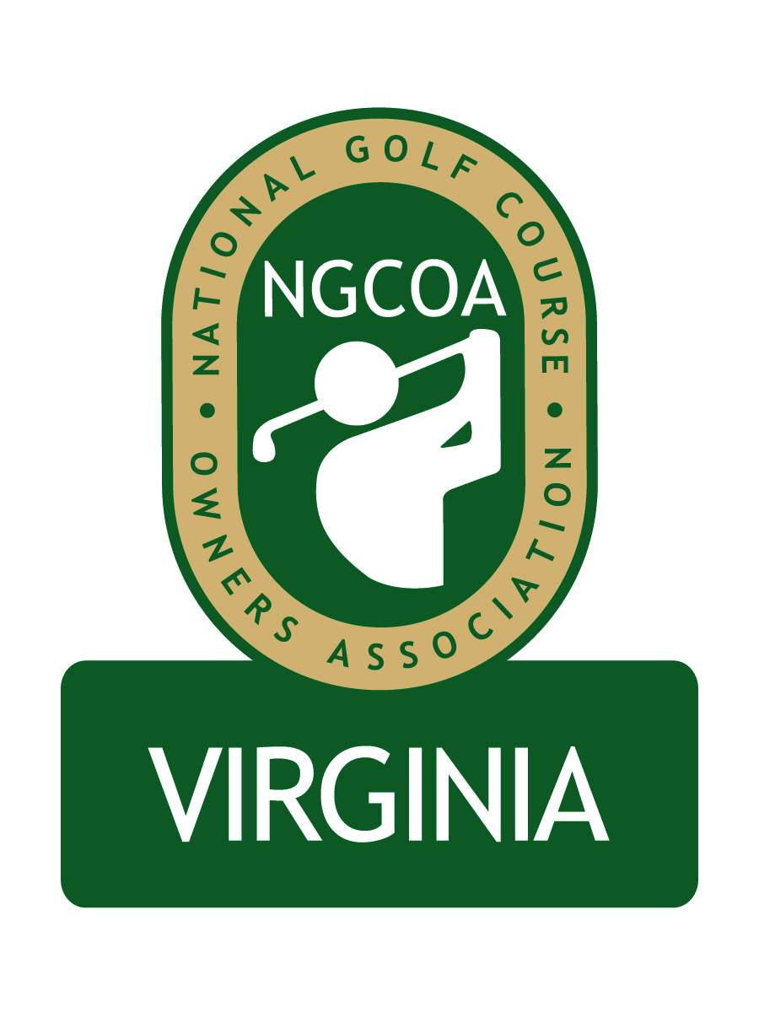
NGCOA Virginia Board Conference Call
1:30-2:30 p.m., Thursday, January 14, 2010

Agenda

Call to order – Roll Call

- Approval of Minutes

- Corporate Filing Update - IRS nonprofit filing, bank account, accounting system

- Executive Director’s Report – Budget Review, management agreement, D&O insurance

- Membership Initiative

- Spring Event – speakers, date, venue

- Industry Partner Program – concept; partner benefits (printed directory to house ads?)

- Government Relations – VGCSA BMP initiative (Rounds4Research)

- National Conference Update

- 2010 Golf Market in Virginia – general projections

- Old & New Business – Davis Garvin, future meetings, VTC show, Virginia Golf Council meeting (& E.D.)

- Adjourn

Conference Call instruction
Tollfree | Participant code
800-505-4464 | 291483

