Private Golf Leader Award – Cedar Point Country Club

Everyone loves a good story of redemption and the one involving Cedar Point Country Club in Suffolk, VA is one of the best. After the recession of 2008-09, the club teetered on bankruptcy when the bank called a multi-million dollar note. But a group of members formed in 2011 to save the club and now it is flourishing as NGCOA Mid-Atlantic’s Private Golf Leader for 2019. It’s an amazing story!

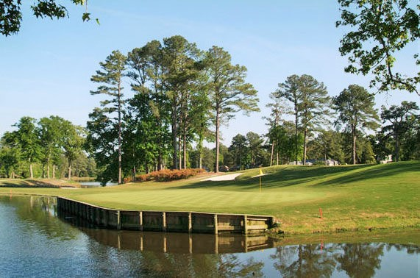

In 1964, the Cedar Point Club opened, serving golfers in a beautiful setting, and with it came the opportunity to purchase homes alongside the fairways and greens. The namesake cedar trees were planted on fairway perimeters as a buffer to the course. There was not a lot of competition for years to come.

Then in the mid-1990’s the National Golf Foundation, proudly and incorrectly proclaimed that golf was booming and that we needed to open a new course every day to keep up with demand in the US. By the end of the millennium, Riverfront GC, Cypress Creek GC, and Nansemond River GC opened nearby, while Elizabeth Manor went through an extensive renovation – competition was fierce, and Cedar Point hit the 35-year mark with virtually no updates to the club or course.

Still, the club was a regional favorite, and they regularly hosted VSGA events, where low scoring was always at a premium. The reason was the namesake cedars, which grew down to the ground, creating lost balls and unplayable lies. The super-fast greens were also a contributor.

Ultimately the club decided on a much-needed renovation, which took place in 2003-04. Remarkably, the club did no capital funding, choosing to borrow $5 million. It was a “build it and they will come” mentality, and it worked…for a while. Of course, behind the scenes, few knew that part of the debt was in place to cover over multiple years of operating losses in excess of $300K annually – in fact, $1.3 million was specifically for that. They simply did not balance the operating budget.

The club had good and not-so-good swings through the mid-2000’s, but then the recession of 2008-09 hit. In 2011, with the club challenged to meet its obligations, the bank called the note. It was do-or-die time, with a declaration of bankruptcy looming.

But that’s when private equity professional and club member Cameron Robinett developed a viable rescue option. He knew they needed capital fast, and he re-organized the “Friends of Cedar Point Country Club” group and set his sights on raising $3 million. Shares of the new ownership group were sold for $5,000 each, and 112 members signed on, raising enough capital to pay off the bank, purchase the assets of the club, make modest capital improvements, and have sufficient working capital for a minimum of five years. They immediately focused on operating efficiency, and an early move was to become more nimble, shrinking the board size from 15 to 7 and eliminating committees. Even more importantly, the board was populated with subject matter experts in various club fields: finance and accounting, facility maintenance, food and beverage, land management, and marketing. Initially, the new ownership group made a commitment to run the club for five years.

The group turned the ship around and balanced the budget. At the five-year mark in 2016, they considered (1) selling the club, (2) hiring a management company, or (3) retaining it and making a long-range plan. They chose the long-range plan after unanimously rejecting the sale option.

They set up a Vision Task Force to identify strengths and weaknesses from a membership perspective. The study took a year, following extensive surveying of the members and of modern club trends. At the start of 2018, a resolution was passed to tackle nine major projects. They did their homework, getting prices for each project, then they put it to the membership to rank them in priority order. Their plan was to finance this through a new monthly capital improvement fee in addition to dues. Knowing that normal club attrition is 8%, they conservatively budgeted for a 20% membership loss (120 members), but due to the appeal of the plan, they actually lost only 40 members. (In 2011, there were 375 members – now there are 600!)

The capital plan was so comprehensive, that it had to be divided into Phase I and Phase II. Phase I just broke ground early in September, 2019 on the first project, the development of sports/aquatics complex, including doubling both the pool size and decking, adding a standalone indoor/outdoor dining outlet, and adding a childcare area, set to open April 30, 2020. Subsequent Phase I projects are (2) a bunker, bulkhead, and bridge re-do, (3) tennis building renovations, and (4) clubhouse renovation, including the lobby, restaurant and kitchen, following a trend to more casual dining. Phase I will continue through Q1 2021.

Later Phase II projects still under consideration are: (1) pro shop expansion, (2) locker room re-do, (3) golf performance center (4) outdoor deck off back of clubhouse, and (5) terrace off south end for banquet events.

On the operations side, the club took over ownership of the pro shop, with profit-sharing for the golf staff. There is an obsession to avoid any operating deficits, and since 2012, they have hit or exceeded budget six out of seven years. They learned from the past to run a tight ship. They continue to grow in membership, but they are constantly monitoring pace of play and tee time availability to ensure a great member experience. Rounds are up about 20% with round times remaining at 4 to 4 hours, 15 minutes even on highly popular, busy Saturday mornings.

An interesting footnote to the project approval was a commitment to staff buy-in. Robinett met with the staff in March, 2018, and told them that ownership would not proceed with the capital projects without 100% buy in from the club’s day to day operators. They all enthusiastically bought in and are as excited as the members as to what’s to come.

Also interesting is the club’s stance on outings. They do not actively seek them, but members who support charitable causes can host an outing. That drives a strong connection to community service, as the limited access tends to make charitable events more lucrative. In 2019, net charity proceeds from events hosted at CPCC events are projected to exceed $400,000. All money that goes directly back into the community.

“It’s a real honor to win this award,” said Club President Cameron Robinett. “It’s a testament to the dedication and hard work our board, members, and management have done over these last eight years. Despite some rocky times, we’ve managed to hang around for 55 years. Our focus is, should be, and will continue to be on the ever evolving desires of our membership to ensure we’re around for another 55 years and beyond.

