Mid-Atlantic Golf Leader Award – Mike Cumberpatch

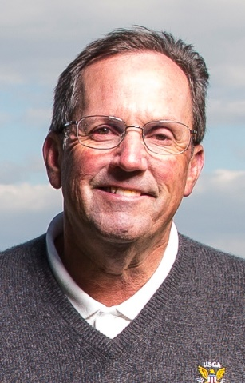

In recognition of leadership and long-term service to golf in the region, Mike Cumberpatch of Annapolis, MD has been named the 2019 Mid-Atlantic Golf Leader by NGCOA Mid-Atlantic. Cumberpatch currently serves as the Executive Director of both the Middle Atlantic Golf Association and the Washington Metropolitan Golf Association, as well as volunteering for the USGA for over 25 years.

You might say golf is in his blood, as Cumberpatch is the son of golfing parents – his Dad was a casual golfer as a US Air Force Officer, and his mom was an accomplished 7-handicapper. Growing up in Bethesda, his first exposure to golf was playing on old sand greens at Sherwood Forest in Annapolis, where the family would go during the summer. He also caddied for his mom, as well as other good players who inspired him to pursue the game.

In 1976 Cumberpatch graduated from American University in DC, where he played on the golf team. His first job was working with his dad in a consulting business offering training in project management. In 1977 he moved to Annapolis and joined the US Naval Academy Golf Club for an initiation of $400 and monthly dues of $28. He remains there as a member today.

After working with his Dad for 13 years, he got married and took a job in the mortgage business and continued to play at USNA GC. And while the club was a founder of the Maryland State Golf Association in 1921, it had dropped its membership, so Cumberpatch was not eligible for state events. So instead he played a lot of invitationals and amateur events, including the British Amateur, the Western, the Eastern, Kenridge and more. Finally his club rejoined the MSGA in 1983, and he then played state events as well.

In 1990, Cumberpatch played in the Middle Atlantic Amateur at Woodholme, a very tough golf course. There he met Joel Kaye, who took a liking to him. A year and a half later, Kaye invited him to join the Board of the MAGA, and he came on in 1992. That same year, while playing in the MAGA Am, he met Jim Farrell of the USGA. Farrell was looking for a younger guy to come onto the USGA Regional Affairs Committee. Almost simultaneously, Cumberpatch went from simply a player to being a trusted leader with two respected golf organizations.

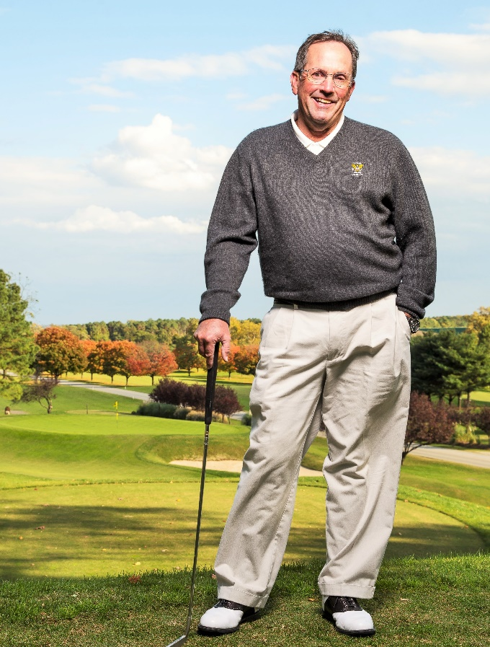

Cumberpatch advanced through the chairs of MAGA, taking the reigns as President in 2001. Along the way, his involvement with the USGA grew. Farrell tapped him to work the Locker Room Committee at the 1995 US Open at Shinnecock Hills. That led to making the acquaintance of Gene McClure, who moved him over to the TV Escort Committee, working with cameramen working the US Open. In all, he worked 11 US Opens and five US Senior Opens. “We had a lot of fun,” he remarked, “but we worked our butts off!”

After his MAGA Presidency, he became the Historian for the association, which was formed in 1902. His role as Chairman of US Open Sectional Qualifying at Woodmont Country Club began in 1999, and he remains involved today.

Cumperpatch was a devoted volunteer for MAGA for many years, but in 2015 he was tapped for service as a staff member. Randy Reed retired as Executive Director of both MAGA and the Washington Metropolitan Golf Association. Tom Koerber of WMGA recruited him, as did the MAGA Board, so in December 2015 he took on a major role. Originally it was to be a three year commitment, but it was extended, and he has agreed to stay on through 2020. In the summer, the hectic schedule requires about 100 hours a week!

So Cumberpatch is now among the best tournament administrators in the region, but his interests are much broader. Special Olympics is a program he holds dear – his brother has Downs Syndrome. He was able to engage the golf associations in the program, and he also started a special service of offering qualified rules officials to work high school events at no charge. Other programs he supports include Wounded Warrior and First Tee. More recently, he organized a rules committee for the Big Ten Golf Championship at Baltimore Country Club.

Among his mentors, Cumberpatch credits Clyde Luther, the former VSGA Rules Chairman who worked over 100 USGA Championships. He also cited Dick Johns, former MAPGA Executive Director. He also recognizes the many superintendents in the region, who have worked with him on events.

“It’s pretty cool to be recognized by the golf course owners, who are behind the scenes,” Cumberpatch remarked, on hearing news of the award. He and wife Lynn have two children, Kate (24) and Christopher (21).

