Public Golf Leader Award – Montgomery County Golf

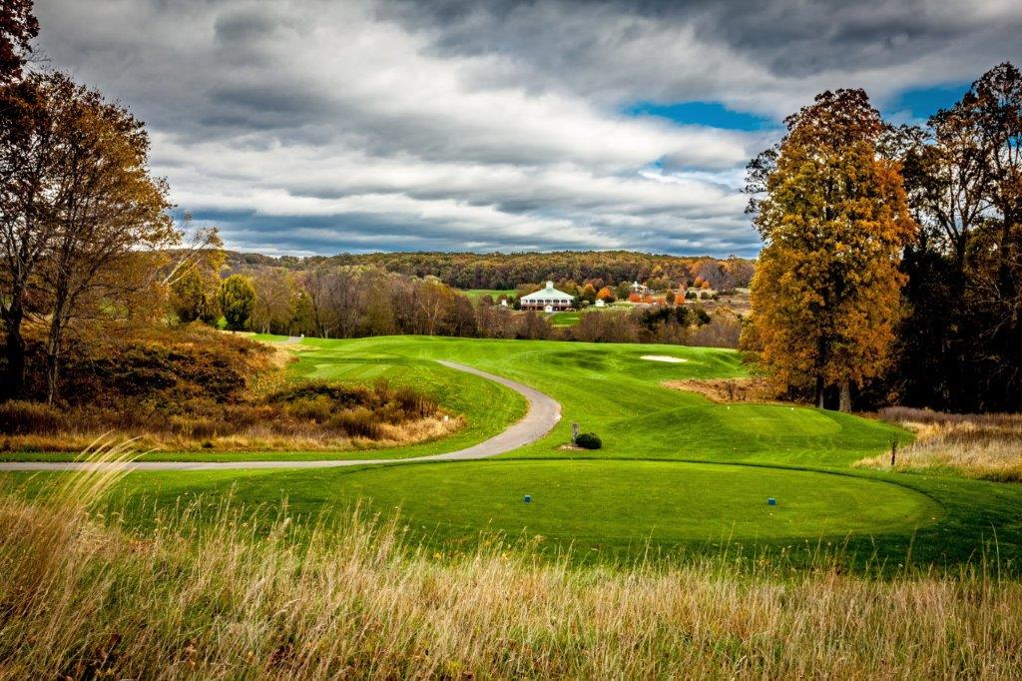
Hole #9, Little Bennett GC

Montgomery County Golf (MCG), based in Rockville, MD, has won the 2019 NGCOA Mid-Atlantic Public Golf Leader. This award recognizes programs executed by public facilities to promote golf in the region. This diverse and unique organization manages nine public golf courses, offering a myriad of services to golfers of all types in the region.

There may be no peer in the US from the standpoint of having nine courses so tightly connected like MCG is. There are long, tough courses and short, fun courses. There are parkland-style courses and others featuring rolling hills. The courses are Falls Road, Hampshire Greens, Laytonsville, Little Bennett, Needwood, Northwest, Poolesville, Rattlewood and Sligo Creek.

Keith Miller, PGA heads the operation as CEO of the Montgomery County Revenue Authority (MCRA), but Miller’s responsibilities with the MCRA go beyond just golf, so he is quick to praise his department heads – Wayne Rohauer (Golf Operations), Jon Lobenstine (Agronomy) and Mike Kenny, PGA (Golf Instruction). Having a centralized management style ensures consistency, as well as efficiencies in buying programs. This also helps in employee training and food and beverage management.
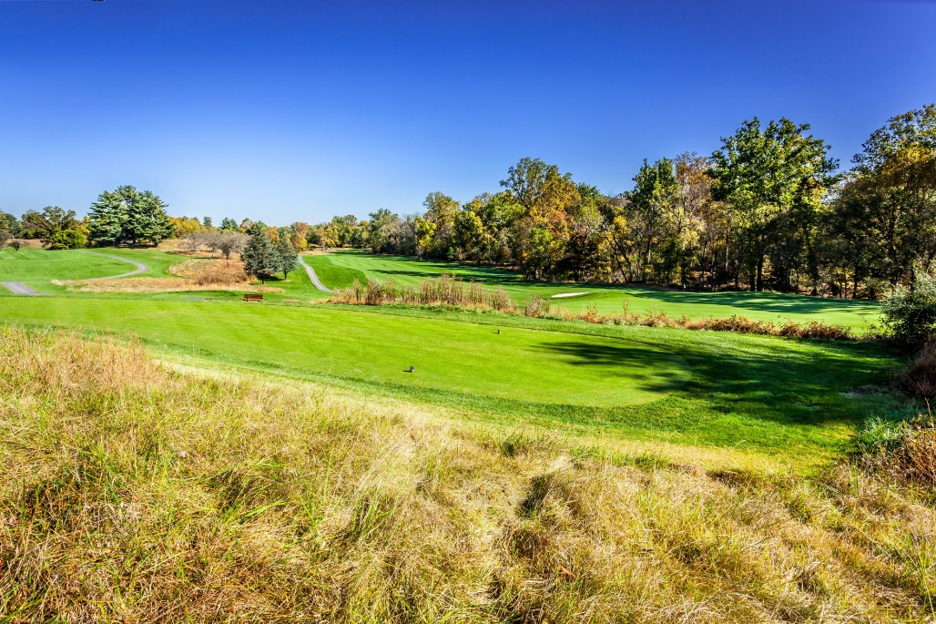
Hole 6, Northwest GC

The MCG team is constantly studying customer preferences by analyzing data and occasional surveys. Since all courses are reasonably close to each other, one particular program can draw customers from multiple courses, like the music concerts at Sligo Creek, where 300-400 people may attend). They have traditional golf events like club championships, but they also seek to appeal to millennials with events like night golf, FootGolf, cross country golf, “100 yards and in” and an “All Sports Battle,” where the game includes elements of football, softball and fling golf. They even offer a “Wine and Paint” program and cooking classes!

MCG enjoys the benefit of group marketing to all customers for all courses. And they can target their marketing according to individual customer interests. They also utilize social media (Facebook and Instagram) regularly with a centralized staff member overseeing all courses. They have their own mobile app, which includes ordering food, and they are working to add an online payment feature. Soon they will test a kiosk system, which could allow for self-check-in, eliminating long lines in the pro shop.

MCG is also monitoring social trends, featuring wine and craft beer tastings. They are totally relaxed in dress code, too. While most players dress in traditional golf attire, sometimes players will wear blue jeans or a t-shirt, which is okay. They have no problem with customers playing music, so long as it’s not so loud to disturb others.

They are up on technology, using dynamic pricing software, which monitors such variables as day of week, time of day, tee time supply and other variables similar to hotel or airline programs. They also sell a “Player’s Pass” for discounted golf fees and merchandise, as well as various membership offerings including unlimited golf. Different levels meet the varied needs of players, depending on how much they play.

For instruction, the MCG Golf Academy is headed by Mike Kenny, PGA, and a big focus is on junior golf. They offer camps, clinics and individual instruction to juniors appropriately grouped by age and skillset. They also have a junior tour at the nine courses. The MCG Golf Academy caters to all ages, abilities and skills.

Wildlife abounds at MCG courses

When it comes to golf course maintenance, they understand that good conditioning is essential. “We have a great team of superintendents,” said Miller. Jon Lobenstine heads the agronomy department, and focusing on environmental stewardship using Best Management Practices. They also work with the University of Maryland to do Turfgrass research on their Needwood course.

While MCG is essentially a municipal operation, Miller highlights a key difference – they get NO subsidy or financial support from taxpayer dollars. Instead, they must stand alone and make sure they hit financial goals. “One key to our success,” said Miller, “is the embracing of our core values – Do Anything Attitude, Genuine Smile and Deliver Excellence. The customers get such a great experience at our facilities.”

“This award means so much to us,” said Miller. “It’s a testament to the hard work of our MCG team.”

