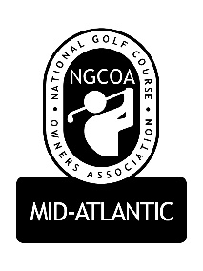

NGCOA Mid-Atlantic Board Annual Meeting
Monday, September 28, 2015

Minutes

Mike Bennett called the business meeting of NGCOA Mid-Atlantic to order. The only business was the election of the Board for 2015-16.

The Nominating Chairman presented the following slate of Directors for the NGCOA Mid-Atlantic Board for 2015-16:

Mike Bennett, President – Traditional Golf Properties
Bob Swiger, Vice President – Raspberry Golf Management
Glen Byrnes, Secretary/Treasurer – The Golden Horseshoe
John Anderes, Director – Queenstown Harbor Golf Club
Damon DeVito, Director – Affinity Golf Management
Mike Fentress, Director – Virginia Beach Golf Management
Joel Gohlmann, Director – Billy Casper Golf
Mike Hatch, Director – Acumen Golf
Joe Hills, Director – Blue Mash Golf Club
Jonathan Ireland, Director – Kinloch Golf Club
Keith Miller, Director – Montgomery County Revenue Authority
Rick Rounsaville, Director – Bulle Rock

There is one open position, which will be left for the board to fill.

Mike Bennett has for any other nominations to the Board of Directors.

As there were none, a motion to accept the slate presented by the Nominating Committee was made and seconded. The motion was approved.

The business meeting of the association was adjourned.

