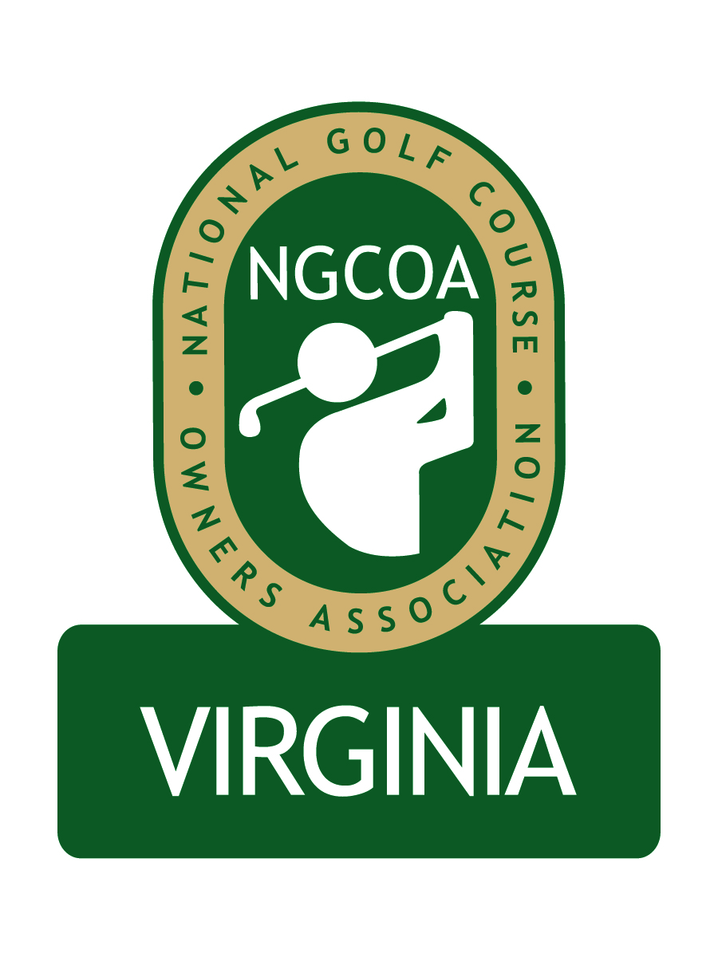

NGCOA Virginia Board Conference Call
Tuesday, August 23, 2011

Minutes

Attendance – Mike Bennett, Bob Swiger, Glen Byrnes, Mike Fentress, Rob Waldron, David Norman, Mike Hatch

The meeting was called to order at 10:05 a.m.

Roll Call of Participants

The meeting began with a roll call of participants.

Treasurer’s Report

Norman gave a short Treasurer’s report. Bennett reviewed the goal of creating approximately $20,000 in new revenues to ensure chapter sustainability.

Annual Event

Participants discussed the format, proposed speakers and vendor opportunities for the upcoming NGCOA VA Annual Meeting on Monday, October 17th at Hermitage Country Club. Swiger thought the previous speakers were very informative with timely topics. Waldron and Fentress agreed that it was important to have excellent speakers. Hatch thought the format was good and that we should look at pricing and promotions to create revenue, including a raffle for donated golf balls or a 50-50. Norman noted that he met with Performance Food Group, who is interested in a sponsorship and a food donation for the reception. The idea of a table top trade show during lunch was discussed, and Hatch suggested a fee of $100. Another version of this idea is to have each lunch table sponsored, with the sponsor’s logo on each table. Swiger suggested a possible raffle of a one-year club membership, which led to a discussion of an online auction between Thanksgiving and Christmas.

The pricing structure continued, with the suggestion that the price would be $400 for a foursome, and if a sponsor wanted a table, it would be $500. A goal is to get more daily fee courses with individual owners to attend. Our goal should be 80-90 attending. Bennett asked board members to commit to making a few calls to clubs in their region to boost attendance. Swiger acknowledged that the fall is a busy time at the end of the season. Bennett said that our date is set, and he suggested that board members might invite vendors or representatives of other clubs to play on their team.
On the topic of speakers, Hatch suggested a representative from NGCOA, perhaps Mike Tinkey who is an expert on third party resellers. Bennett noted that the in-house presentations by board members the first year were very good. Waldron said Billy Casper is not available, but he also likes Bob Rotella, Alex Miceli and John Feinstein. Norman mentioned that Grant Grayson, NGCOA VA General Counsel, offered to speak on the current status of the golf market. Hatch said we need to be specific on the topics we want to hear. Bennett said Grayson is good speaking on club transition. Bennett likes Jim Koppenhaver of Pellucid Corp., who provides a fresh look at the golf business, but he noted that we would incur expense in getting him from Chicago to Richmond. Hatch suggested Gary Strohl of Pinehurst, whose topic is affordable golf. Hatch also recommended a spokesman from Club Link in Canada who specializes in cluster marketing. Norman mentioned that he had contacted Jim Baugh, a noted consultant helping with the “grow the game” initiative, but he was unavailable on our meeting date. The group decided that there should be one business presentation, one entertaining presentation, plus a NGCOA update. Norman, Bennett and Hatch volunteered to contact top prospects and report back on availability and cost.

Partner Program

Bennett began the discussion citing that NGCOA’s generous support of our chapter is phasing out after October this year, noting the goal to develop $20,000 of sustainable revenue through various means. He notes that we are currently running an efficient operation which is low cost. Currently we have nine corporate partners. Fentress suggested that sponsorships should be for multiple events as a package. Norman cited the current sponsorship levels (ranging from $500 to $4,000), and Hatch said he thought they were OK. Hatch suggested that each board member should identify their top five vendors (by $ volume) and target them for sponsorship. He suggested that board members should call their vendor and encourage them to participate, then introduce David Norman as the contact – once contact is made, they should notify Norman to allow for a timely response. Hatch believes we can gain support through the maintenance area as well. He suggests a well-drafted letter to vendor prospects, introducing the sponsorship opportunity. He asks all board members to send their “short list” to Norman (including name, company, phone and email). Waldron cautioned that we cannot go to the well too much. Hatch and Waldron discussed the possibility of hiring a part-time sales position. We need to develop marketing materials for the program. Norman introduced the idea of a newsletter to provide news to members, plus exposure to sponsors. The idea had appeal, but there was also concern about cost – an alternative might be to print and mail copies to paid members and vendors, while providing an electronic copy to everyone else. Hatch said the perfect timing would be following our annual meeting.

The idea of a trade show was discussed – it was tabled for now. Norman announced that NGCOA VA members have been granted free admission to the VTC turf conference in January.

Membership

Waldron asked how we could establish a foothold in membership for northern Virginia. The pitch is different for everyone. He noted that the “mom & pop” facilities are getting hurt greatly by the economy, and he feared many would not invest in NGCOA VA membership. This is not so much the case with private clubs, who look to be leaders. One idea would be to partner with the CMAA chapter in the region for an educational program. A strategy for private clubs is to get a top club to join (e.g., Robert Trent Jones GC), then target peer clubs sequentially. One tool might be a letter associated with an announcement of the annual meeting.

The multi-course membership was discussed. MCO clubs with over 10 courses only pay dues to national currently, and there is no rebate to our chapter. So how do we capture revenue from the clubs and get them engaged in membership? Waldron noted that many clubs are managed by MCO’s, not owned. Thus it was suggested that clubs be billed separately for membership, as opposed to a package deal with the parent company. Dues of $100 per course per year were recommended.

Other Revenue

Norman overviewed the concept of an online auction around the holiday season. Clubs could donate a foursome or perhaps resort golf packages. The idea of a Gold Passport was discussed, which would parallel the Michigan model (top courses donate golf – either comp, or with cart fee only – then the high-end book would sell for $500 with a limit of 200 books). The idea was tabled.

Returning to the discussion of the annual event, Hatch said we must focus on making the annual meeting profitable. We should seek sponsorships for various facets, such as breakfast, lunch, reception, range, putting contest and golf holes.

Old / New Business

It was noted that board elections will take place at this meeting and we need to inquire with current members about their intentions to serve. Bennett will name a Nominating Committee chairman, who will contact board members.

It was suggested that we invite the Virginia Tourism Corporation and the Lieutenant Governor to our annual meeting.

Adjournment

The meeting was adjourned at 12:15 p.m.

