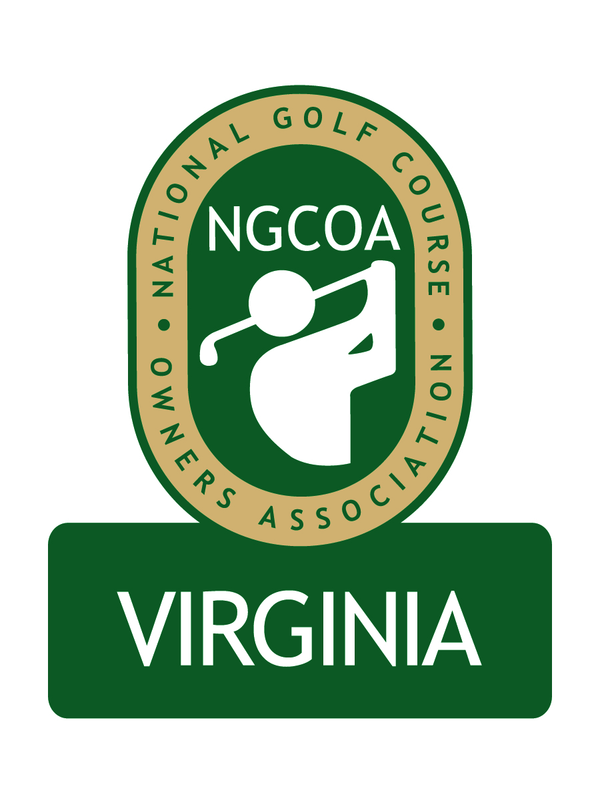

NGCOA Virginia Board Conference Call
Thursday, January 20, 2011

Minutes

Attendance – David Norman, Glen Byrnes, Mike Bennett, Phil Owenby, Bob Swiger, Don Ryder

The meeting was called to order at 1:32 pm.

Roll Call of Participants

The meeting began with a roll call of participants.

Approval of Minutes

The minutes of the December meeting were approved.

Board Update

The group welcomed Phil Owenby to the Board. We are still awaiting Gordon Digby’s replacement to be named for consideration on the military course position. Mike Bennett has contacted Merv Troyer regarding the daily fee position. David Norman will issue an email invitation to current Board members regarding the open position of Secretary/Treasurer.

Virginia Golf Trail / Virginia Tourism Update

Bennett reported that VGT has announced that 22 courses have signed up for the Trail. Virginia Tourism has no funding of this initiative. This is a “for profit” entity, and the web site is supposed to launch on January 25th (originally targeted earlier). None of the NGCOA VA Board member organizations are participating. Judy Watkins of Virginia Tourism sent an email indicating that a meeting will be held for golf organizations in Virginia and that NGCOA VA would be invited.

Membership Update & Partner Program

Since the last meeting Two Rivers CC and Hanover CC have verbally committed to join. We are soliciting Hampton Roads Golf (Merv Troyer), which includes seven courses. We are also working on the Corporate Partner program, and they Board asked to receive a list of prospects.

Government Relations

There is key nutrient management legislation being considered in the Virginia legislature. An email was sent to clubs asking them to support a version that would be best for golf courses. It was suggested to coordinate this with additional information on the Virginia Golf Course Superintendents website (www.vgcsa.org). In addition, the group discussed ADA issues.
Virginia Golf Council & VTC Show Update

A key topic at the recent Virginia Golf Council meeting was current legislative issues, including nutrient management. The USGA Green Section Conference will take place on March 8 at The Country Club of Virginia, and each council organization is asked to contribute $200 to support the event. There was a short report on the “Get Golf Ready” program, which had some effect, but did not reach expectations. VSGA volunteered to handle admin duties for the group this year.

Mike Bennett and David Norman met with Virginia Turfgrass Council representatives at the VTC Conference and Show to discuss a possible partnership for 2012. The VTC would consider a proposal over the next 60 days. A conservative approach was offered, such as NGCOA VA promoting the event, and receiving free admission and a free booth and education space. Byrnes cautioned that we do not want to lose our identity in the context of the event, and suggested that our annual meeting remain a separate event.

Web Site Update

Preparations are on target to launch the web site around the first of February.

2011 Event Schedule

Norman outlined possible conference call topics for months when there is no scheduled event. Hatch, Byrnes and Bennett noted the need to engage our members. For the annual meeting, it was suggested to avoid busy part of the golf season, possibly going in mid-October on a Tuesday, Wednesday or Thursday. We would like to inform non-members of upcoming events and to engage them in the list serve service. There will be a joint event with CMAA-VA on June 20 at The Country Club of Virginia.

Old & New Business

The next Board conference call will be at 1:30 pm on Thursday, March 3rd.

The meeting was adjourned at 2:30 pm.

