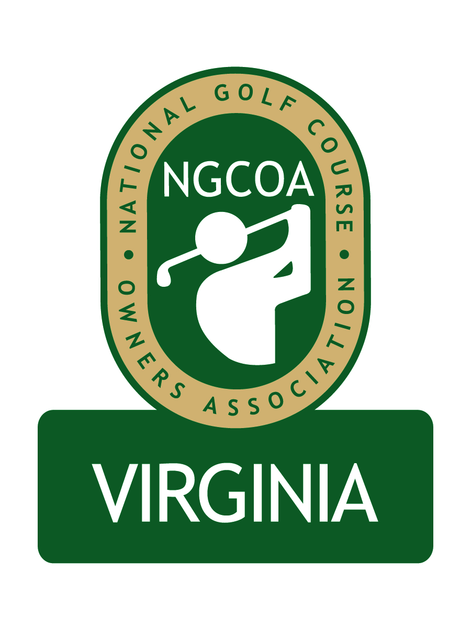

NGCOA Virginia Board Conference Call
November 12, 2013

Minutes

Attendance – David Norman, Mike Bennett, Damon DeVito, Glen Byrnes, Mike Hatch, Don Ryder, Bob Swiger, Mike Cutler

The meeting was called to order at 2:04 pm.

Roll Call of Participants

The meeting began with a roll call of participants.

Approval of Minutes

The minutes of the previous meeting were approved.

Treasurer’s Report

Norman gave the Treasurer’s report, which was approved.

Economic Impact Study Update

The Economic Impact Study commissioned by the Virginia Golf Council is currently underway via SRI, the research company utilized by the World Golf Foundation. The study is utilizing 202 data. NGCOA VA’s share of the cost is approximately $1,700, which will be payable in 2014.

Byrnes suggested that the Virginia Golf Council should have a web page containing information on the organizations and representatives that comprise the Council. Norman will create a page on the NGCOA VA site for this purpose, since he is the current administrator for VGC.

Partner Program Update

Norman announced that Club Prophet Systems has an interest in becoming a Partner. Also Billy Casper Golf is expected to become a Partner in 2014. Mike Bennett suggested IBS as a prospective partner, and the CEO is a member of one of the board member’s club.

Webinar Education

Norman reported on Mike Aldrich’s presentation, “Three Simple Steps to 1,000 Rounds.” It was suggested to do another one on health care reform. It was also suggested to ask Joe Rice at the national office for webinar topics.

Holiday Online Auction

Norman reported on the Holiday Online Auction, scheduled to run December 8-13. He requested help in promoting the auction to prospective bidders (e.g., amateur golfers). It is easy to establish an account and bid. He asked board members to please donate to the auction.

Regional Expansion

Norman mentioned his conversation with Bob Swiger about the expansion to MD and DC, including prospective board members. Swiger knows several top prospects through affiliations with the Raspberry Golf Trail – these include the owners of Blue Mash, Waverly Woods, Queenstown Harbor and Lake Presidential. Bennett suggested we target the active folks who may already be members of NGCOA.

Old Business / New Business

The next board call is set for 2 pm, Tuesday, December 17th.

Norman reported that the Virginia Golf Council letter to the Governor and Lt. Governor was sent the day following their election, expressing our support on behalf of the golf industry.

Adjourn

The meeting was adjourned at 2:34 pm.

