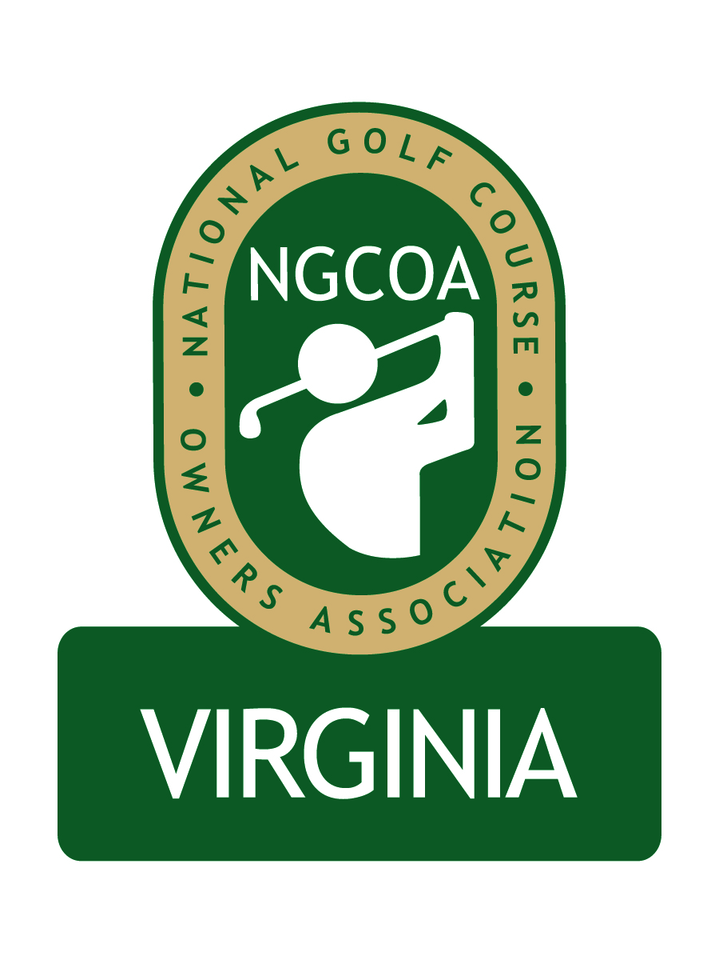

NGCOA Virginia Board Conference Call
Thursday, December 16, 2010

Minutes

Attendance – David Norman, Glen Byrnes, Rob Waldron, Mike Bennett, Richard Cromwell, Bob Swiger, Don Ryder

The meeting was called to order at 1:32 pm.

Roll Call of Participants

The meeting began with a roll call of participants.

Approval of Minutes

A motion to approve the minutes of the last conference call passed.

Board Nominations

Norman gave a review of the nominees to the Board and noted the course types represented. Bennett noted the desire to maintain relevance of NGCOA VA and to keep a broad representation. He suggested that the sectors represented by departing Board members (large private, daily fee and military) be replaced by representatives from the same sectors. It was suggested that the “military course” position remain open until the Navy replaces Gordon Digby, and Swiger agreed but suggested that the selection should not be automatic for his replacement. A motion to defer action on this position until March 31, 2011 passed. Norman was asked to inform Digby that we would consider his replacement for our Board (but not guaranteed).

Byrnes asked about the possibility of Cromwell remaining on the Board. Cromwell said although he was coming off the Board, he would be happy to assist NGCOA VA in the future. Byrnes thanked Cromwell for his service. The Board then discussed the prospects for the private and daily fee positions, and they asked Norman to proceed with an electronic ballot to select the selections.

Virginia Golf Trail / Virginia Tourism Letter

Norman reviewed the letter Virginia Tourism sent regarding the Virginia Golf Trail, suggesting a meeting of golf organizations in 2011. It appears that around 20 courses have signed up to participate in the Golf Trail program. They are offering special promotions and pricing to entice membership.

Strategic Planning– membership growth, partner program, budget

The group discussed membership growth. Byrnes suggested that getting another Board member in northern Virginia could help us recruit in that area. Norman added that Partner Program solicitation would begin in January.

Government Relations

DN gave an overview of the ADA regulations affecting golf courses. Waldron noted the additional requirements for accessible golf, as well as the increased cost, should this be enacted.

GolfDirect

The group discussed the GolfDirect on-course marketing program. No Board member planned to participate in the program, and there was no interest in pursuing this for NGCOA VA.

Old & New Business – VTC Show (comp admission, possible partnership, photos), future meetings

Norman mentioned the upcoming VTC Show, where Board members are invited on a complimentary basis by VTC. We will have an exploratory meeting in January with VTC to evaluate potential partnership opportunities for the 2012 event.

The status of the web site development was discussed. Norman is currently working with Cybergolf on this project. Byrnes suggested that an online directory should designated which courses are members, perhaps by bolding their name. Waldron suggested that the database should be offered in two versions, (1) general (just club name, address, phone and web site), which would be open to everyone, and (2) members only (add in personal contact names, direct lines and email addresses).

The next Board Conference Call was set for 1:30 pm, Thursday, January 20, 2011.

The meeting was adjourned at 2:34 p.m.

