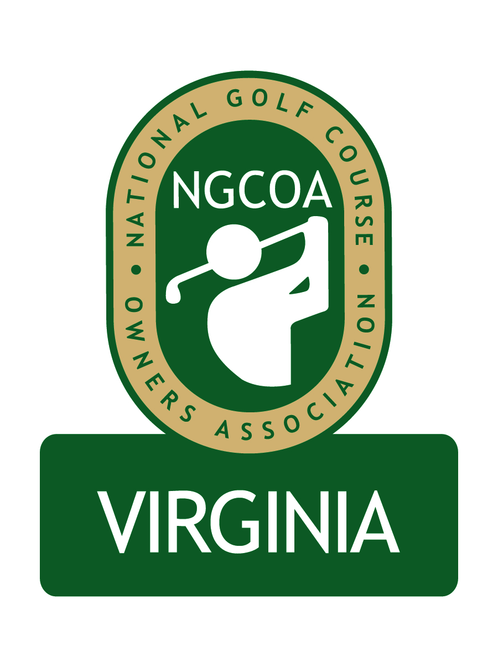

NGCOA Virginia Board Conference Call
February 14, 2013

Minutes

Attendance – David Norman, Mike Bennett, Mike Hatch, Phil Owenby, Bob Swiger, Glen Byrnes, Mike Cutler, Don Ryder, Joe Rice, David Partridge

The meeting was called to order at 1:32 pm.

Roll Call of Participants

The meeting began with a roll call of participants. Bennett congratulated Ryder on The Homestead’s Joe Jemsek Award at the NGCOA Annual Banquet.

Treasurer’s Report

Norman gave the Treasurer’s report, which was approved.

Recap of Meetings – NGCOA Conference, VTC Conference, VA Golf Council Meeting

Rice gave a report on the NGCOA Conference. They are currently surveying for member feedback. The “Day at the Course” event (behind the scenes tour) was excellent, as well as the golf tournament. The Golf Industry Show was also good. There were 650 participants in the conference, which was slightly lower than last year in Las Vegas, but on par with Orlando the year before. Rice announced that conference coordinator Anne Lyndrop is retiring, and they are working on a succession plan. Hatch remarked that this year’s speakers were excellent – he met with Dana Garmany (Troon Golf) and Peter Hill (Billy Casper Golf). Ryder said the annual banquet was a first class event, offering a reunion amongst industry leaders.

Norman gave a report on the VTC Conference at the Fredericksburg Expo, which was on par with the previous year. The VGCSA held its annual meeting off-site at Fredericksburg Country Club with record attendance.

Norman also reported on the Virginia Golf Council Meeting. Jon Guhl of MAPGA is spearheading an effort to renew the Economic Impact Study. The price will be significantly less than last time – estimated at $13,500. There is a chance we could get Virginia Tourism to co-op the study for 50% of the cost. That would lessen the commitment from each VGC member. It was mentioned that some VGC member organizations are larger than others, and perhaps cost-sharing could reflect that. One a different matter, a question came up about the Virginia Golf Trail came up, noting that information is still on the Virginia Tourism website, even though it is believed to be defunct. Cannon Ridge is now closed, as the lessors (Gary Schaal and Deane Beman) have withdrawn from management.

National Office Update / Membership

In 2012 membership was down slightly (1% in # members, 3% in revenue). NGCOA now has a staff member focused on acquisition. National Golf Day is set for April 16 in Washington, DC. The Podesta Group is assisting with the “We Are Golf” effort. Government relations efforts include getting golf added to benefits for flood insurance; however, for the tax side the fight continues to get golf included. Club Car and Pepsi have renewed their national sponsorships.

2013 Events Discussion

We are looking to stage a series of webinars about every six weeks, and the first one will be presented by Mike Aldrich, PGA Regional Player Development Manager. The group agreed that there must be good subject matter and that we could seek a sponsor for the series. Rice recommended “hot topics” for the webinars (e.g., healthcare reform). It was suggested to leave time for interaction.

The plans for the Annual Meeting were discussed – we need to set the site and date. Hatch noted that there were not many individual owners in attendance last year. We hope to attract more this year. The group liked the current format of education in the morning and golf in the afternoon.

Partner Program

Norman called on a number of Partner Prospects at the Golf Industry Show. He is currently following up on renewals and new prospects.

Government Relations Update

The Virginia DCR is going to make $100,000 in grants available to nutrient management planners. All golf courses in Virginia will be required to have a certified nutrient management plan in place by July, 2017.

Old Business / New Business

A question was brought up about the FCC’s regulations on “narrow banding.” Bennett shared his experience in getting quotes to fix the problem, and they ranged widely. He has a list of contacts, which he is willing to share. Hatch asked if a service provider might offer a group price.

There is an open position on the NGCOA VA Board. It was suggested to seek a person who is a single course owner, without regard to location of the course.

The next meeting will be Thursday, March 28 at 2 pm.

Adjourn

The meeting was adjourned at 3:02 pm.

