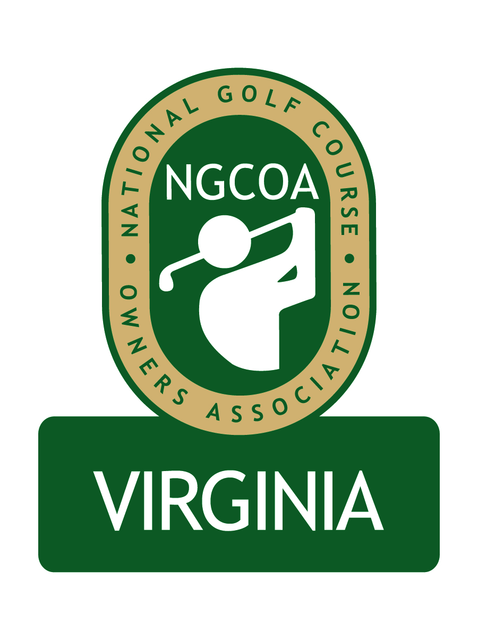

NGCOA Virginia Board Conference Call
February 23, 2012

Minutes

Attendance – David Norman, Mike Bennett, Mike Hatch, Phil Owenby, Bob Swiger, Glen Byrnes

The meeting was called to order at 1:32 pm.

Roll Call of Participants

The meeting began with a roll call of participants.

Treasurer’s Report

Norman gave the Treasurer’s report, which was approved. Dues revenue has been covering about 50% of the management fee, and partner program revenue is needed soon.

Virginia Golf Council Meeting Recap

Mike Bennett and David Norman represented NGCOA VA at the Virginia Golf Council meeting in January. The BMP report has been completed and VGCSA thanked all parties for their support, and they announced that the project is not moving into the water quality monitoring phase. Dick Johns announced his retirement from the MAPGA and introduced his replacement, Jon Guhl.

Government Relations

More detail on the BMP project was presented. The document is available in hard copy, on thumb drives or online at www.vgcsa.org/bmps. The project was conducted in cooperation with Virginia agencies, which will benefits for the golf industry in the future

Virginia Tourism

Alisa Bailey is leaving Virginia Tourism as CEO – a successor has not been named. It was approved to make Virginia Tourism an honorary partner of NGCOA VA. The board was encouraged to visit the golf portion of the Virginia Tourism website (www.virginia.org) and offer suggestions for improvement. A board asked for an update on the Virginia Golf Trail.

2012 Events

A joint event with CMAA and VGCSA is set for March 12th at Hermitage CC. Andrew Green of McDonald & Sons will be a speaker, and Peter McDonough will give an update on the BMP project. The NGCOA Annual Meeting & Golf Outing has been set for September 19th at Augustine GC in Stafford (part of the Raspberry Golf Trail family). Norman asked for recommendations of topics for the webinar series. Golf 2.0 was suggested, perhaps engaging John Malinowski, MAPGA President and Jon Guhl, MAPGA Executive Director.

Partner Program

Each board member was asked to recruit one corporate partner (could simply be a referral to David Norman). There was a discussion of the newsletter amenities – generally the shorter the better; need good photography; representing different regions and types of clubs; have ads separately on an insert; mailing with no envelope is OK; distribution to include eBlast with minimal print run.

Membership Growth

It was suggested that the national office send Golf Business to prospective members.

Old & New Business

The Golf Now “debacle” is now happening at 30% of the golf clubs that do not have a PGA pro. It was suggested that owners and PGA pros work together on this issue.

There should be a focus on player development; perhaps with a series of 2-3 presentations (possible speakers include Malinowski, Guhl and Baldassari).

The ADA initiatives for swimming pools were discussed, including the chair lifts for swimming pools. There was a discussion on whether private clubs would be exempt – then the issue of swim meets was introduced, which made it less clear. Traditional Golf Properties is following this closely, and Colonial Williamsburg has already started compliance (the stated fine is $55K per day!). The deadline was to be March 15th.

Adjournment

The meeting was adjourned at 2:25 pm.

