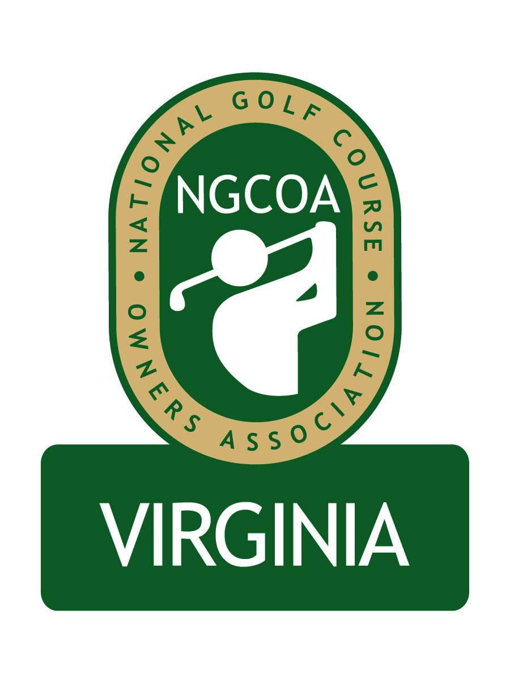
NGCOA Virginia Board Conference Call
Thursday, February 25, 2010

Minutes

Attendance – Richard Cromwell, Dave Donofrio, Bob Swiger, David Norman, Don Ryder, Nancy Downie, Mike Hatch, Gordon Digby

The meeting was called to order at 1:35 pm.

Roll Call of Participants

The meeting began with a roll call of participants.

Approval of Minutes

A motion (Swiger/Hatch) to approve the minutes of the January 14, 2010 Board Conference Call passed.

Corporate Filing Update

Norman reported that the filing with the IRS for nonprofit (501c6) status “awaiting assignment” to an IRS agent. Our accountant has informed us that we will submit a 990 form once we are approved.

Meeting Reports

Norman gave an update on the Virginia Golf Council meeting held in January. Donofrio attended the Virginia Turfgrass Council Show, which he said was smaller than last year, but there was good education. Norman attended the Golf Industry Show, including the NGCOA social event and the executive directors meeting. Attendance was down somewhat, but better than expected, considering the economy and west coast location. Next year’s event in Orlando is expected to be well-attended.

National Update

Norman reported that the national office is seeking to identify a vendor for Directors and Officers Liability Insurance, and they are working with Davis Garvin. He also noted that we will not have to change our fiscal year, as national is now adopting a calendar year reporting system, which will match our system.

Membership Initiative

Hatch asked about the status of membership nationally. Downie said it is now recovering. Downie noted that some of the emails on membership sent by Norman are drawing response. Hatch reported that some of his calls show clubs are struggling now – generally they ask for more information on membership. Swiger indicated that he expects to have a new member joining soon.

Spring Event

Cromwell reported on our next event, a joint meeting with the Virginias Chapter of CMAA, set for Monday, May 17 at Boonsboro Country Club in Lynchburg. He said the CMAA Board is excited about the event. The meeting portion will include brainstorming and roundtables. Everyone needs to bring new ideas. He will check with CMAA on how we will handle registration.

Industry Partner Program

Norman overviewed the general concept of an Industry Partner Program. We are no longer pursuing the concept of a joint directory with VGCSA, as the printer’s quote indicated that the larger book and shipping would cost more for both associations.

Government Relations

Norman gave an update on the VGCSA’s Rounds4Research initiative – a program to auction one foursome at each Virginia course to raise money for a “Best Management Practices” project to benefit golf in Virginia. He asked for support of the program from NGCOA VA. He also reviewed the status of the “WE ARE GOLF” national initiative, supported by NGCOA, GCSAA, PGA of America and CMAA.

“Best Practices” Conference Call

Norman reminded the Board about the “Best Practices” conference call for members, which would commence at 2:45 pm today.

Old & New Business

Hatch suggested that we have a separate meeting for owners, to include “mom and pop” operations. He wondered if our current meeting format might discourage them from attending, thus we should be careful how we promote events. He suggested a “buddy system,” pairing new owners with established one. He wants to make sure we engage owners, not just managers. Networking around the room is key.

The Board selected the next conference call date – Thursday, April 1 at 1:30 p.m. The meeting was adjourned at 2:15 pm.

