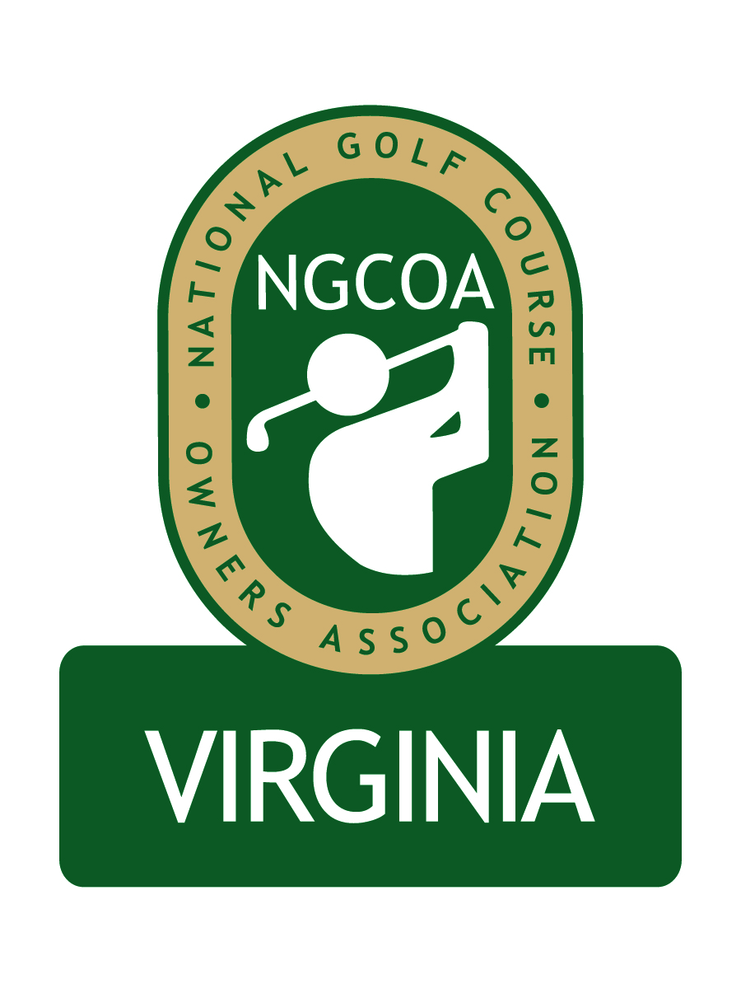

NGCOA Virginia Board Conference Call
March 20, 2014

Minutes

Attendance – David Norman, John Anderes, Bob Swiger, Glen Byrnes, Mike Hatch, Mike Bennett, Joe Rice, Rick Rounsaville, Joe Hills, Keith Miller, Damon DeVito, Phil Owenby, Don Ryder

The meeting was called to order at 3:03 pm.

Minutes

The minutes of the February 14, 2014 meeting were approved.

Treasurer’s Report

Norman presented the Treasurer’s report, indicating that income and expenses are in line. Bennett asked about the Partner Program, and Norman replied that he is seeking to move renewals earlier, with a goal to make them based on the calendar year, rather than the anniversary date.

Welcome & Update from National Office

Rice gave a recap of the national conference, saying that “The Day at the Course” program was very popular again this year. He noted that Jack Nicklaus was honored at the annual dinner and did a Q&A. Next year’s conference is in San Antonio.

The Strategic Plan is ongoing, led by Harrison Coerver. The focus is on relevance.

NGCOA is also working on the online tee time issue. Four companies have been invited to participate, including Golf Pipeline and Golf Now.

Rice reported that the first chapter leader monthly conference call was good, with excellent participation. He also mentioned that Suburban Propane is a new national partner.

Mid-Atlantic Expansion

Norman mentioned that our counsel is working on the Bylaws revisions. We are working on the site for the Annual Meeting, and Owenby is assisting with a proposal for consideration by Congressional CC. We will also investigate the possibility of a satellite event in conjunction with National Golf Day.

Virginia Economic Impact Study

Norman gave an overview of the PR efforts surrounding the publishing of the Economic Impact Study for the golf industry in Virginia. A general press release, with a link to the study, was issued to all golf industry outlets. The Virginia Golf Council distributed copies of the study to all legislators in the Virginia House and Senate. The study was also utilized in a meeting with Virginia Tourism.

Webinar Series

A webinar is scheduled for March 27, 2014, “Golf’s Money Making Machine,” to be presented by PGA Development Manager Mike Aldrich.

Golf Investor Survey, Handicap Vendor Discussion

Norman reported on the request by Rob Waldron of Marcus & Millichap to promote a “Golf Investor Survey” to our members. Norman noted some pros and cons. Board members cited several issues and asked why this was not being done through the national office. The board decided to pass on promoting the survey.

Norman presented the issue of the solicitation of Virginia clubs by handicap service vendor Golfnet (the company that formerly was employed by VSGA/MAPGA, before they switched vendors to GHIN). It was noted that competition in general is good for the marketplace. It was noted that we represent owners, and we are the customers for this service. We will continue to monitor the issue to see what develops.

Other

Rice gave further explanation on National Golf Day, which is on May 21 in Washington, DC. There will be a limited number of participants with specific assignments, although other events are open. The goal is to promote the economic, charitable and environmental impacts for golf. Forbes-Tate has been retained as the lobbying firm representing the World Golf Foundation.

Bennett noted that Golf Now has contacted him on a new promotion with a “guaranteed floor price,” but then they negotiate for a better tee time to barter, with a lower floor. They are feeling the push back from our national office. Recently National Golf Management, which operates a number of Myrtle Beach courses, dropped Golf Now. Golf Now is making some marketing changes and trying to get clubs to adopt their new system. Hills noted that they have 20 beta properties they are testing.

Bennett also noted the new IRS ruling reclassifying “mandatory” gratuities (i.e., “service charges”). These service charges are now automatically classified as wages; however, true tips are not.

Rice reported that a membership campaign, tied to the announcement of our expanded chapter, is being developed.

Next Meeting

The next board conference call will be at 2 pm on Thursday, April 24th.

Adjournment

The meeting was adjourned at 4:08 pm.

