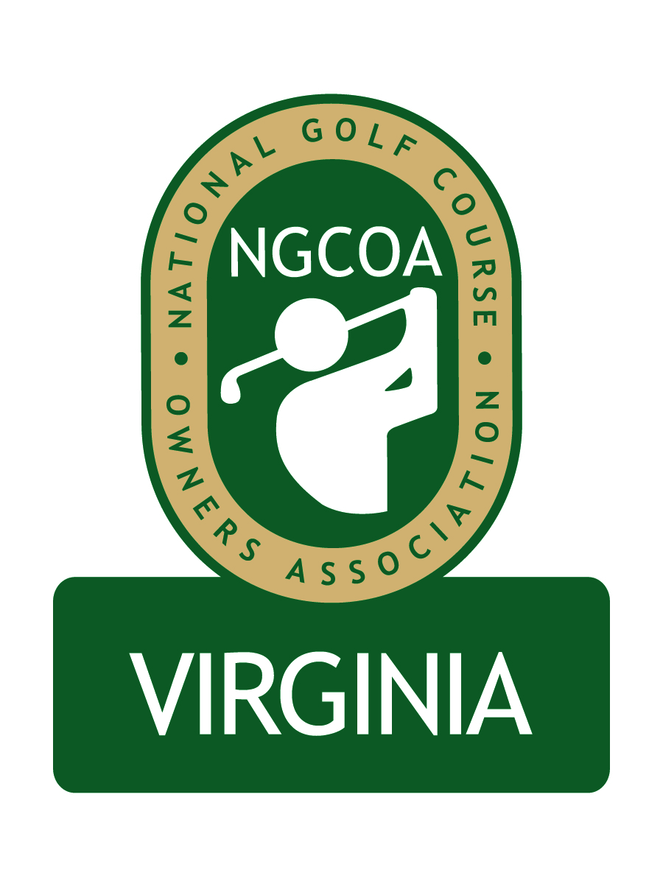

NGCOA Virginia Board Conference Call
March 28, 2013

Minutes

Attendance – David Norman, Mike Bennett, Phil Owenby, Bob Swiger, Mike Fentress

The meeting was called to order at 2:02 pm.

Roll Call of Participants

The meeting began with a roll call of participants.

Approval of Minutes

The minutes of the previous meeting were approved.

Treasurer’s Report

Norman gave the Treasurer’s report, which was approved.

Report from National Office

Norman read the report from the national office from Nancy Downie as follows:

Club Car - renewed contract for next 5 years, with added member benefits
($15 rebate on conversions; free conference registration for renewals and conversions; GPS/Visage added value)

Pepsi - working on stronger Pepsi offering and that will be coming through in the next couple of months. Should be a better discount/rebate, extends program across all Pepsi brands (Gatorade, Monster, etc.) and bottles and cans.

WE ARE GOLF - National Golf Day is April 16 and NGCOA is attending. Our President, Linda Rogers, is attending and will be considered one of our "storytellers" and will speak about the impacts golf has on communities from a charitable, environmental, wellness and - most important - economic standpoint (same messaging as before). She will be in meeting with key legislators that Podesta has identified as both advocates and foes of the business.

Membership is strong - retention is up, revenue is above budget year-to-date, and new membership efforts are paying off.

Conference - top line survey results are in and it was one of the most well-attended events (less than Vegas but higher than all others in the last several years) with tremendous satisfaction from members.

Education, staff service, and the Day at the Golf Facility all got very high marks.

Annual Meeting Discussion – Awards Program

Norman presented a new concept for our Annual Meeting, featuring an annual awards program with presenting sponsors (see attachment following minutes). The concept was created by Mike Hatch and Damon DeVito.

Bennett liked the idea and commented that it could grow participation in our chapter – he complimented Mike Hatch and suggested we implement it. Swiger agreed. Fentress also liked the idea and mentioned that MAPGA has a similar awards program. Owenby commented that it could create more awareness and credibility for our organization. Bennett also mentioned that he knows and respects Damon DeVito, the partner on the concept.

2013 Events Discussion

A new webinar on Health Care Reform is being planned, featuring Steve Northrup of The Podesta Group. On June 10th we will stage the NGCOA-VGCSA-CMAA Joint Event at Princess Anne CC, featuring former Augusta National superintendent Billy Fuller.

Mike Bennett offered to host the NGCOA Annual Meeting at Fords Colony Country Club in Williamsburg in early October. They are converting the Blue Heron Course greens to an ultradwarf bermudagrass. The Marriott property on-site will be available for overnight guests.

Partner Program

Norman is following up on Partner Prospects he called on at the Golf Industry Show. Confirmed partners are the VSGA, Yamaha Golf Cars, Richard Mandell Golf Architecture and Golf Property Analysts. He is following up on renewals from 2012 as well.

Government Relations Update

Norman reminded that the Virginia DCR is going to make $100,000 in grants available to nutrient management planners. All golf courses in Virginia will be required to have a certified nutrient management plan in place by July, 2017.

Old Business / New Business

There is an open position on the NGCOA VA Board. Some names were discussed, and everyone felt comfortable with Damon DeVito as a good candidate.

The next meeting is scheduled for Thursday, May 9 at 2 pm.

Adjourn

The meeting was adjourned at 2:51 pm.
NGCOA VA Annual Meeting
Proposal – Awards Program
Presented by Mike Hatch

In an effort to grow the awareness of the NGCOA VA chapter, we should look at making the fall meeting carry more weight by adding an awards piece to the day.

Goals – This idea has a few related objectives:

• Increase attendance and engagement at annual meeting
• Idea sharing to benefit Virginia owners and stimulate discussion
• Generate additional sponsorship dollars for state chapter

Year 1 Awards - Keep it simple by sticking with three easiest to populate awards that have some synergy in identifying nominees.

1. “Greenest of the Year” (environmental stewardship)
2. “Membership Campaign of the Year” (private club)
3. “Best New Marketing Program” (daily fee/semi-private)

A fourth award that would be extremely easy to award without nominations would be a “VGCOA Service Award” for outstanding service to the chapter.

Future Year Awards – Suggest keeping it to a maximum of six. “Idea of the Year” and “Cost Savings Idea of the Year” were discussed as future awards once nominee process is established.

Winners Receive – Engraved and personalized crystal trophies or framed certificates

Sponsorship – we could sell the naming rights for the awards.

• First option (perhaps 15 days following notice) to local contacts from national NGCOA sponsors and then other state sponsors. Remaining spots opened up to others. Hold 30 days max total to line up sponsors before launching call for award nominees. Use these 30 days to also develop the logistics of the awards and nominations process.
• Naming sponsors would receive signage at event, logos with call for award nominees and congratulations of winners. Sponsors will present respective awards and be invited to winners’ breakfast/dinner.

Attracting Nominees
• Nominations Committee of volunteers to be tasked with attracting sufficient nominees. In year one it is likely to be necessary to be proactive with invitations.
• Anyone may submit online nomination via very simple form. Further qualification is always possible, but form should not be an obstacle.
• Board member facilities are eligible for nomination, but Board members (or other course owners/managers) are not permitted to serve on the committee that judges, if they have an interest in a property under consideration.
• In future years each award could have a Selection Committee separate from the Nominations Committee. The Selection Committee(s) could be provided a short list of 3-5 courses for each award by the Nominations Committee. The Selection Committee could be very little work and development tool to foster participation from new faces to the VGCOA, but it is probably best left to future years.

