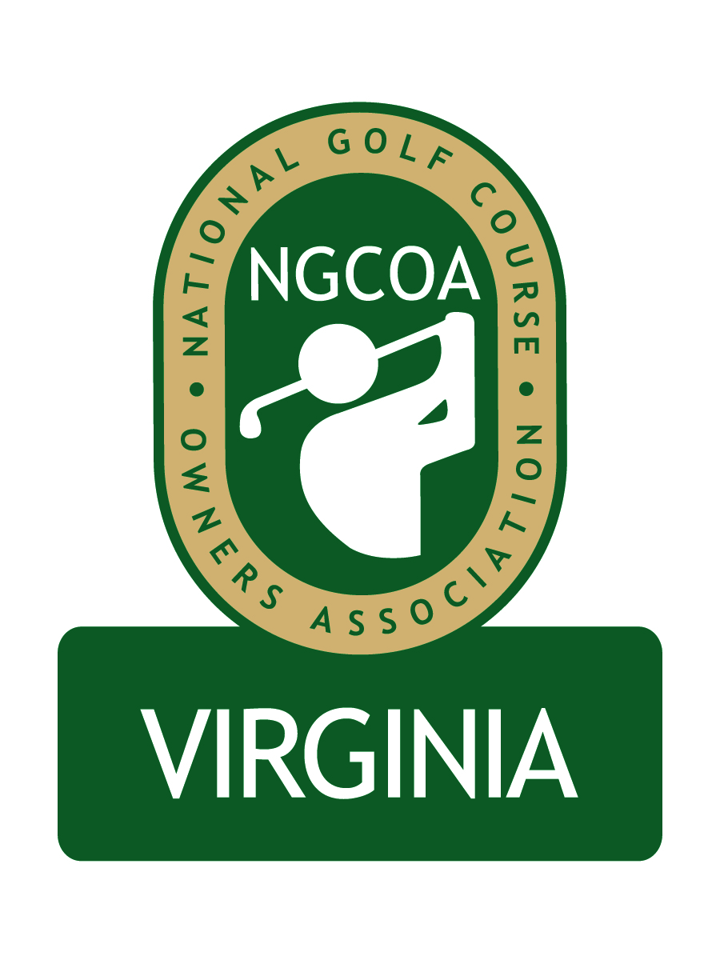
NGCOA Virginia Board Conference Call
Thursday, March 3, 2011

Minutes

Attendance – David Norman, Glen Byrnes, Mike Bennett, Phil Owenby, Mike Hatch, Andy Weissinger, Nancy Downie, Peter McDonough, Joe Rice, Rob Waldron

The meeting was called to order at 1:31 pm.

Roll Call of Participants

The meeting began with a roll call of participants. The group welcomed new board member Andy Weissinger.

BMP & Government Relations Update

Peter McDonough was introduced as the superintendent of Keswick Resort & Club and Government Relations Chair of VGCSA. McDonough reported that State Bill 1831 regarding nutrient management was supported by the turf industry and it passed. He explained that the Virginia Agribusiness Council does the lobbying for VGCSA. He also noted that the EPA has approved Virginia’s plan for compliance with the Chesapeake Bay Act. Bennett explained that this act required the reduction of nitrogen, phosphorus and sediment in the Bay. McDonough noted that Virginia has 40 Bay watershed areas. He highlighted a key element of success in the bill was to supersede the localities’ ability to pass local regulations more stringent than what is in the bill so long as the must have a certified nutrient management plan in place by 2017 – if they do, then local government CANNOT regulate them. We received full support from the Governor. He also noted that localities must report to the DCR this year to get TMDL (total maximum daily load) compliance.

Bennett asked what the next steps would be. McDonough indicated that promotion and communication are essential. Bennett noted that a risk is that individual courses could be pitted against one another, unless we successfully organize and act in concert.

McDonough also updated the group on the “Best Management Practices for Golf Courses in Virginia” project, in conjunction with Virginia Tech researchers. There are several sections covered, with the top experts authoring them. DCR wants to use our plan as a model. Once BMP is signed off on, there will be a “nutrient credit exchange” for open space environment – in other words, golf courses could conceivably sell their credit for maintaining open space to an unrelated developer who needs credits.

Approval of Minutes

The minutes of the January meeting were approved.

Treasurer’s Report

The Treasurer’s report was approved.

NGCOA Update

Joe Rice, who recently became NGCOA Director of Membership, was called on to provide an update from the national office. Rice welcomed Weissinger, and also congratulated Hatch on his appointment to the national board. Rice noted that golf is a local game and a local business. He is on a “listening tour” with chapters to identify how the national office can best assist the chapters. They are currently refining the membership proposition and identifying member needs, and there is a commitment to grow membership. He mentioned that the staff is already working on the 2012 Conference in Las Vegas (Feb. 27 - March 2), as well as National Golf Day on April 13th on Capitol Hill.

Membership Update & Partner Program

Norman gave a general review of the membership initiative and requested board members to help. Weissinger offered his assistance and pledged that his club would join. Bennett and Hatch suggested that we post our minutes to the website, then send an email with a link to them, to show members how active we are, as well as to demonstrate transparency. A key to success will be our ability to remain relevant.

Norman and Hatch commented on the Partner Program. Each board member was asked to identify their top 10 vendors. We would like to ultimately acquire 30-40 corporate partners.

2011 Event Schedule

The USGA Regional Conference is set for March 8th at The Country Club of Virginia. We have a joint event with CMAA Virginias Chapter on June 20th, also at The Country Club of Virginia. We are working on a date and site for the Annual Meeting this fall.

Virginia Tourism Meeting

Bennett and Byrnes attended the Virginia Tourism’s Golf Marketing meeting on March 1st. VTC gave an overview of their co-op marketing program, which is in two tiers, $5,000 and $25,000, and information is available at www.vatc.org. They said the new golf guide has been published and that they will attend the Pittsburgh Golf Show (for a $75 fee, they will display brochures for your course). It was suggested that we invite them to participate in our conference calls.

Byrnes reported that they did not cover the issue of the Virginia Golf Trail. He stated our position that the state should not give an independent operator the “rights” to a “golf trail,” and that we need to get them to look at a broader perspective. We need to make them more aware of the Virginia Golf Council, as the group they should interact with. It was noted that non-golf representatives were there from Stafford County and Virginia wineries (a part of the Virginia Golf Trail). VTC mentioned that grant applications are due in May, and they are willing to help with the applications.

Old & New Business

The next Board conference call will be at 1:30 pm on Tuesday, April 12th.
The group discussed the concept of webinars and conference calls as a format for education and networking. They would be open to all members and center on hot topics. Hatch suggested that they should focus on operations. Bennett suggested the topic of third party resellers. Hatch and Byrnes suggested the use of list serve as well. Bennett also mentioned the topic of attorneys who specialize in restructuring memberships. Weissinger suggested we get ideas from our members on “best practices.” Bennett asked Rice to provide advice on speakers, and Rice indicated that the national office will be a resource to us. Owenby liked the webinar format. Bennett suggested we target the first one in May.

The meeting was adjourned at 2:37 pm.

